https://www.javatpoint.com/spring-boot-tutorial

Spring Boot Tutorial
Spring Boot Tutorial provides basic and advanced concepts of Spring Framework. Our Spring Boot Tutorial is designed for beginners and professionals both.
Spring Boot is a Spring module that provides the RAD (Rapid Application Development) feature to the Spring framework.
Our Spring Boot Tutorial includes all topics of Spring Boot such, as features, project, maven project, starter project wizard, Spring Initializr, CLI, applications, annotations, dependency management, properties, starters, Actuator, JPA, JDBC, etc.

What is Spring Boot
Spring Boot is a project that is built on the top of the Spring Framework. It provides an easier and faster way to set up, configure, and run both simple and web-based applications.
It is a Spring module that provides the RAD (Rapid Application Development) feature to the Spring Framework. It is used to create a stand-alone Spring-based application that you can just run because it needs minimal Spring configuration.
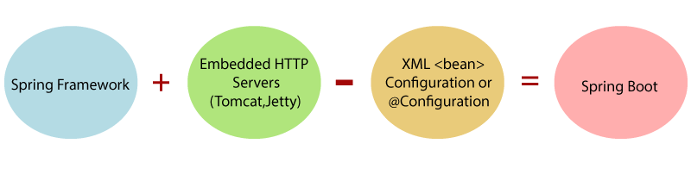
In short, Spring Boot is the combination of Spring Framework and Embedded Servers.

In Spring Boot, there is no requirement for XML configuration (deployment descriptor). It uses convention over configuration software design paradigm that means it decreases the effort of the developer.
We can use Spring STS IDE or Spring Initializr to develop Spring Boot Java applications.

Why should we use Spring Boot Framework?
We should use Spring Boot Framework because:
- The dependency injection approach is used in Spring Boot.
- It contains powerful database transaction management capabilities.
- It simplifies integration with other Java frameworks like JPA/Hibernate ORM, Struts, etc.
- It reduces the cost and development time of the application.
Along with the Spring Boot Framework, many other Spring sister projects help to build applications addressing modern business needs. There are the following Spring sister projects are as follows:
- Spring Data: It simplifies data access from the relational and NoSQL databases.
- Spring Batch: It provides powerful batch processing.
- Spring Security: It is a security framework that provides robust security to applications.
- Spring Social: It supports integration with social networking like LinkedIn.
- Spring Integration: It is an implementation of Enterprise Integration Patterns. It facilitates integration with other enterprise applications using lightweight messaging and declarative adapters.

Advantages of Spring Boot
- It creates stand-alone Spring applications that can be started using Java -jar.
- It tests web applications easily with the help of different Embedded HTTP servers such as Tomcat, Jetty, etc. We don't need to deploy WAR files.
- It provides opinionated 'starter' POMs to simplify our Maven configuration.
- It provides production-ready features such as metrics, health checks, and externalized configuration.
- There is no requirement for XML configuration.
- It offers a CLI tool for developing and testing the Spring Boot application.
- It offers the number of plug-ins.
- It also minimizes writing multiple boilerplate codes (the code that has to be included in many places with little or no alteration), XML configuration, and annotations.
- It increases productivity and reduces development time.

Limitations of Spring Boot
Spring Boot can use dependencies that are not going to be used in the application. These dependencies increase the size of the application.

Goals of Spring Boot
The main goal of Spring Boot is to reduce development, unit test, and integration test time.
- Provides Opinionated Development approach
- Avoids defining more Annotation Configuration
- Avoids writing lots of import statements
- Avoids XML Configuration.
By providing or avoiding the above points, Spring Boot Framework reduces Development time, Developer Effort, and increases productivity.

Prerequisite of Spring Boot
To create a Spring Boot application, following are the prerequisites. In this tutorial, we will use Spring Tool Suite (STS) IDE.
- Java 1.8
- Maven 3.0+
- Spring Framework 5.0.0.BUILD-SNAPSHOT
- An IDE (Spring Tool Suite) is recommended.

Spring Boot Features
- Web Development
- SpringApplication
- Application events and listeners
- Admin features
- Externalized Configuration
- Properties Files
- YAML Support
- Type-safe Configuration
- Logging
- Security
Web Development
It is a well-suited Spring module for web application development. We can easily create a self-contained HTTP application that uses embedded servers like Tomcat, Jetty, or Undertow. We can use the spring-boot-starter-web module to start and run the application quickly.
SpringApplication
The SpringApplication is a class that provides a convenient way to bootstrap a Spring application. It can be started from the main method. We can call the application just by calling a static run() method.
public static void main(String[] args)
{
SpringApplication.run(ClassName.class, args);
}
Spring Boot uses events to handle the variety of tasks. It allows us to create factories file that is used to add listeners. We can refer it to using the ApplicationListener key.
Always create factories file in META-INF folder like META-INF/spring.factories.
Admin Support
Spring Boot provides the facility to enable admin-related features for the application. It is used to access and manage applications remotely. We can enable it in the Spring Boot application by using spring.application.admin.enabled property.

Externalized Configuration
Spring Boot allows us to externalize our configuration so that we can work with the same application in different environments. The application uses YAML files to externalize configuration.
Properties Files
Spring Boot provides a rich set of Application Properties. So, we can use that in the properties file of our project. The properties file is used to set properties like server-port =8082 and many others. It helps to organize application properties.
YAML Support
It provides a convenient way of specifying the hierarchical configuration. It is a superset of JSON. The SpringApplication class automatically supports YAML. It is an alternative of properties file.
Type-safe Configuration
The strong type-safe configuration is provided to govern and validate the configuration of the application. Application configuration is always a crucial task which should be type-safe. We can also use annotation provided by this library.
Logging
Spring Boot uses Common logging for all internal logging. Logging dependencies are managed by default. We should not change logging dependencies if no customization is needed.
Security
Spring Boot applications are spring bases web applications. So, it is secure by default with basic authentication on all HTTP endpoints. A rich set of Endpoints is available to develop a secure Spring Boot application.

Prerequisite
Before learning Spring Boot, you must have the basic knowledge of Spring Framework.

Audience
Our Spring Boot Tutorial is designed to help beginners and professionals.

Problem
We assure you that you will not find any problem with the Spring Boot Tutorial. But if there is any mistake, please post the problem in the contact form.

Spring vs. Spring Boot vs. Spring MVC

Spring vs. Spring Boot
Spring: Spring Framework is the most popular application development framework of Java. The main feature of the Spring Framework is dependency Injection or Inversion of Control (IoC). With the help of Spring Framework, we can develop a loosely coupled application. It is better to use if application type or characteristics are purely defined.
Spring Boot: Spring Boot is a module of Spring Framework. It allows us to build a stand-alone application with minimal or zero configurations. It is better to use if we want to develop a simple Spring-based application or RESTful services.
The primary comparison between Spring and Spring Boot are discussed below:
Spring | Spring Boot
Spring Framework is a widely used Java EE framework for building applications. | Spring Boot Framework is widely used to develop REST APIs.
It aims to simplify Java EE development that makes developers more productive. | It aims to shorten the code length and provide the easiest way to develop Web Applications.
The primary feature of the Spring Framework is dependency injection. | The primary feature of Spring Boot is Autoconfiguration. It automatically configures the classes based on the requirement.
It helps to make things simpler by allowing us to develop loosely coupled applications. | It helps to create a stand-alone application with less configuration.
The developer writes a lot of code (boilerplate code) to do the minimal task. | It reduces boilerplate code.
To test the Spring project, we need to set up the sever explicitly. | Spring Boot offers embedded server such as Jetty and Tomcat, etc.
It does not provide support for an in-memory database. | It offers several plugins for working with an embedded and in-memory database such as H2.
Developers manually define dependencies for the Spring project in pom.xml. | Spring Boot comes with the concept of starter in pom.xml file that internally takes care of downloading the dependencies JARs based on Spring Boot Requirement.

Spring Boot vs. Spring MVC
Spring Boot: Spring Boot makes it easy to quickly bootstrap and start developing a Spring-based application. It avoids a lot of boilerplate code. It hides a lot of complexity behind the scene so that the developer can quickly get started and develop Spring-based applications easily.
Spring MVC: Spring MVC is a Web MVC Framework for building web applications. It contains a lot of configuration files for various capabilities. It is an HTTP oriented web application development framework.
Spring Boot and Spring MVC exist for different purposes. The primary comparison between Spring Boot and Spring MVC are discussed below:

Spring Boot | Spring MVC
Spring Boot is a module of Spring for packaging the Spring-based application with sensible defaults. | Spring MVC is a model view controller-based web framework under the Spring framework.
It provides default configurations to build Spring-powered framework. | It provides ready to use features for building a web application.
There is no need to build configuration manually. | It requires build configuration manually.
There is no requirement for a deployment descriptor. | A Deployment descriptor is required.
It avoids boilerplate code and wraps dependencies together in a single unit. | It specifies each dependency separately.
It reduces development time and increases productivity. | It takes more time to achieve the same.

Spring Boot Architecture
Spring Boot is a module of the Spring Framework. It is used to create stand-alone, production-grade Spring Based Applications with minimum efforts. It is developed on top of the core Spring Framework.
Spring Boot follows a layered architecture in which each layer communicates with the layer directly below or above (hierarchical structure) it.
Before understanding the Spring Boot Architecture, we must know the different layers and classes present in it. There are four layers in Spring Boot are as follows:
- Presentation Layer
- Business Layer
- Persistence Layer
- Database Layer
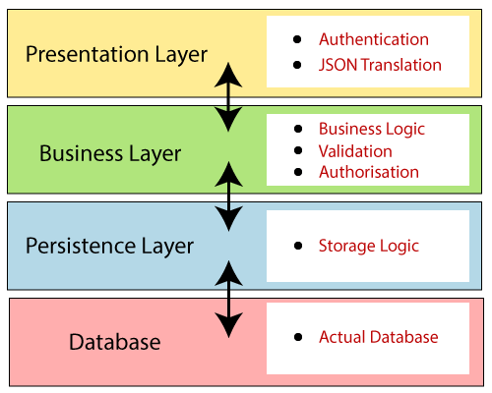
Presentation Layer: The presentation layer handles the HTTP requests, translates the JSON parameter to object, and authenticates the request and transfer it to the business layer. In short, it consists of views i.e., frontend part.
Business Layer: The business layer handles all the business logic. It consists of service classes and uses services provided by data access layers. It also performs authorization and validation.
Persistence Layer: The persistence layer contains all the storage logic and translates business objects from and to database rows.
Database Layer: In the database layer, CRUD (create, retrieve, update, delete) operations are performed.

Spring Boot Flow Architecture
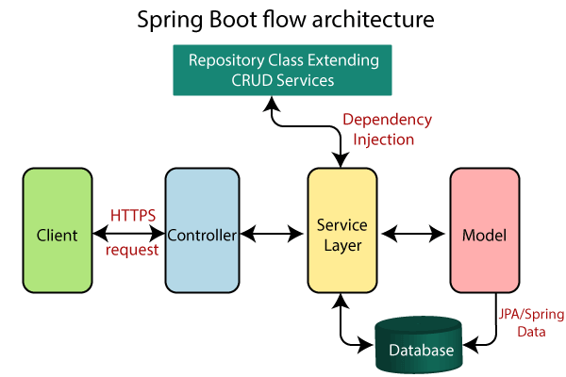
- Now we have validator classes, view classes, and utility classes.
- Spring Boot uses all the modules of Spring-like Spring MVC, Spring Data, etc. The architecture of Spring Boot is the same as the architecture of Spring MVC, except one thing: there is no need for DAO and DAOImpl classes in Spring boot.
- Creates a data access layer and performs CRUD operation.
- The client makes the HTTP requests (PUT or GET).
- The request goes to the controller, and the controller maps that request and handles it. After that, it calls the service logic if required.
- In the service layer, all the business logic performs. It performs the logic on the data that is mapped to JPA with model classes.
- A JSP page is returned to the user if no error occurred.

Spring Boot Annotations
Spring Boot Annotations is a form of metadata that provides data about a program. In other words, annotations are used to provide supplemental information about a program. It is not a part of the application that we develop. It does not have a direct effect on the operation of the code they annotate. It does not change the action of the compiled program.
In this section, we are going to discuss some important Spring Boot Annotation that we will use later in this tutorial.

Core Spring Framework Annotations
@Required: It applies to the bean setter method. It indicates that the annotated bean must be populated at configuration time with the required property, else it throws an exception BeanInitilizationException.
Example
1.7M
- public class Machine
- {
- private Integer cost;
- @Required
- public void setCost(Integer cost)
- {
- this.cost = cost;
- }
- public Integer getCost()
- {
- return cost;
- }
- }

@Autowired: Spring provides annotation-based auto-wiring by providing @Autowired annotation. It is used to autowire spring bean on setter methods, instance variable, and constructor. When we use @Autowired annotation, the spring container auto-wires the bean by matching data-type.
Example

- @Component
- public class Customer
- {
- private Person person;
- @Autowired
- public Customer(Person person)
- {
- this.person=person;
- }
- }
@Configuration: It is a class-level annotation. The class annotated with @Configuration used by Spring Containers as a source of bean definitions.
Example
- @Configuration
- public class Vehicle
- {
- @BeanVehicle engine()
- {
- return new Vehicle();
- }
- }
@ComponentScan: It is used when we want to scan a package for beans. It is used with the annotation @Configuration. We can also specify the base packages to scan for Spring Components.
Example
- @ComponentScan(basePackages = "com.javatpoint")
- @Configuration
- public class ScanComponent
- {
- // ...
- }
@Bean: It is a method-level annotation. It is an alternative of XML <bean> tag. It tells the method to produce a bean to be managed by Spring Container.
Example
- @Bean
- public BeanExample beanExample()
- {
- return new BeanExample ();
- }

Spring Framework Stereotype Annotations
@Component: It is a class-level annotation. It is used to mark a Java class as a bean. A Java class annotated with @Component is found during the classpath. The Spring Framework pick it up and configure it in the application context as a Spring Bean.
Example
- @Component
- public class Student
- {
- .......
- }
@Controller: The @Controller is a class-level annotation. It is a specialization of @Component. It marks a class as a web request handler. It is often used to serve web pages. By default, it returns a string that indicates which route to redirect. It is mostly used with @RequestMapping annotation.
Example
- @Controller
- @RequestMapping("books")
- public class BooksController
- {
- @RequestMapping(value = "/{name}", method = RequestMethod.GET)
- public Employee getBooksByName()
- {
- return booksTemplate;
- }
- }
@Service: It is also used at class level. It tells the Spring that class contains the business logic.
Example
- package com.javatpoint;
- @Service
- public class TestService
- {
- public void service1()
- {
- //business code
- }
- }
@Repository: It is a class-level annotation. The repository is a DAOs (Data Access Object) that access the database directly. The repository does all the operations related to the database.
- package com.javatpoint;
- @Repository
- public class TestRepository
- {
- public void delete()
- {
- //persistence code
- } }

Spring Boot Annotations
- @EnableAutoConfiguration: It auto-configures the bean that is present in the classpath and configures it to run the methods. The use of this annotation is reduced in Spring Boot 1.2.0 release because developers provided an alternative of the annotation, i.e. @SpringBootApplication.
- @SpringBootApplication: It is a combination of three annotations @EnableAutoConfiguration, @ComponentScan, and @Configuration.

Spring MVC and REST Annotations
- @RequestMapping: It is used to map the web requests. It has many optional elements like consumes, header, method, name, params, path, produces, and value. We use it with the class as well as the method.
Example
- @Controller
- public class BooksController
- {
- @RequestMapping("/computer-science/books")
- public String getAllBooks(Model model)
- {
- //application code
- return "bookList";
- }
- @GetMapping: It maps the HTTP GET requests on the specific handler method. It is used to create a web service endpoint that fetches It is used instead of using: @RequestMapping(method = RequestMethod.GET)
- @PostMapping: It maps the HTTP POST requests on the specific handler method. It is used to create a web service endpoint that creates It is used instead of using: @RequestMapping(method = RequestMethod.POST)
- @PutMapping: It maps the HTTP PUT requests on the specific handler method. It is used to create a web service endpoint that creates or updates It is used instead of using: @RequestMapping(method = RequestMethod.PUT)
- @DeleteMapping: It maps the HTTP DELETE requests on the specific handler method. It is used to create a web service endpoint that deletes a resource. It is used instead of using: @RequestMapping(method = RequestMethod.DELETE)
- @PatchMapping: It maps the HTTP PATCH requests on the specific handler method. It is used instead of using: @RequestMapping(method = RequestMethod.PATCH)
- @RequestBody: It is used to bind HTTP request with an object in a method parameter. Internally it uses HTTP MessageConverters to convert the body of the request. When we annotate a method parameter with @RequestBody, the Spring framework binds the incoming HTTP request body to that parameter.
- @ResponseBody: It binds the method return value to the response body. It tells the Spring Boot Framework to serialize a return an object into JSON and XML format.
- @PathVariable: It is used to extract the values from the URI. It is most suitable for the RESTful web service, where the URL contains a path variable. We can define multiple @PathVariable in a method.
- @RequestParam: It is used to extract the query parameters form the URL. It is also known as a query parameter. It is most suitable for web applications. It can specify default values if the query parameter is not present in the URL.
- @RequestHeader: It is used to get the details about the HTTP request headers. We use this annotation as a method parameter. The optional elements of the annotation are name, required, value, defaultValue. For each detail in the header, we should specify separate annotations. We can use it multiple time in a method
- @RestController: It can be considered as a combination of @Controller and @ResponseBody annotations. The @RestController annotation is itself annotated with the @ResponseBody annotation. It eliminates the need for annotating each method with @ResponseBody.
- @RequestAttribute: It binds a method parameter to request attribute. It provides convenient access to the request attributes from a controller method. With the help of @RequestAttribute annotation, we can access objects that are populated on the server-side.

Note: We have used all the above annotations in our RESTful Web Services Tutorial with real-world examples.

Spring Boot Application Properties
Spring Boot Framework comes with a built-in mechanism for application configuration using a file called application.properties. It is located inside the src/main/resources folder, as shown in the following figure.
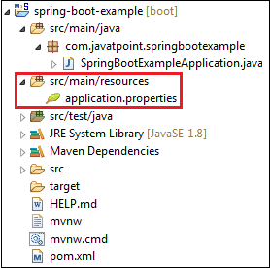
Spring Boot provides various properties that can be configured in the application.properties file. The properties have default values. We can set a property(s) for the Spring Boot application. Spring Boot also allows us to define our own property if required.
The application.properties file allows us to run an application in a different environment. In short, we can use the application.properties file to:
- Configure the Spring Boot framework
- define our application custom configuration properties

Example of application.properties
- #configuring application name
- spring.application.name = demoApplication
- #configuring port
- server.port = 8081
In the above example, we have configured the application name and port. The port 8081 denotes that the application runs on port 8081.

Note: The lines started with # are comments.
YAML Properties File
Spring Boot provides another file to configure the properties is called yml file. The Yaml file works because the Snake YAML jar is present in the classpath. Instead of using the application.properties file, we can also use the application.yml file, but the Yml file should be present in the classpath.
Example of application.yml
- spring:
- application:
- name: demoApplication
- server:
- port: 8081
In the above example, we have configured the application name and port. The port 8081 denotes that the application runs on port 8081.

Spring Boot Property Categories
There are sixteen categories of Spring Boot Property are as follows:
- Core Properties
- Cache Properties
- Mail Properties
- JSON Properties
- Data Properties
- Transaction Properties
- Data Migration Properties
- Integration Properties
- Web Properties
- Templating Properties
- Server Properties
- Security Properties
- RSocket Properties
- Actuator Properties
- DevTools Properties
- Testing Properties

Application Properties Table
The following tables provide a list of common Spring Boot properties:
Property | Default Values | Description
Debug | false | It enables debug logs.
spring.application.name |  | It is used to set the application name.
spring.application.admin.enabled | false | It is used to enable admin features of the application.
spring.config.name | application | It is used to set config file name.
spring.config.location |  | It is used to config the file name.
server.port | 8080 | Configures the HTTP server port
server.servlet.context-path |  | It configures the context path of the application.
logging.file.path |  | It configures the location of the log file.
spring.banner.charset | UTF-8 | Banner file encoding.
spring.banner.location | classpath:banner.txt | It is used to set banner file location.
logging.file |  | It is used to set log file name. For example, data.log.
spring.application.index |  | It is used to set application index.
spring.application.name |  | It is used to set the application name.
spring.application.admin.enabled | false | It is used to enable admin features for the application.
spring.config.location |  | It is used to config the file locations.
spring.config.name | application | It is used to set config the file name.
spring.mail.default-encoding | UTF-8 | It is used to set default MimeMessage encoding.
spring.mail.host |  | It is used to set SMTP server host. For example, smtp.example.com.
spring.mail.password |  | It is used to set login password of the SMTP server.
spring.mail.port |  | It is used to set SMTP server port.
spring.mail.test-connection | false | It is used to test that the mail server is available on startup.
spring.mail.username |  | It is used to set login user of the SMTP server.
spring.main.sources |  | It is used to set sources for the application.
server.address |  | It is used to set network address to which the server should bind to.
server.connection-timeout |  | It is used to set time in milliseconds that connectors will wait for another HTTP request before closing the connection.
server.context-path |  | It is used to set context path of the application.
server.port | 8080 | It is used to set HTTP port.
server.server-header |  | It is used for the Server response header (no header is sent if empty)
server.servlet-path | / | It is used to set path of the main dispatcher servlet
server.ssl.enabled |  | It is used to enable SSL support.
spring.http.multipart.enabled | True | It is used to enable support of multi-part uploads.
spring.servlet.multipart.max-file-size | 1MB | It is used to set max file size.
spring.mvc.async.request-timeout |  | It is used to set time in milliseconds.
spring.mvc.date-format |  | It is used to set date format. For example, dd/MM/yyyy.
spring.mvc.locale |  | It is used to set locale for the application.
spring.social.facebook.app-id |  | It is used to set application's Facebook App ID.
spring.social.linkedin.app-id |  | It is used to set application's LinkedIn App ID.
spring.social.twitter.app-id |  | It is used to set application's Twitter App ID.
security.basic.authorize-mode | role | It is used to set security authorize mode to apply.
security.basic.enabled | true | It is used to enable basic authentication.
Spring.test.database.replace | any | Type of existing DataSource to replace.
Spring.test.mockmvc.print | default | MVC Print option
spring.freemaker.content-type | text/html | Content Type value
server.server-header |  | Value to use for the server response header.
spring.security.filter.dispatcher-type | async, error, request | Security filter chain dispatcher types.
spring.security.filter.order | -100 | Security filter chain order.
spring.security.oauth2.client.registration.* |  | OAuth client registrations.
spring.security.oauth2.client.provider.* |  | OAuth provider details.

Spring Boot Starters
Spring Boot provides a number of starters that allow us to add jars in the classpath. Spring Boot built-in starters make development easier and rapid. Spring Boot Starters are the dependency descriptors.
In the Spring Boot Framework, all the starters follow a similar naming pattern: spring-boot-starter-*, where * denotes a particular type of application. For example, if we want to use Spring and JPA for database access, we need to include the spring-boot-starter-data-jpa dependency in our pom.xml file of the project.

Third-Party Starters
We can also include third party starters in our project. But we do not use spring-boot-starter for including third party dependency. The spring-boot-starter is reserved for official Spring Boot artifacts. The third-party starter starts with the name of the project. For example, the third-party project name is abc, then the dependency name will be abc-spring-boot-starter.
The Spring Boot Framework provides the following application starters under the org.springframework.boot group.
1.9M
OOPs Concepts in Java
Name | Description
spring-boot-starter-thymeleaf | It is used to build MVC web applications using Thymeleaf views.
spring-boot-starter-data-couchbase | It is used for the Couchbase document-oriented database and Spring Data Couchbase.
spring-boot-starter-artemis | It is used for JMS messaging using Apache Artemis.
spring-boot-starter-web-services | It is used for Spring Web Services.
spring-boot-starter-mail | It is used to support Java Mail and Spring Framework's email sending.
spring-boot-starter-data-redis | It is used for Redis key-value data store with Spring Data Redis and the Jedis client.
spring-boot-starter-web | It is used for building the web application, including RESTful applications using Spring MVC. It uses Tomcat as the default embedded container.
spring-boot-starter-data-gemfire | It is used to GemFire distributed data store and Spring Data GemFire.
spring-boot-starter-activemq | It is used in JMS messaging using Apache ActiveMQ.
spring-boot-starter-data-elasticsearch | It is used in Elasticsearch search and analytics engine and Spring Data Elasticsearch.
spring-boot-starter-integration | It is used for Spring Integration.
spring-boot-starter-test | It is used to test Spring Boot applications with libraries, including JUnit, Hamcrest, and Mockito.
spring-boot-starter-jdbc | It is used for JDBC with the Tomcat JDBC connection pool.
spring-boot-starter-mobile | It is used for building web applications using Spring Mobile.
spring-boot-starter-validation | It is used for Java Bean Validation with Hibernate Validator.
spring-boot-starter-hateoas | It is used to build a hypermedia-based RESTful web application with Spring MVC and Spring HATEOAS.
spring-boot-starter-jersey | It is used to build RESTful web applications using JAX-RS and Jersey. An alternative to spring-boot-starter-web.
spring-boot-starter-data-neo4j | It is used for the Neo4j graph database and Spring Data Neo4j.
spring-boot-starter-data-ldap | It is used for Spring Data LDAP.
spring-boot-starter-websocket | It is used for building the WebSocket applications. It uses Spring Framework's WebSocket support.
spring-boot-starter-aop | It is used for aspect-oriented programming with Spring AOP and AspectJ.
spring-boot-starter-amqp | It is used for Spring AMQP and Rabbit MQ.
spring-boot-starter-data-cassandra | It is used for Cassandra distributed database and Spring Data Cassandra.
spring-boot-starter-social-facebook | It is used for Spring Social Facebook.
spring-boot-starter-jta-atomikos | It is used for JTA transactions using Atomikos.
spring-boot-starter-security | It is used for Spring Security.
spring-boot-starter-mustache | It is used for building MVC web applications using Mustache views.
spring-boot-starter-data-jpa | It is used for Spring Data JPA with Hibernate.
spring-boot-starter | It is used for core starter, including auto-configuration support, logging, and YAML.
spring-boot-starter-groovy-templates | It is used for building MVC web applications using Groovy Template views.
spring-boot-starter-freemarker | It is used for building MVC web applications using FreeMarker views.
spring-boot-starter-batch | It is used for Spring Batch.
spring-boot-starter-social-linkedin | It is used for Spring Social LinkedIn.
spring-boot-starter-cache | It is used for Spring Framework's caching support.
spring-boot-starter-data-solr | It is used for the Apache Solr search platform with Spring Data Solr.
spring-boot-starter-data-mongodb | It is used for MongoDB document-oriented database and Spring Data MongoDB.
spring-boot-starter-jooq | It is used for jOOQ to access SQL databases. An alternative to spring-boot-starter-data-jpa or spring-boot-starter-jdbc.
spring-boot-starter-jta-narayana | It is used for Spring Boot Narayana JTA Starter.
spring-boot-starter-cloud-connectors | It is used for Spring Cloud Connectors that simplifies connecting to services in cloud platforms like Cloud Foundry and Heroku.
spring-boot-starter-jta-bitronix | It is used for JTA transactions using Bitronix.
spring-boot-starter-social-twitter | It is used for Spring Social Twitter.
spring-boot-starter-data-rest | It is used for exposing Spring Data repositories over REST using Spring Data REST.

Spring Boot Production Starters
Name | Description
spring-boot-starter-actuator | It is used for Spring Boot's Actuator that provides production-ready features to help you monitor and manage your application.
spring-boot-starter-remote-shell | It is used for the CRaSH remote shell to monitor and manage your application over SSH. Deprecated since 1.5.

Spring Boot Technical Starters
Name | Description
spring-boot-starter-undertow | It is used for Undertow as the embedded servlet container. An alternative to spring-boot-starter-tomcat.
spring-boot-starter-jetty | It is used for Jetty as the embedded servlet container. An alternative to spring-boot-starter-tomcat.
spring-boot-starter-logging | It is used for logging using Logback. Default logging starter.
spring-boot-starter-tomcat | It is used for Tomcat as the embedded servlet container. Default servlet container starter used by spring-boot-starter-web.
spring-boot-starter-log4j2 | It is used for Log4j2 for logging. An alternative to spring-boot-starter-logging.

Spring Boot Starter Parent
The spring-boot-starter-parent is a project starter. It provides default configurations for our applications. It is used internally by all dependencies. All Spring Boot projects use spring-boot-starter-parent as a parent in pom.xml file.
- <parent>
- <groupId>org.springframework.boot</groupId>
- <artifactId>spring-boot-starter-parent</artifactId>
- <version>1.4.0.RELEASE</version>
- </parent>
Parent Poms allow us to manage the following things for multiple child projects and modules:
- Configuration: It allows us to maintain consistency of Java Version and other related properties.
- Dependency Management: It controls the versions of dependencies to avoid conflict.
- Source encoding
- Default Java Version
- Resource filtering
- It also controls the default plugin configuration.
The spring-boot-starter-parent inherits dependency management from spring-boot-dependencies. We only need to specify the Spring Boot version number. If there is a requirement of the additional starter, we can safely omit the version number.

Spring Boot Starter Parent Internal
Spring Boot Starter Parent defines spring-boot-dependencies as a parent pom. It inherits dependency management from spring-boot-dependencies.
10 Sec
- <parent>
- <groupId>org.springframework.boot</groupId>
- <artifactId>spring-boot-dependencies</artifactId>
- <version>1.6.0.RELEASE</version>
- <relativePath>../../spring-boot-dependencies</relativePath>
- </parent>
Default Parent Pom
- <properties>
- <java.version>1.8</java.version>
- <resource.delimiter>@</resource.delimiter>
- <project.build.sourceEncoding>UTF-8</project.build.sourceEncoding>
- <project.reporting.outputEncoding>UTF-8</project.reporting.outputEncoding>
- <maven.compiler.source>${java.version}</maven.compiler.source>
- <maven.compiler.target>${java.version}</maven.compiler.target>
- </properties>
The properties section defines the application default values. The default Java version is 1.8. We can also override Java version by specifying a property <java.version>1.8</java.version> in the project pom. The parent pom also contains the few other settings related to encoding and source. The Spring Boot framework uses these defaults in case, if we have not defined in the application.properties file.
Plugin Management
The spring-boot-starter-parent specifies the default configuration for a host of plugins including maven-failsafe-plugin, maven-jar-plugin and maven-surefire-plugin.
- <plugin>
- <groupId>org.apache.maven.plugins</groupId>
- <artifactId>maven-failsafe-plugin</artifactId>
- <executions>
- <execution>
- <goals>
- <goal>integration-test</goal>
- <goal>verify</goal>
- </goals>
- </execution>
- </executions>
- </plugin>
- <plugin>
- <groupId>org.apache.maven.plugins</groupId>
- <artifactId>maven-jar-plugin</artifactId>
- <configuration>
- <archive>
- <manifest>
- <mainClass>${start-class}</mainClass> <addDefaultImplementationEntries>true</addDefaultImplementationEntries>
- </manifest>
- </archive>
- </configuration>
- </plugin>
- <plugin>
- <groupId>org.apache.maven.plugins</groupId>
- <artifactId>maven-surefire-plugin</artifactId>
- <configuration>
- <includes>
- <include>**/*Tests.java</include>
- <include>**/*Test.java</include>
- </includes>
- <excludes>
- <exclude>**/Abstract*.java</exclude>
- </excludes>
- </configuration>
- </plugin>

Spring Boot Dependencies
The spring-boot-starter-parent dependency inherit from the spring-boot-dependencies, it shares all these characteristics as well. Hence the Spring Boot manages the list of the dependencies as the part of the dependency management.
- <properties>
- <activemq.version>5.13.4</activemq.version>
- ...
- <ehcache.version>2.10.2.2.21</ehcache.version>
- <ehcache3.version>3.1.1</ehcache3.version>
- ...
- <h2.version>1.4.192</h2.version>
- <hamcrest.version>1.3</hamcrest.version>
- <hazelcast.version>3.6.4</hazelcast.version>
- <hibernate.version>5.0.9.Final</hibernate.version>
- <hibernate-validator.version>5.2.4.Final</hibernate-validator.version>
- <hikaricp.version>2.4.7</hikaricp.version>
- <hikaricp-java6.version>2.3.13</hikaricp-java6.version>
- <hornetq.version>2.4.7.Final</hornetq.version>
- <hsqldb.version>2.3.3</hsqldb.version>
- <htmlunit.version>2.21</htmlunit.version>
- <httpasyncclient.version>4.1.2</httpasyncclient.version>
- <httpclient.version>4.5.2</httpclient.version>
- <httpcore.version>4.4.5</httpcore.version>
- <infinispan.version>8.2.2.Final</infinispan.version>
- <jackson.version>2.8.1</jackson.version>
- ....
- <jersey.version>2.23.1</jersey.version>
- <jest.version>2.0.3</jest.version>
- <jetty.version>9.3.11.v20160721</jetty.version>
- <jetty-jsp.version>2.2.0.v201112011158</jetty-jsp.version>
- <spring-security.version>4.1.1.RELEASE</spring-security.version>
- <tomcat.version>8.5.4</tomcat.version>
- <undertow.version>1.3.23.Final</undertow.version>
- <velocity.version>1.7</velocity.version>
- <velocity-tools.version>2.0</velocity-tools.version>
- <webjars-hal-browser.version>9f96c74</webjars-hal-browser.version>
- <webjars-locator.version>0.32</webjars-locator.version>
- <wsdl4j.version>1.6.3</wsdl4j.version>
- <xml-apis.version>1.4.01</xml-apis.version>
- </properties>
- <prerequisites>
- <maven>3.2.1</maven>
- </prerequisites>

Spring Boot Starter without Parent
In some cases, we need not to inherit spring-boot-starter-parent in the pom.xml file. To handle such use cases, Spring Boot provides the flexibility to still use the dependency management without inheriting the spring-boot-starter-parent.
- <dependencyManagement>
- <dependencies>
- <dependency>
- <!-- Import dependency management from Spring Boot -->
- <groupId>org.springframework.boot</groupId>
- <artifactId>spring-boot-dependencies</artifactId>
- <version>2.1.1.RELEASE</version>
- <type>pom</type>
- <scope>import</scope>
- </dependency>
- </dependencies>
- </dependencyManagement>
In the above code, we can see that we have used <scope> tag for this. It is useful when we want to use different version for a certain dependency.

Spring Boot Starter Web
There are two important features of spring-boot-starter-web:
- It is compatible for web development
- Auto configuration
If we want to develop a web application, we need to add the following dependency in pom.xml file:
- <dependency>
- <groupId>org.springframework.boot</groupId>
- <artifactId>spring-boot-starter-web</artifactId>
- <version>2.2.2.RELEASE</version>
- </dependency>
Starter of Spring web uses Spring MVC, REST and Tomcat as a default embedded server. The single spring-boot-starter-web dependency transitively pulls in all dependencies related to web development. It also reduces the build dependency count. The spring-boot-starter-web transitively depends on the following:
- org.springframework.boot:spring-boot-starter
- org.springframework.boot:spring-boot-starter-tomcat
- org.springframework.boot:spring-boot-starter-validation
- com.fasterxml.jackson.core:jackson-databind
- org.springframework:spring-web
- org.springframework:spring-webmvc
By default, the spring-boot-starter-web contains the following tomcat server dependency:
M
Java Try Catch
- <dependency>
- <groupId>org.springframework.boot</groupId>
- <artifactId>spring-boot-starter-tomcat</artifactId>
- <version>2.0.0.RELEASE</version>
- <scope>compile</scope>
- </dependency>
The spring-boot-starter-web auto-configures the following things that are required for the web development:
- Dispatcher Servlet
- Error Page
- Web JARs for managing the static dependencies
- Embedded servlet container

Spring Boot Embedded Web Server
Each Spring Boot application includes an embedded server. Embedded server is embedded as a part of deployable application. The advantage of embedded server is, we do not require pre-installed server in the environment. With Spring Boot, default embedded server is Tomcat. Spring Boot also supports another two embedded servers:
- Jetty Server
- Undertow Server

Using another embedded web server
For servlet stack applications, the spring-boot-starter-web includes Tomcat by including spring-boot-starter-tomcat, but we can use spring-boot-starter-jetty or spring-boot-starter-undertow instead.
For reactive stack applications, the spring-boot-starter-webflux includes Reactor Netty by including spring-boot-starter-reactor-netty, but we can use spring-boot-starter-tomcat, spring-boot-starter-jetty, or spring-boot-starter-undertow instead.

Jetty Server
The Spring Boot also supports an embedded server called Jetty Server. It is an HTTP server and Servlet container that has the capability of serving static and dynamic content. It is used when machine to machine communication is required.
If we want to add the Jetty server in the application, we need to add the spring-boot-starter-jetty dependency in our pom.xml file.
Remember: While using Jetty server in the application, make sure that the default Tomcat server is excluded from the spring-boot-starter-web. It avoids the conflict between servers.
- <dependency>
- <groupId>org.springframework.boot</groupId>
- <artifactId>spring-boot-starter-web</artifactId>
- <exclusions>
- <exclusion>
- <groupId>org.springframework.boot</groupId>
- <artifactId>spring-boot-starter-tomcat</artifactId>
- </exclusion>
- </exclusions>
- </dependency>
- <dependency>
- <groupId>org.springframework.boot</groupId>
- <artifactId>spring-boot-starter-jetty</artifactId>
- </dependency>
We can also customize the behavior of the Jetty server by using the application.properties file.

Undertow Server
Spring Boot provides another server called Undertow. It is also an embedded web server like Jetty. It is written in Java and manage and sponsored by JBoss. The main advantages of Undertow server are:
- Supports HTTP/2
- HTTP upgrade support
- Websocket Support
- Provides support for Servlet 4.0
- Flexible
- Embeddable
Remember: While using Undertow server in the application, make sure that the default Tomcat server is excluded from the spring-boot-starter-web. It avoids the conflict between servers.
- <dependency>
- <groupId>org.springframework.boot</groupId>
- <artifactId>spring-boot-starter-web</artifactId>
- <exclusions>
- <exclusion>
- <groupId>org.springframework.boot</groupId>
- <artifactId>spring-boot-starter-tomcat</artifactId>
- </exclusion>
- </exclusions>
- </dependency>
- <dependency>
- <groupId>org.springframework.boot</groupId>
- <artifactId>spring-boot-starter-undertow</artifactId>
- </dependency>
We can also customize the behavior of the Undertow server by using the application.properties file.

spring-boot-starter-web vs. spring-boot-starter-tomcat
The spring-boot-starter-web contains the spring web dependencies that includes spring-boot-starter-tomcat. The spring-boot-starter-web contains the following:
- spring-boot-starter
- jackson
- spring-core
- spring-mvc
- spring-boot-starter-tomcat
While the spring-boot-starter-tomcat contains everything related to Tomcat server.
- core
- el
- logging
- websocket
The starter-tomcat has the following dependencies:
- <dependency>
- <groupId>org.apache.tomcat.embed</groupId>
- <artifactId>tomcat-embed-core</artifactId>
- <version>8.5.23</version>
- <scope>compile</scope>
- </dependency>
- <dependency>
- <groupId>org.apache.tomcat.embed</groupId>
- <artifactId>tomcat-embed-el</artifactId>
- <version>8.5.23</version>
- <scope>compile</scope>
- </dependency>
- <dependency>
- <groupId>org.apache.tomcat.embed</groupId>
- <artifactId>tomcat-embed-websocket</artifactId>
- <version>8.5.23</version>
- <scope>compile</scope>
- </dependency>
We can also use spring-mvc without using the embedded Tomcat server. If we want to do so, we need to exclude the Tomcat server by using the <exclusion> tag, as shown in the following code.
- <dependency>
- <groupId>org.springframework.boot</groupId>
- <artifactId>spring-boot-starter-web</artifactId>
- <exclusions>
- <exclusion>
- <groupId>org.springframework.boot</groupId>
- <artifactId>spring-boot-starter-tomcat</artifactId>
- </exclusion>
- </exclusions>
- </dependency>

Spring Data JPA
Spring Data is a high-level Spring Source project. Its purpose is to unify and easy access to the different kinds of persistence stores, both relational database systems, and NoSQL data stores.
When we implement a new application, we should focus on the business logic instead of technical complexity and boilerplate code. That's why the Java Persistent API (JPA) specification and Spring Data JPA are extremely popular.
Spring Data JPA adds a layer on the top of JPA. It means, Spring Data JPA uses all features defined by JPA specification, especially the entity, association mappings, and JPA's query capabilities. Spring Data JPA adds its own features such as the no-code implementation of the repository pattern and the creation of database queries from the method name.
Spring Data JPA handles most of the complexity of JDBC-based database access and ORM (Object Relational Mapping). It reduces the boilerplate code required by JPA. It makes the implementation of your persistence layer easier and faster.
Spring Data JPA aims to improve the implementation of data access layers by reducing the effort to the amount that is needed.

Spring Data JPA Features
There are three main features of Spring Data JPA are as follows:
- No-code repository: It is the most popular persistence-related pattern. It enables us to implement our business code on a higher abstraction level.
- Reduced boilerplate code: It provides the default implementation for each method by its repository interfaces. It means that there is no longer need to implement read and write operations.
- Generated Queries: Another feature of Spring Data JPA is the generation of database queries based on the method name. If the query is not too complex, we need to define a method on our repository interface with the name that starts with findBy. After defining the method, Spring parses the method name and creates a query for it. For example:
- public interface EmployeeRepository extends CrudRepository<Employee, Long>
- {
- Employee findByName(String name);
- }
In the above example, we extend the CrudRepository that uses two generics: Employee and Long. The Employee is the entity that is to be managed, and Long is the data type of primary key
Spring internally generates a JPQL (Java Persistence Query Language) query based on the method name. The query is derived from the method signature. It sets the bind parameter value, execute the query, and returns the result.
There are some other features are as follows:
- It can integrate custom repository code.
- It is a powerful repository and custom object-mapping abstraction.
- It supports transparent auditing.
- It implements a domain base class that provides basic properties.
- It supports several modules such as Spring Data JPA, Spring Data MongoDB, Spring Data REST, Spring Data Cassandra, etc.

Spring Data Repository
Spring Data JPA provides three repositories are as follows:
- CrudRepository: It offers standard create, read, update, and delete It contains method like findOne(), findAll(), save(), delete(), etc.
- PagingAndSortingRepository: It extends the CrudRepository and adds the findAll methods. It allows us to sort and retrieve the data in a paginated way.
- JpaRepository: It is a JPA specific repository It is defined in Spring Data Jpa. It extends the both repository CrudRepository and PagingAndSortingRepository. It adds the JPA-specific methods, like flush() to trigger a flush on the persistence context.
- <dependency>
- <groupId>org.springframework.data</groupId>
- <artifactId>spring-data-jpa</artifactId>
- <version>2.2.3.RELEASE</version>
- </dependency>

Spring Boot Starter Data JPA
Spring Boot provides spring-boot-starter-data-jpa dependency to connect Spring application with relational database efficiently. The spring-boot-starter-data-jpa internally uses the spring-boot-jpa dependency (since Spring Boot version 1.5.3).
- <dependency>
- <groupId>org.springframework.boot</groupId>
- <artifactId>spring-boot-starter-data-jpa</artifactId>
- <version>2.2.2.RELEASE</version>
- </dependency>
The databases are designed with tables/relations. Earlier approaches (JDBC) involved writing SQL queries. In the JPA, we will store the data from objects into table and vice-versa. However, JPA evolved as a result of a different thought process.
Before JPA, ORM was the term more commonly used to refer to these frameworks. It is the reason Hibernate is called the ORM framework.
JPA allows us to map application classes to table in the database.
- Entity Manager: Once we define the mapping, it handles all the interactions with the database.
- JPQL (Java Persistence Query Language): It provides a way to write queries to execute searches against entities. It is different from the SQL queries. JPQL queries already understand the mapping that is defined between entities. We can add additional conditions if required.
- Criteria API: It defines a Java-based API to execute searches against the database.

Hibernate vs. JPA
Hibernate is the implementation of JPA. It is the most popular ORM framework, while JPA is an API that defines the specification. Hibernate understands the mapping that we add between objects and tables. It ensures that data is retrieved/ stored from the database based on the mapping. It also provides additional features on the top of the JPA.

Spring Boot JPA Example
In this example, we will use spring-boot-starter-data-jpa dependency to create a connection with the H2 database.
Step 1: Open spring Initializr https://start.spring.io/.
Step 2: Provide the Group name. We have provided com.javatpoint.
Step 3: Provide the Artifact Id. We have provided spring-boot-jpa-example.
Step 4: Add the dependencies: Spring Web, Spring Data JPA, and H2 Database.
Step 5: Click on the Generate button. When we click on the Generate button, it wraps the project in Jar file and downloads it to the local system.
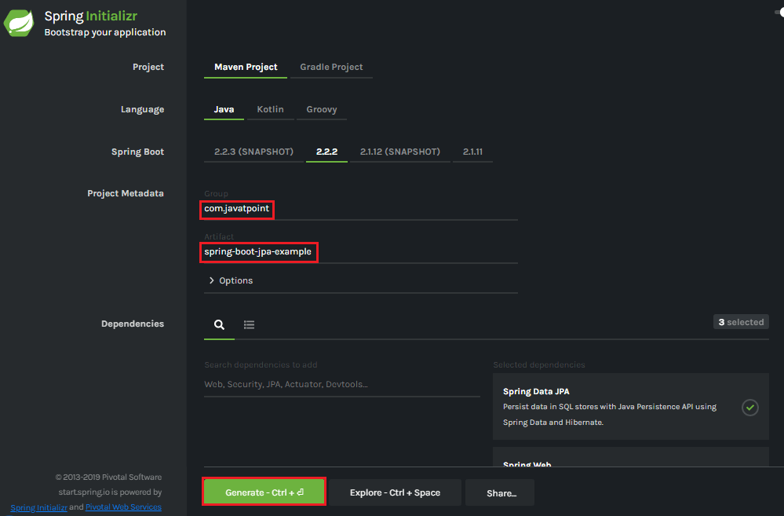
Step 6: Extract the Jar file and paste it into the STS workspace.
Step 7: Import the project folder into STS.
File -> Import -> Existing Maven Projects -> Browse -> Select the folder spring-boot-jpa-example -> Finish
It takes some time to import.
Step 8: Create a package with the name com.javatpoint.controller in the folder src/main/java.
Step 9: Create a Controller class with the name ControllerDemo in the package com.javatpoint.controller.
ControllerDemo.java
- package com.javatpoint.controller;
- import org.springframework.stereotype.Controller;
- import org.springframework.web.bind.annotation.RequestMapping;
- @Controller
- public class ControllerDemo
- {
- @RequestMapping("/")
- public String home()
- {
- return "home.jsp";
- }
- }
Step 10: Create another package with the name com.javatpoint.model in the folder src/main/java.
Step 11: Create a class with the name User in the package com.javatpoint.model.
User.java
- package com.javatpoint.model;
- import javax.persistence.Entity;
- import javax.persistence.Id;
- import javax.persistence.Table;
- @Entity
- @Table(name="userdata")
- public class User
- {
- @Id
- private int id;
- private String username;
- public int getId()
- {
- return id;
- }
- public void setId(int id)
- {
- this.id = id;
- }
- public String getUname()
- {
- return username;
- }
- public void setUname(String username)
- {
- this.username = username;
- }
- @Override
- public String toString()
- {
- return "User [id=" + id + ", uname=" + username + "]";
- }
- }
Now we need to Configure the H2 database.
Step 12: Open the application.properties file and configure the following things: port, enable the H2 console, datasource, and URL.
application.properties
- server.port=8085
- spring.h2.console.enabled=true
- spring.datasource.plateform=h2
- spring.datasource.url=jdbc:h2:mem:javatpoint
Step 13: Create a SQL file in the folder src/main/resources.
Right-click on the folder src/main/resources -> New -> File -> Provide the File name -> Finish
We have provided the file name data.sql and insert the following data into it.
data.sql
- insert into userdata values(101,'Tom');
- insert into userdata values(102,'Andrew');
- insert into userdata values(103,'Tony');
- insert into userdata values(104,'Bob');
- insert into userdata values(105,'Sam');
Step 14: Create a folder with the name webapp in the src folder.
Step 15: Create a JSP file with the name that we have returned in the ControllerDemo. In the ControllerDemo.java, we have returned home.jsp.
home.jsp
- <%@ page language="java" contentType="text/html; charset=ISO-8859-1"
- pageEncoding="ISO-8859-1"%>
- <!DOCTYPE html>
- <html>
- <head>
- <meta charset="ISO-8859-1">
- <title>Insert title here</title>
- </head>
- <body>
- <form action="addUser">
- ID :<br />
- <input type="text" name="t1"><br />
- User name :<br />
- <input type="text" name="t2"><br />
- <input type="submit" value="Add">
- </form>
- </body>
- </html>
Step 16: Run the SpringBootJpaExampleApplication.java file. We can see in the console that our application is successfully running on port 8085.
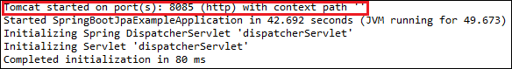
Step 17: Open the browser and invoke the URL http://localhost:8085/h2-console/. It shows the Driver Class, JDBC URL that we have configured in the application.properties file, and the default User Name sa.
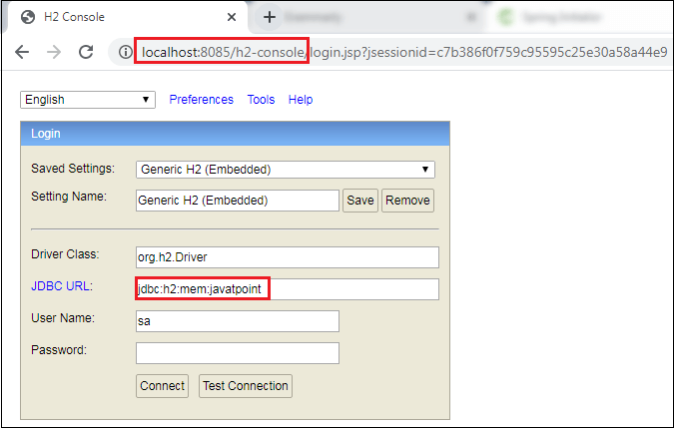
We can also test the connection by clicking on the Test Connection button. If the connection is successful, it shows a message Test Successful.
Step 18: Click on the Connect button. It shows the structure of the table userdata that we have defined in the User.java.
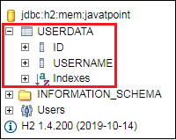
Step 19: Execute the following query to see the data that we have inserted in the data.sql file.
- SELECT * FROM USERDATA;

Spring Boot Starter Actuator

Spring Boot Actuator
Spring Boot Actuator is a sub-project of the Spring Boot Framework. It includes a number of additional features that help us to monitor and manage the Spring Boot application. It contains the actuator endpoints (the place where the resources live). We can use HTTP and JMX endpoints to manage and monitor the Spring Boot application. If we want to get production-ready features in an application, we should use the Spring Boot actuator.

Spring Boot Actuator Features
There are three main features of Spring Boot Actuator:
- Endpoints
- Metrics
- Audit
Endpoint: The actuator endpoints allows us to monitor and interact with the application. Spring Boot provides a number of built-in endpoints. We can also create our own endpoint. We can enable and disable each endpoint individually. Most of the application choose HTTP, where the Id of the endpoint, along with the prefix of /actuator, is mapped to a URL.
For example, the /health endpoint provides the basic health information of an application. The actuator, by default, mapped it to /actuator/health.
Metrics: Spring Boot Actuator provides dimensional metrics by integrating with the micrometer. The micrometer is integrated into Spring Boot. It is the instrumentation library powering the delivery of application metrics from Spring. It provides vendor-neutral interfaces for timers, gauges, counters, distribution summaries, and long task timers with a dimensional data model.
Audit: Spring Boot provides a flexible audit framework that publishes events to an AuditEventRepository. It automatically publishes the authentication events if spring-security is in execution.

Enabling Spring Boot Actuator
We can enable actuator by injecting the dependency spring-boot-starter-actuator in the pom.xml file.
- <dependency>
- <groupId>org.springframework.boot</groupId>
- <artifactId>spring-boot-starter-actuator</artifactId>
- <version>2.2.2.RELEASE</version>
- </dependency>

Spring Boot Actuator Endpoints
The actuator endpoints allow us to monitor and interact with our Spring Boot application. Spring Boot includes number of built-in endpoints and we can also add custom endpoints in Spring Boot application.
The following table describes the widely used endpoints.
Id | Usage | Default
actuator | It provides a hypermedia-based discovery page for the other endpoints. It requires Spring HATEOAS to be on the classpath. | True
auditevents | It exposes audit events information for the current application. | True
autoconfig | It is used to display an auto-configuration report showing all auto-configuration candidates and the reason why they 'were' or 'were not' applied. | True
beans | It is used to display a complete list of all the Spring beans in your application. | True
configprops | It is used to display a collated list of all @ConfigurationProperties. | True
dump | It is used to perform a thread dump. | True
env | It is used to expose properties from Spring's ConfigurableEnvironment. | True
flyway | It is used to show any Flyway database migrations that have been applied. | True
health | It is used to show application health information. | False
info | It is used to display arbitrary application info. | False
loggers | It is used to show and modify the configuration of loggers in the application. | True
liquibase | It is used to show any Liquibase database migrations that have been applied. | True
metrics | It is used to show metrics information for the current application. | True
mappings | It is used to display a collated list of all @RequestMapping paths. | True
shutdown | It is used to allow the application to be gracefully shutdown. | True
trace | It is used to display trace information. | True
For Spring MVC, the following additional endpoints are used.
Id | Description | Default
docs | It is used to display documentation, including example requests and responses for the Actuator's endpoints. | False
heapdump | It is used to return a GZip compressed hprof heap dump file. | True
jolokia | It is used to expose JMX beans over HTTP (when Jolokia is on the classpath). | True
logfile | It is used to return the contents of the logfile. | True
prometheus | It is used to expose metrics in a format that can be scraped by a prometheus server. It requires a dependency on micrometer-registry- prometheus. | True

Spring Boot actuator properties
Spring Boot enables security for all actuator endpoints. It uses form-based authentication that provides user Id as the user and a randomly generated password. We can also access actuator-restricted endpoints by customizing basicauth security to the endpoints. We need to override this configuration by management.security.roles property. For example:
- management.security.enabled=true
- management.security.roles=ADMIN
- security.basic.enabled=true
- security.user.name=admin
- security.user.passowrd=admin

Spring Boot Actuator Example
Let's understand the concept of the actuator through an example.
Step 1: Open Spring Initializr https://start.spring.io/ and create a Maven project.
Step 2: Provide the Group name. We have provided com.javatpoint.
Step 3: Provide the Artifact Id. We have provided the spring-boot-actuator-example.
Step 4: Add the following dependencies: Spring Web, Spring Boot Starter Actuator, and Spring Data Rest HAL Browser.
Step 5: Click on the Generate button. When we click on the Generate button, it wraps all the specifications related to the project into a Jar file and downloads it to our local system.
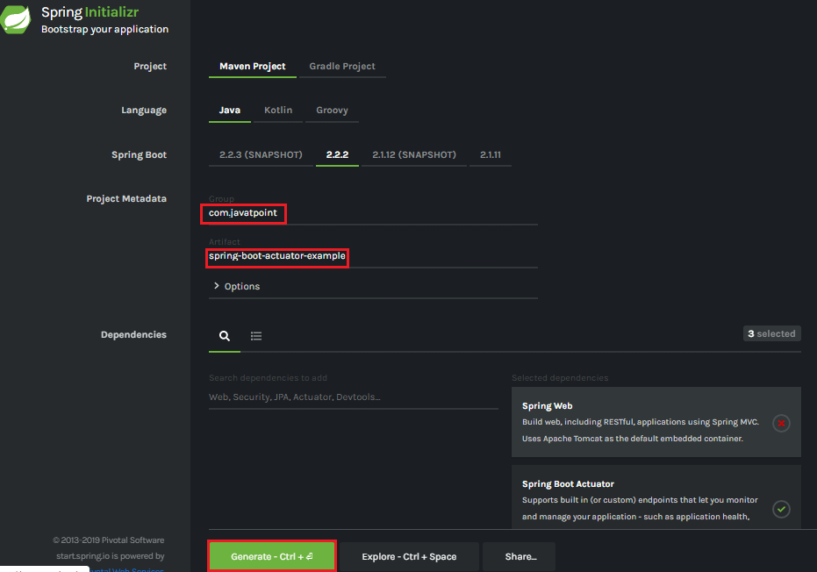
Step 6: Extract the Jar file and paste it into the STS workspace.
Step 7: Import the project folder.
File -> Import -> Existing Maven Projects -> Browse -> Select the folder spring-boot-actuator-example -> Finish
It takes some time to import. After importing the project, we can see the project directory in the package explorer section.
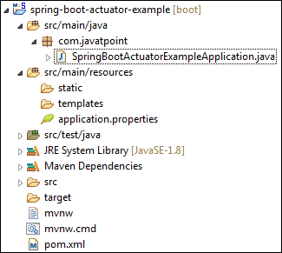
Step 8: Create a Controller class. We have created the controller class with the name DemoRestController.
DemoRestController.java
- package com.javatpoint;
- import org.springframework.web.bind.annotation.GetMapping;
- import org.springframework.web.bind.annotation.RestController;
- @RestController
- public class DemoRestController
- {
- @GetMapping("/hello")
- public String hello()
- {
- return "Hello User!";
- }
- }
Step 9: Open the application.properties file and disable the security feature of the actuator by adding the following statement.
application.properties
- management.security.enabled=false
Step 10: Run the SpringBootActuatorExampleApplication.java file.
Step 11: Open the browser and invoke the URL http://localhost:8080/actuator. It returns the following page:
- {"_links":{"self":{"href":"http://localhost:8080/actuator","templated":false},"health":{"href":"http://localhost:8080/actuator/health","templated":false},"health-path":{"href":"http://localhost:8080/actuator/health/{*path}","templated":true},"info":{"href":"http://localhost:8080/actuator/info","templated":false}}}
The application runs on port 8080 by default. Once the actuator has started, we can see the list of all the endpoints exposed over HTTP.
Let's invoke the health endpoint by invoking the URL http://localhost:8080/actuator/health. It denotes the status UP. It means the application is healthy and running without any interruption.
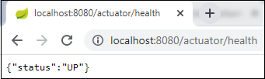
Similarly, we can invoke other endpoints that helps us to monitor and manage the Spring Boot application.

Spring Boot Starter Test
The spring-boot-starter-test is the primary dependency for the test. It contains the majority of elements required for our tests.
There are several different types of tests that we can write to help test and automate the health of an application. Before starting any testing, we need to integrate the testing framework.
With Spring Boot, we need to add starter to our project, for testing we only need to add the spring-boot-starter-test dependency.
- <dependency>
- <groupId>org.springframework.boot</groupId>
- <artifactId>spring-boot-starter-test</artifactId>
- <version>2.2.2.RELEASE</version>
- <scope>test</scope>
- </dependency>
It pulls all the dependencies related to test. After adding it, we can build up a simple unit test. We can either create the Spring Boot project through IDE or generate it using Spring Initializr.
00:03/05:29

Note: If you are adding test dependency manually, add it to the bottom of the pom.xml file.
In the above dependency, one thing to be noticed that it includes the scope of test <scope>test</scope>. It means when the application is bundled and packaged for deployment, any dependency that is declared with the test scopes is ignored. The test scope dependencies are only available when running in the development and Maven test modes.
When we create a simple Spring Boot application, by default, it contains the test dependency in the pom.xml file and ApplicationNameTest.java file under in the folder src/test/java.
Let's create a simple maven project.

Spring Boot Starter Test Example
Step 1: Open Spring Initializr https://start.spring.io/.
Step 2: Provide the Group name and Artifact Id. We have provided Group name com.javatpoint and Artifact spring-boot-test-example.
Step 3: Add the Spring Web dependency.
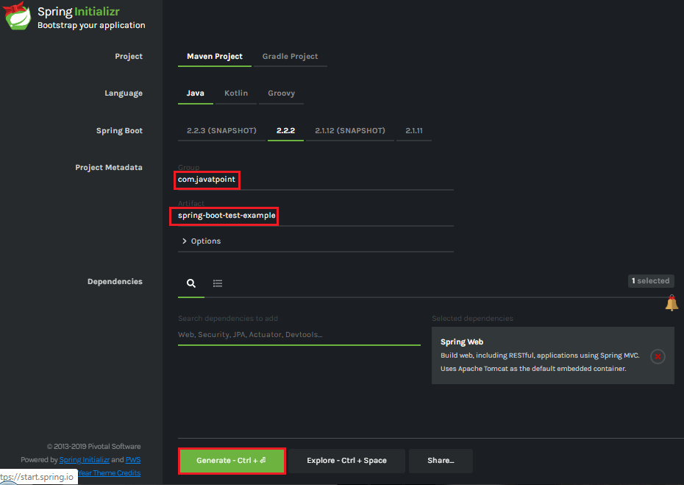
Step 4: Click on the Generate button. When we click on the Generate button, it wraps all the specifications related to the project and downloads a Jar file to our local system.
Step 5: Extract the downloaded Jar file.
Step 6: Import the folder to STS. It takes some time to import.
File -> Import -> Existing Maven Projects -> Browse -> Select the folder spring-boot-test-example -> Finish
After importing the project, we can see the following project directory in the Package Explorer section of the STS.
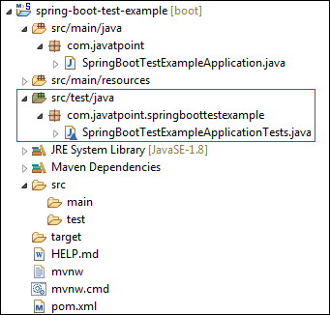
We can see in the above directory that it contains a test file named SpringBootTestExampleApplicationTest.java in the folder src/test/java.
SpringBootTestExampleApplicationTest.java
- package com.javatpoint.springboottestexample;
- import org.junit.jupiter.api.Test;
- import org.springframework.boot.test.context.SpringBootTest;
- @SpringBootTest
- class SpringBootTestExampleApplicationTests
- {
- @Test
- void contextLoads()
- {
- }
- }
The above code implements two annotation by default: @SpringBootTest, and @Test.
- @SpringBootTest: It applies on a Test Class that runs Spring Boot based tests. It provides the following features over and above the regular Spring TestContext Framework:
  - It uses SpringBootContextLoader as the default ContextLoader if no specific @ContextConfiguration(loader=...) is defined.
  - It automatically searches for a @SpringBootConfiguration when nested @Configuartion is not used, and no explicit classes are specified.
  - It provides support for different WebEnvironment modes.
  - It registers a TestRestTemplate or WebTestClient bean for use in web tests that are using the webserver.
  - It allows application arguments to be defined using the args attribute.
Step 7: Open the SpringBootTestExampleApplicationTest.java file and run it as Junit Test.
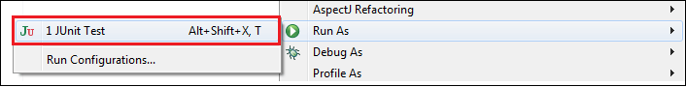
When we run the above code, it displays the following:
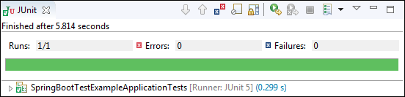

Spring Boot DevTools
Spring Boot 1.3 provides another module called Spring Boot DevTools. DevTools stands for Developer Tool. The aim of the module is to try and improve the development time while working with the Spring Boot application. Spring Boot DevTools pick up the changes and restart the application.
We can implement the DevTools in our project by adding the following dependency in the pom.xml file.
- <dependency>
- <groupId>org.springframework.boot</groupId>
- <artifactId>spring-boot-devtools</artifactId>
- <scope>runtime<scope >
- </dependency>

Spring Boot DevTools Features
Spring Boot DevTools provides the following features:
- Property Defaults
- Automatic Restart
- LiveReload
- Remote Debug Tunneling
- Remote Update and Restart
Property Defaults: Spring Boot provides templating technology Thymeleaf that contains the property spring.thymeleaf.cache. It disables the caching and allows us to update pages without the need of restarting the application. But setting up these properties during the development always creates some problems.
When we use the spring-boot-devtools module, we are not required to set properties. During the development caching for Thymeleaf, Freemarker, Groovy Templates are automatically disabled.

Note: If we do not want to apply property defaults on an application, we can set configprop:spring.devtools.add-properties[] to false in the application.properties file.
Automatic Restart: Auto-restart means reloading of Java classes and configure it at the server-side. After the server-side changes, it deployed dynamically, server restarts happen, and load the modified code. It is mostly used in microservice-based applications. Spring Boot uses two types of ClassLoaders:
- The classes that do not change (third-Jars) are loaded in the base ClassLoader.
- The classes that we are actively developing are loaded in the restart ClassLoader.
When the application restarts, the restart ClassLoader is thrown away, and a new one is populated. Therefore, the base ClassLoader is always available and populated.
We can disable the auto-restart of a server by using the property spring.devtools.restart.enabled to false.

Remember:
- The DevTools always monitors the classpath resources.
- There is only a way to trigger a restart is to update the classpath.
- DevTools required a separate application classloader to work properly. By default, Maven fork the application process.
- Auto-restart works well with LiveReload.
- DevTools depends on the application context's shutdown hook to close it during the restart.
LiveReload: The Spring Boot DevTools module includes an embedded server called LiveReload. It allows the application to automictically trigger a browser refresh whenever we make changes in the resources. It is also known as auto-refresh.
Note: We can disable the LiveReload by setting the property spring.devtools.livereload.enabled to false.
It provides browser extensions for Chrome, Firefox, and Safari. By default, LiveReload is enabled. The LiveReload works on the following path:
- /META-INF/maven
- /META-INF/resources
- /resources
- /static
- /public
- /templates
We can also disable auto-reload in browser by excluding the above paths. For example:
- spring.devtools.restart.exclude=public/**, static/**, templates/**
We can see the other additional path by using the property spring.devtools.restart.additional-paths. For example:
- spring.devtools.restart.additional-paths=/path-to-folder
If we want to exclude additional path and want to keep defaults then use the property spring.devtools.restart.additional-exclude. For example:
- spring.devtools.restart.additional-exclude=styles/**

Remember
- We can run one LiveReload server at a time.
- Before starting the application, ensure that no other LiveReload server is running.
- If we start multiple applications from IDE, it supports only the first LiveReload.
Remote Debug Tunneling: Spring Boot can tunnel JDWP (Java Debug Wire Protocol) over HTTP directly to the application. It can even work application deployment to Internet Cloud providers that only expose port 80 and 443.
Remote Update and Restart: There is another trick that DevTools offers is: it supports remote application updates and restarts. It monitors local classpath for file changes and pushes them to a remote server, which is then restarted. We can also use this feature in combination with LiveReload.

Using a Trigger File
Automatic restart sometimes can slow down development time due to frequent restarts. To remove this problem, we can use a trigger file. Spring Boot monitors trigger file and detects modifications in that file. It restarts the server and reloads all previous changes.
We can implement the trigger file in our application by adding the property spring.devtools.restart.trigger-file. The file can be internal or external. For example:
- spring.devtools.restart.trigger-file=c:/workspace-sts-3.9.9.RELEASE/restart-trigger.txt

Spring Boot DevTools Example
Step 1: Create a Maven project using Spring Initializr https://start.spring.io/.
Step 2: Provide the Group name and Artifact Id. We have provided Group name com.javatpoint and Artifact Id spring-boot-devtools-example.
Step 3: Add the following dependencies: spring-boot-starter-web and spring-boot-devtools.
Step 4: Click on the Generate button. It downloads the Jar file of the project.
Step 5: Extract the Jar file.
Step 6: Import the folder to STS. It takes time to import.
File -> Import -> Existing Maven Projects -> Browse -> Select the folder spring-boot-devtools-example -> Finish
When the project imports successfully, we can see the following directory in the Package Explorer section of the STS.
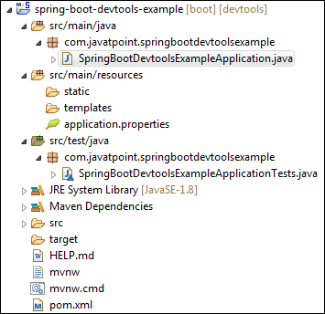
Step 7: Open the SpringBootDevtoolsExampleApplication.java and run it as Java Application.
After that, make any changes (edit or remove some file or code) in the application, and save that changes. As soon as we save the changes, the server restarts and pick up the changes.
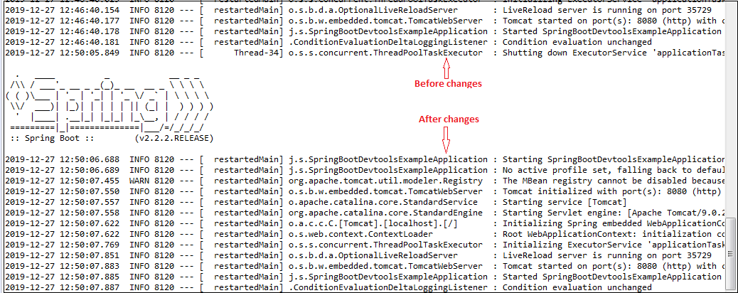

Spring Boot Multi-Module Project

Multi-Module Project
A Spring Boot project that contains nested maven projects is called the multi-module project. In the multi-module project, the parent project works as a container for base maven configurations.
In other words, a multi-module project is built from a parent pom that manages a group of submodules. Or A multi-module project is defined by a parent POM referencing one or more submodules.
The parent maven project must contain the packaging type pom that makes the project as an aggregator. The pom.xml file of the parent project consists the list of all modules, common dependencies, and properties that are inherited by the child projects. The parent pom is located in the project's root directory. The child modules are actual Spring Boot projects that inherit the maven properties from the parent project.
When we run the multi-module project, all the modules are deployed together in an embedded Tomcat Server. We can deploy an individual module, also.

Parent POM
The parent POM defines the Group ID, Artifact ID, version, and packaging. In the previous Maven projects, we have seen that the parent POM defines the packaging jar. But in the multi-module project, the parent POM defines the packaging pom. The packaging pom refers to other Maven projects.

Why we need multi-module project
Splitting the project into multiple modules is useful and easy to maintain. We can also easily edit or remove modules in the project without affecting the other modules. It is useful when we required to deploy modules individually.
We only need to specify all the dependencies in the parent pom. All the other modules share the same pom, so we need not to specify the same dependency in each module separately. It makes the code easier to keep in order with a big project.

Child module-ear, war, and jar
The child module may be any project and can have any packaging. We are free to create any type of dependency between modules and bundles together.
For example, we are creating an EAR (Enterprise ARchive), WAR (Web ARchive), and JAR (Java ARchive) file. A JAR file is bundled into a war file that is bundled into an EAR file. The EAR file is the final package that is ready to deploy on the application server.
The EAR file contains one or many WAR files. Each WAR file contains the service project that has common code to all WAR files and packaging type in the JAR.
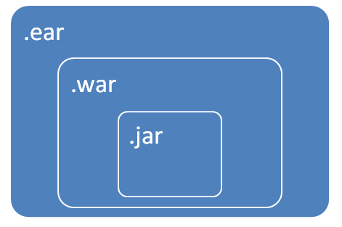

Maven child projects/ modules
- The child modules are independent maven projects that share properties from the parent project.
- All child projects can be built with a single command because it is inside a parent project.
- It is easier to define the relationship between the projects.

Multi-Module Project Directory Structure
Let's understand the multi-module project directory structure.
In the following image, we have created a project named spring-boot-multi-module-project. It contains the parent pom at the bottom of the directory. After that, we have created two Maven Modules named module1 and module2, respectively. These two modules contain their own pom files.
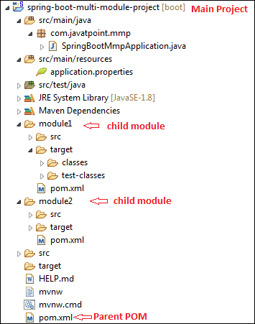
Let's open the parent POM and see what it configures when we create Maven modules in the project.
pom.xml
- <?xml version="1.0" encoding="UTF-8"?>
- <project xmlns="http://maven.apache.org/POM/4.0.0" xmlns:xsi="http://www.w3.org/2001/XMLSchema-instance" xsi:schemaLocation="http://maven.apache.org/POM/4.0.0 https://maven.apache.org/xsd/maven-4.0.0.xsd">
- <modelVersion>4.0.0</modelVersion>
- <parent>
- <groupId>org.springframework.boot</groupId>
- <artifactId>spring-boot-starter-parent</artifactId>
- <version>2.2.2.BUILD-SNAPSHOT</version>
- <relativePath/> <!-- lookup parent from repository -->
- </parent>
- <groupId>com.javatpoint</groupId>
- <artifactId>spring-boot-example</artifactId>
- <version>0.0.1-SNAPSHOT</version>
- <name>spring-boot-multi-module-project</name>
- <description>Demo project for Spring Boot</description>
- <properties>
- <java.version>1.8</java.version>
- </properties>
- <packaging>pom</packaging>
- <dependencies>
- <dependency>
- <groupId>org.springframework.boot</groupId>
- <artifactId>spring-boot-starter</artifactId>
- </dependency>
- <dependency>
- <groupId>org.springframework.boot</groupId>
- <artifactId>spring-boot-starter-parent</artifactId>
- <version>2.2.1.RELEASE</version>
- <type>pom</type>
- </dependency>
- <dependency>
- <groupId>org.springframework.boot</groupId>
- <artifactId>spring-boot-starter-web</artifactId>
- </dependency>
- <dependency>
- <groupId>org.springframework</groupId>
- <artifactId>spring-webmvc</artifactId>
- </dependency>
- <dependency>
- <groupId>org.springframework.boot</groupId>
- <artifactId>spring-boot-starter-test</artifactId>
- <scope>test</scope>
- <exclusions>
- <exclusion>
- <groupId>org.junit.vintage</groupId>
- <artifactId>junit-vintage-engine</artifactId>
- </exclusion>
- </exclusions>
- </dependency>
- </dependencies>
- <build>
- <plugins>
- <plugin>
- <groupId>org.springframework.boot</groupId>
- <artifactId>spring-boot-maven-plugin</artifactId>
- </plugin>
- </plugins>
- </build>
- <repositories>
- <repository>
- <id>spring-milestones</id>
- <name>Spring Milestones</name>
- <url>https://repo.spring.io/milestone</url>
- </repository>
- <repository>
- <id>spring-snapshots</id>
- <name>Spring Snapshots</name>
- <url>https://repo.spring.io/snapshot</url>
- <snapshots>
- <enabled>true</enabled>
- </snapshots>
- </repository>
- </repositories>
- <pluginRepositories>
- <pluginRepository>
- <id>spring-milestones</id>
- <name>Spring Milestones</name>
- <url>https://repo.spring.io/milestone</url>
- </pluginRepository>
- <pluginRepository>
- <id>spring-snapshots</id>
- <name>Spring Snapshots</name>
- <url>https://repo.spring.io/snapshot</url>
- <snapshots>
- <enabled>true</enabled>
- </snapshots>
- </pluginRepository>
- </pluginRepositories>
- <modules>
- <module>module1</module>
- <module>module2</module>
- </modules>
- </project>
The above pom file is same as we have seen in the previous examples. But in this pom file, two things to be noticed: packaging and modules.
When we create multi-module project, we need to configure packaging pom in the parent pom file instead of jar.
- <packaging>pom</packaging>
When we create Maven Modules in the project, Spring Boot automatically configures the modules in the parent pom inside the module tag, as shown below.
- <modules>
- <module>module1</module>
- <module>module2</module>
- </modules>
Now, we are going to see what inside the pom file of module1.
pom.xml
- <?xml version="1.0"?>
- <project xsi:schemaLocation="http://maven.apache.org/POM/4.0.0 http://maven.apache.org/xsd/maven-4.0.0.xsd" xmlns="http://maven.apache.org/POM/4.0.0"
- xmlns:xsi="http://www.w3.org/2001/XMLSchema-instance">
- <modelVersion>4.0.0</modelVersion>
- <parent>
- <groupId>com.javatpoint</groupId>
- <artifactId>spring-boot-multi-module-project</artifactId>
- <version>0.0.1-SNAPSHOT</version>
- </parent>
- <groupId>com.javatpoint</groupId>
- <artifactId>module1</artifactId>
- <version>0.0.1-SNAPSHOT</version>
- <name>module1</name>
- <url>http://maven.apache.org</url>
- <properties>
- <project.build.sourceEncoding>UTF-8</project.build.sourceEncoding>
- </properties>
- <dependencies>
- <dependency>
- <groupId>junit</groupId>
- <artifactId>junit</artifactId>
- <version>3.8.1</version>
- <scope>test</scope>
- </dependency>
- </dependencies>
- </project>
Here, a point to be noticed that the above pom file does not contain the common dependencies like starter-web, web-mvc, etc. It inherits all the common dependencies and the properties from the parent pom.

Spring Boot Multi-Module Project Example
Let' create an example of a multi-module application.
- In the following example, we have created a maven project named spring-boot-multimodule. It is the main application. In the main application, we have created five modules are as follows:
- application
- model
- repository
- service-api
- service-impl
Application Module
The application module is the main module of the project. It contains the application class in which the main method is defined that is necessary to run the Spring Boot Application. It also contains application configuration properties, Controller, views, and resources.
The Application Module includes Model Module, Service Implementation Module as dependency that contains Model Module, Repository Module, and Service API module.
Model Module
The Model Module contains Entities and Visual Objects to be used in the project.
Repository Module
The Repository module contains repositories to be used in the project. It depends on the Model Module.
Service API Module
The Service API module contains all project services. It also depends on Model Module.
Service Implementation Module
The Service Implementation module implements the service. It depends on Repository Module and Service API Module.

POM Aggregator (Parent POM)
The parent pom contains all the application modules. It also includes all the common dependencies and properties that are needed by more than one module. Dependencies are defined without version because the project has defined the Spring IO Platform as a parent.
Let's understand the structure of the multi-module application that we have created.
- Spring-boot-multimodule
- ├── pom.xml
- │ └── REDME.adoc
- ├── application
- │ ├── pom.xml
- │ └── src
- │ └── main
- │ ├── java
- │ │ └── sample
- │ │ └── multimodule
- │ │ ├── SampleWebJspApplication.java
- │ │ └── web
- │ │ └── WelcomeController.java
- │ └── resources
- │ ├── application.properties
- │ └── templates
- │ └── welcome
- │ └── show.html
- ├── model
- │ ├── pom.xml
- │ └── src
- │ └── main
- │ └── java
- │ └── sample
- │ └── multimodule
- │ └── domain
- │ └── entity
- │ └── Account.java
- |
- ├── repository
- │ ├── pom.xml
- │ └── src
- │ └── main
- │ └── java
- │ └── sample
- │ └── multimodule
- │ └── repository
- │ └── AccountRepository.java
- ├── service-api
- │ ├── pom.xml
- │ └── src
- │ └── main
- │ └── java
- │ └── sample
- │ └── multimodule
- │ └── service
- │ └── api
- │ ├── AccountNotFoundException.java
- │ └── AccountService.java
- └── service-impl
- ├── pom.xml
- └── src
- └── main
- └── java
- └── sample
- └── multimodule
- └── service
- └── impl
- └── AccountServiceImpl.java
Step 1: Create a Maven Project with the name spring-boot-multimodule.
Step 2: Open the pom.xml (parent pom) file and change the packaging type jar to pom.
pom.xml (parent pom)
- <?xml version="1.0" encoding="UTF-8" standalone="no"?>
- <project xmlns="http://maven.apache.org/POM/4.0.0" xmlns:xsi="http://www.w3.org/2001/XMLSchema-instance" xsi:schemaLocation="http://maven.apache.org/POM/4.0.0 http://maven.apache.org/xsd/maven-4.0.0.xsd">
- <modelVersion>4.0.0</modelVersion>
- <!-- Spring IO Platform is the parent of the generated application to
- be able to use Spring Boot and all its default configuration -->
- <parent>
- <groupId>io.spring.platform</groupId>
- <artifactId>platform-bom</artifactId>
- <version>2.0.1.RELEASE</version>
- </parent>
- <groupId>sample.multimodule</groupId>
- <artifactId>sample.multimodule</artifactId>
- <version>0.0.1-SNAPSHOT</version>
- <packaging>pom</packaging>
- <name>Parent - Pom Aggregator</name>
- <properties>
- <java.version>1.8</java.version>
- </properties>
- <dependencies>
- <!-- Spring Boot dependencies -->
- <dependency>
- <groupId>org.springframework.boot</groupId>
- <artifactId>spring-boot-starter</artifactId>
- </dependency>
- <dependency>
- <groupId>org.springframework.boot</groupId>
- <artifactId>spring-boot-starter-data-jpa</artifactId>
- </dependency>
- <dependency>
- <groupId>org.springframework.boot</groupId>
- <artifactId>spring-boot-starter-test</artifactId>
- <scope>test</scope>
- </dependency>
- </dependencies>
- </project>
One thing to be noticed in the above pom file is that there is no maven module configured because we have not created yet. Now we will create Maven Modules one by one that we have specified above.
Step 3: Create a Maven Module with the name application.
Step 4: Open the pom.xml file of application module and ensure that the packaging type is jar.
pom.xml
- <?xml version="1.0" encoding="UTF-8" standalone="no"?>
- <project xmlns="http://maven.apache.org/POM/4.0.0" xmlns:xsi="http://www.w3.org/2001/XMLSchema-instance" xsi:schemaLocation="http://maven.apache.org/POM/4.0.0 http://maven.apache.org/xsd/maven-4.0.0.xsd">
- <modelVersion>4.0.0</modelVersion>
- <parent>
- <groupId>sample.multimodule</groupId>
- <artifactId>sample.multimodule</artifactId>
- <version>0.0.1-SNAPSHOT</version>
- </parent>
- <artifactId>sample.multimodule.application</artifactId>
- <packaging>jar</packaging>
- <name>Project Module - Application</name>
- <dependencies>
- <!-- Project modules -->
- <dependency>
- <groupId>sample.multimodule</groupId>
- <artifactId>sample.multimodule.service.impl</artifactId>
- <version>${project.version}</version>
- </dependency>

- <!-- Spring Boot dependencies -->
- <dependency>
- <groupId>org.apache.tomcat.embed</groupId>
- <artifactId>tomcat-embed-jasper</artifactId>
- <scope>provided</scope>
- </dependency>
- <dependency>
- <groupId>org.springframework.boot</groupId>
- <artifactId>spring-boot-starter-web</artifactId>
- </dependency>
- <dependency>
- <groupId>org.springframework.boot</groupId>
- <artifactId>spring-boot-starter-thymeleaf</artifactId>
- </dependency>

- </dependencies>

- <build>
- <plugins>
- <!-- Spring Boot plugins -->
- <plugin>
- <groupId>org.springframework.boot</groupId>
- <artifactId>spring-boot-maven-plugin</artifactId>
- </plugin>
- </plugins>
- </build>

- </project>
Step 5: Create the main class. It is the class that is to be run.
SampleWebJspApplication.java
- package sample.multimodule;
- import org.springframework.boot.autoconfigure.SpringBootApplication;
- import org.springframework.boot.SpringApplication;
- import org.springframework.boot.orm.jpa.EntityScan;
- @SpringBootApplication
- public class SampleWebJspApplication
- {
- public static void main(String[] args) throws Exception
- {
- SpringApplication.run(SampleWebJspApplication.class, args);
- }
- }
Step 6: Create a Controller class with the name WelocameController under the package smaple.multimodule.web.
WelcomeController.java
- package sample.multimodule.web;
- import java.util.Date;
- import java.util.Map;
- import org.springframework.beans.factory.annotation.Autowired;
- import org.springframework.beans.factory.annotation.Value;
- import org.springframework.stereotype.Controller;
- import org.springframework.web.bind.annotation.RequestMapping;
- import sample.multimodule.domain.entity.Account;
- import sample.multimodule.service.api.AccountService;
- @Controller
- public class WelcomeController
- {
- @Value("${application.message:Hello World}")
- private String message = "Hello World";
- @Autowired
- protected AccountService accountService;
- @RequestMapping("/")
- public String welcome(Map<String, Object> model)
- {
- // Trying to obtain 23 account
- Account account = accountService.findOne("23");
- if(account == null){
- // If there's some problem creating account, return show view with error status
- model.put("message", "Error getting account!");
- model.put("account", "");
- return "welcome/show";
- }
- // Return show view with 23 account info
- String accountInfo = "Your account number is ".concat(account.getNumber());
- model.put("message", this.message);
- model.put("account", accountInfo);
- return "welcome/show";
- }
- @RequestMapping("foo")
- public String foo(Map<String, Object> model) {
- throw new RuntimeException("Foo");
- }
- }
Step 7: Create a HTML file with the name show.html under the folder src/main/resource -> templates ->welcome.
show.html
- <!DOCTYPE HTML>
- <html xmlns:th="http://www.thymeleaf.org">
- <head>
- <title>Spring Boot Multimodule</title>
- <meta http-equiv="Content-Type" content="text/html; charset=UTF-8" />
- </head>
- <body>
- <div>
- <b>Message: </b>
- <span th:text="${message}" />
- </div>
- <div>
- <b>Your account: </b>
- <span th:text="${account}" />
- </div>
- </body>
- </html>
Step 8: Open theapplication.properties file, configure the application message and thymeleaf cache to false.
application.properties
- # Application messages
- application.message = Hello User!
- dummy.type = type-inside-the-war
- # Spring Thymeleaf config
- spring.thymeleaf.cache = false
After creating all the above files, the application module directory looks like the following:
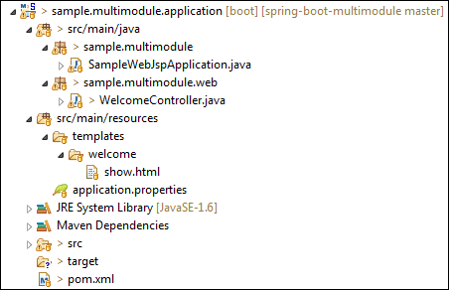
Let's create the second module that is model.
Step 9: Create a Maven Module with the name model.
Step 10: Open the pom.xml file of model module and ensure that the packaging type is jar.
pom.xml
- <?xml version="1.0" encoding="UTF-8" standalone="no"?>
- <project xmlns="http://maven.apache.org/POM/4.0.0" xmlns:xsi="http://www.w3.org/2001/XMLSchema-instance" xsi:schemaLocation="http://maven.apache.org/POM/4.0.0 http://maven.apache.org/xsd/maven-4.0.0.xsd">
- <modelVersion>4.0.0</modelVersion>
- <parent>
- <groupId>sample.multimodule</groupId>
- <artifactId>sample.multimodule</artifactId>
- <version>0.0.1-SNAPSHOT</version>
- </parent>
- <artifactId>sample.multimodule.model</artifactId>
- <packaging>jar</packaging>
- <name>Project Module - Model</name>
- <description>Module that contains all Entities and Visual Objects to be used in the project. It doesn't have any dependencies.
- </description>
- </project>
Step 11: Create a class with the name Account under the package sample.multimodule.domain.entity.
Account.java
- package sample.multimodule.domain.entity;
- import javax.persistence.Entity;
- import javax.persistence.Id;
- import javax.persistence.GeneratedValue;
- import javax.persistence.GenerationType;
- @Entity
- public class Account
- {
- @Id
- @GeneratedValue(strategy = GenerationType.AUTO)
- private Long id;

- private String number;

- private String type;

- private String creditCardNumber;

- /**
- * Create an empty account.
- */
- public Account() {

- }

- /**
- * Create a new account.
- *
- * @param number
- * the account number
- * @param id
- * the account id
- */
- public Account(Long id, String number) {
- this.number = number;
- this.id = id;
- }

- public Long getId() {
- return id;
- }

- public void setId(Long id) {
- this.id = id;
- }

- public String getNumber() {
- return number;
- }

- public void setNumber(String number) {
- this.number = number;
- }

- public String getType() {
- return type;
- }

- public void setType(String type) {
- this.type = type;
- }

- public String getCreditCardNumber() {
- return creditCardNumber;
- }

- public void setCreditCardNumber(String creditCardNumber) {
- this.creditCardNumber = creditCardNumber;
- }

- }
After creating all the above files, the model module directory looks like the following:
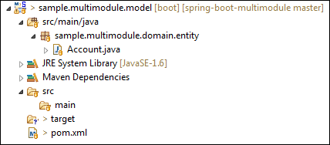
Let's create the third module that is the repository.
Step 12: Create a Maven Module with the name repository.
Step 13: Open the pom.xml file of application module and ensure that the packaging type is jar.
pom.xml
- <?xml version="1.0" encoding="UTF-8" standalone="no"?>
- <project xmlns="http://maven.apache.org/POM/4.0.0" xmlns:xsi="http://www.w3.org/2001/XMLSchema-instance" xsi:schemaLocation="http://maven.apache.org/POM/4.0.0 http://maven.apache.org/xsd/maven-4.0.0.xsd">
- <modelVersion>4.0.0</modelVersion>
- <parent>
- <groupId>sample.multimodule</groupId>
- <artifactId>sample.multimodule</artifactId>
- <version>0.0.1-SNAPSHOT</version>
- </parent>
- <artifactId>sample.multimodule.repository</artifactId>
- <packaging>jar</packaging>
- <name>Project Module - Repository</name>
- <description>Module that contains all repositories to be used in the project. Depends of Model Module.</description>

- <dependencies>
- <!-- Project modules -->
- <dependency>
- <groupId>sample.multimodule</groupId>
- <artifactId>sample.multimodule.model</artifactId>
- <version>${project.version}</version>
- </dependency>

- <!-- Spring Boot dependencies -->
- <dependency>
- <groupId>org.hsqldb</groupId>
- <artifactId>hsqldb</artifactId>
- <scope>runtime</scope>
- </dependency>

- </dependencies>

- </project>
Step 14: Create a class with the name AccountRepositoryunder the package sample.multimodule.repository.
AccountRepository.java
- package sample.multimodule.repository;
- import org.springframework.data.domain.*;
- import org.springframework.data.repository.*;
- import org.springframework.stereotype.Repository;
- import sample.multimodule.domain.entity.Account;
- @Repository
- public interface AccountRepository extends CrudRepository<Account, Long>
- {
- Account findByNumber(String number);
- }
After creating all the above files, the repository module directory looks like the following:
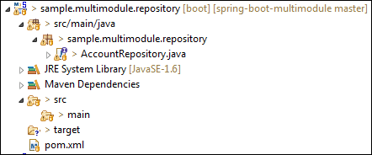
Let's create the fourth module that is service-api.
Step 15: Create a Maven Module with the name service-api.
Step 16: Open the pom.xml file of application service-api and ensure that the packaging type is jar.
pom.xml
- <?xml version="1.0" encoding="UTF-8" standalone="no"?>
- <project xmlns="http://maven.apache.org/POM/4.0.0" xmlns:xsi="http://www.w3.org/2001/XMLSchema-instance" xsi:schemaLocation="http://maven.apache.org/POM/4.0.0 http://maven.apache.org/xsd/maven-4.0.0.xsd">
- <modelVersion>4.0.0</modelVersion>
- <parent>
- <groupId>sample.multimodule</groupId>
- <artifactId>sample.multimodule</artifactId>
- <version>0.0.1-SNAPSHOT</version>
- </parent>
- <artifactId>sample.multimodule.service.api</artifactId>
- <packaging>jar</packaging>
- <name>Project Module - Service API</name>
- <description>Module that contains API of all project services. Depends of Model Module.</description>

- <dependencies>

- <!-- Project Modules -->
- <dependency>
- <groupId>sample.multimodule</groupId>
- <artifactId>sample.multimodule.model</artifactId>
- <version>${project.version}</version>
- </dependency>
- </dependencies>
- </project>
Step 17: Create a package with the name sample.multimodule.service.api.
Step 18: Create a class with the name AccountNotFoundException. It handles the exception if the account is not found.
AccountNotFoundException.java
- package sample.multimodule.service.api;
- public class AccountNotFoundException extends RuntimeException
- {
- private static final long serialVersionUID = -3891534644498426670L;
- public AccountNotFoundException(String accountId)
- {
- super("No such account with id: " + accountId);
- }
- }
Step 19: Create a class with the name AccountService. It provides the service related to account, such as find and create an account.
AccountService.java
- package sample.multimodule.service.api;
- import java.util.List;
- import sample.multimodule.domain.entity.Account;
- public interface AccountService
- {
- /**
- * Finds the account with the provided account number.
- *
- * @param number The account number
- * @return The account
- * @throws AccountNotFoundException If no such account exists.
- */
- Account findOne(String number) throws AccountNotFoundException;
- /**
- * Creates a new account.
- * @param number
- * @return created account
- */
- Account createAccountByNumber(String number);
- }
After creating all the above files, the service-api module directory looks like the following:
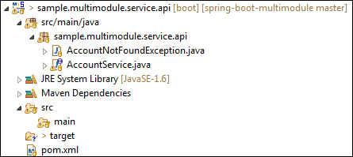
Step 20: Create a Maven Module with the name service-impl.
Step 21: Open the pom.xml file of application service-impl and ensure that the packaging type is jar.
pom.xml
- <?xml version="1.0" encoding="UTF-8" standalone="no"?>
- <project xmlns="http://maven.apache.org/POM/4.0.0" xmlns:xsi="http://www.w3.org/2001/XMLSchema-instance" xsi:schemaLocation="http://maven.apache.org/POM/4.0.0 http://maven.apache.org/xsd/maven-4.0.0.xsd">
- <modelVersion>4.0.0</modelVersion>
- <parent>
- <groupId>sample.multimodule</groupId>
- <artifactId>sample.multimodule</artifactId>
- <version>0.0.1-SNAPSHOT</version>
- </parent>
- <artifactId>sample.multimodule.service.impl</artifactId>
- <packaging>jar</packaging>
- <name>Project Module - Service Implementation</name>
- <description>Module that contains services implementation defined on Service API module. Depends of Repository Module and Service API Module.</description>
- <dependencies>
- <!-- Project Modules -->
- <dependency>
- <groupId>sample.multimodule</groupId>
- <artifactId>sample.multimodule.repository</artifactId>
- <version>${project.version}</version>
- </dependency>
- <dependency>
- <groupId>sample.multimodule</groupId>
- <artifactId>sample.multimodule.service.api</artifactId>
- <version>${project.version}</version>
- </dependency>
- </dependencies>
- </project>
Step 22: Create a class with the name AccountServiceImpl under the package sample.multimodule.service.impl.
AccountServiceImpl.java
- package sample.multimodule.service.impl;
- import java.util.ArrayList;
- import java.util.List;
- import org.springframework.beans.factory.annotation.Value;
- import org.springframework.beans.factory.annotation.Autowired;
- import org.springframework.stereotype.Service;
- import sample.multimodule.domain.entity.Account;
- import sample.multimodule.repository.AccountRepository;
- import sample.multimodule.service.api.AccountService;
- import sample.multimodule.service.api.AccountNotFoundException;
- @Service
- public class AccountServiceImpl implements AccountService
- {
- @Value("${dummy.type}")
- private String dummyType;
- @Autowired
- private AccountRepository accountRepository;
- /**
- * {@inheritDoc}
- * <p/>
- * Dummy method for testing purposes.
- *
- * @param number The account number. Set 0000 to get an {@link AccountNotFoundException}
- */
- @Override
- public Account findOne(String number) throws AccountNotFoundException {
- if(number.equals("0000")) {
- throw new AccountNotFoundException("0000");
- }
- Account account = accountRepository.findByNumber(number);
- if(account == null){
- account = createAccountByNumber(number);
- }
- return account;
- }
- @Override
- public Account createAccountByNumber(String number) {
- Account account = new Account();
- account.setNumber(number);
- return accountRepository.save(account);
- }
- public String getDummyType() {
- return dummyType;
- }
- public void setDummyType(String dummyType) {
- this.dummyType = dummyType;
- }
- }
After creating all the above files, the service-impl module directory looks like the following:
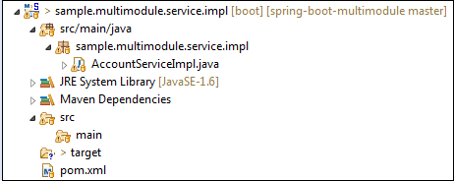
Now open the parent pom file, we see that all the Maven Modules that we have created is configured in the parent pom inside the tag. We need not to configure it manually.
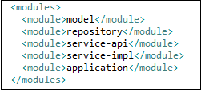
Now ensure that all the five modules are created, as shown below:
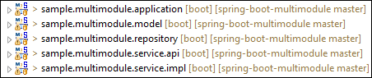
After creating all the modules, the main project directory looks like the following:
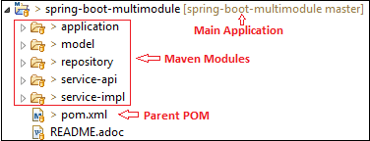
Step 23: Now run the SampleWebJspApplication.java file as Java Application.
Step 24: Open the browser and invoke the URL http://localhost:8080. It returns the Message and account number that is 23.
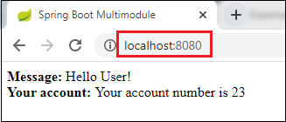

Spring Boot Packaging
In the J2EE application, modules are packed as JAR, WAR, and EAR. It is the compressed file formats that is used in the J2EE. J2EE defines three types of archives:
- WAR
- JAR
- EAR
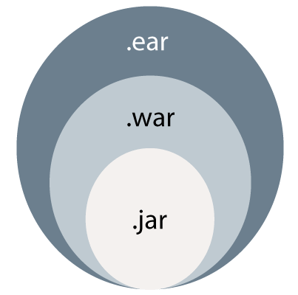

WAR
WAR stands for Web Archive. WAR file represents the web application. Web module contains servlet classes, JSP files, HTML files, JavaScripts, etc. are packaged as a JAR file with .war extension. It contains a special directory called WEB-INF.
WAR is a module that loads into a web container of the Java Application Server. The Java Application Server has two containers: Web Container and EJB Container.
The Web Container hosts the web applications based on Servlet API and JSP. The web container requires the web module to be packaged as a WAR file. It is a WAR file special JAR file that contains a web.xmlv file in the WEB-INF folder.
An EJB Container hosts Enterprise Java beans based on EJB API. It requires EJB modules to be packaged as a JAR file. It contains an ejb-jar.xml file in the META-INF folder.
The advantage of the WAR file is that it can be deployed easily on the client machine in a Web server environment. To execute a WAR file, a Web server or Web container is required. For example, Tomcat, Weblogic, and Websphere.

JAR
JAR stands for Java Archive. An EJB (Enterprise Java Beans) module that contains bean files (class files), a manifest, and EJB deployment descriptor (XML file) are packaged as JAR files with the extension .jar. It is used by software developers to distribute Java classes and various metadata.
In other words, A file that encapsulates one or more Java classes, a manifest, and descriptor is called JAR file. It is the lowest level of the archive. It is used in J2EE for packaging EJB and client-side Java Applications. It makes the deployment easy.

EAR
EAR stands for Enterprise Archive. EAR file represents the enterprise application. The above two files are packaged as a JAR file with the .ear extension. It is deployed into the Application Server. It can contain multiple EJB modules (JAR) and Web modules (WAR). It is a special JAR that contains an application.xml file in the META-INF folder.

Spring Boot Auto-configuration
Spring Boot auto-configuration automatically configures the Spring application based on the jar dependencies that we have added.
For example, if the H2 database Jar is present in the classpath and we have not configured any beans related to the database manually, the Spring Boot's auto-configuration feature automatically configures it in the project.
We can enable the auto-configuration feature by using the annotation @EnableAutoConfiguration. But this annotation does not use because it is wrapped inside the @SpringBootApplication annotation. The annotation @SpringBootApplication is the combination of three annotations: @ComponentScan, @EnableAutoConfiguration, and @Configuration. However, we use @SpringBootApplication annotation instead of using @EnableAutoConfiguration.
@SpringBootApplication=@ComponentScan+@EnableAutoConfiguration+@Configuration
When we add the spring-boot-starter-web dependency in the project, Spring Boot auto-configuration looks for the Spring MVC is on the classpath. It auto-configures dispatcherServlet, a default error page, and web jars.
Similarly, when we add the spring-boot-starter-data-jpa dependency, we see that Spring Boot Auto-configuration, auto-configures a datasource and an Entity Manager.
All auto-configuration logic is implemented in spring-boot-autoconfigure.jar, as shown in the following figure.
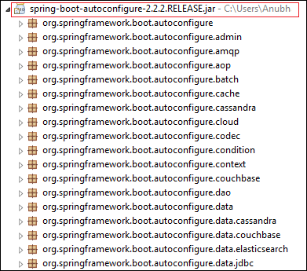

Need of auto-configuration
Spring-based application requires a lot of configuration. When we use Spring MVC, we need to configure dispatcher servlet, view resolver, web jars among other things. The following code shows typical configuration of a dispatcher servlet in a web application:
- <servlet>
- <servlet-name>dispatcher</servlet-name>
- <servlet-class>
- org.springframework.web.servlet.DispatcherServlet
- </servlet-class>
- <init-param>
- <param-name>contextConfigLocation</param-name>
- <param-value>/WEB-INF/todo-servlet.xml</param-value>
- </init-param>
- <load-on-startup>1</load-on-startup>
- </servlet>
- <servlet-mapping>
- <servlet-name>dispatcher</servlet-name>
- <url-pattern>/</url-pattern>
- </servlet-mapping>
Similarly, when we use Hibernate/ JPA, we need to configure datasource, a transaction manager, an entity manager factory among a host of other things.
Configuring datasource
- <bean id="dataSource" class="com.mchange.v2.c3p0.ComboPooledDataSource"
- destroy-method="close">
- <property name="driverClass" value="${db.driver}" />
- <property name="jdbcUrl" value="${db.url}" />
- <property name="user" value="${db.username}" />
- <property name="password" value="${db.password}" />
- </bean>
- <jdbc:initialize-database data-source="dataSource">
- <jdbc:script location="classpath:config/schema.sql" />
- <jdbc:script location="classpath:config/data.sql" />
- </jdbc:initialize-database>
Configuring entity manager factory
- <bean
- class="org.springframework.orm.jpa.LocalContainerEntityManagerFactoryBean"
- id="entityManagerFactory">
- <property name="persistenceUnitName" value="hsql_pu" />
- <property name="dataSource" ref="dataSource" />
- </bean>
Configuring transaction manager
- <bean id="transactionManager" class="org.springframework.orm.jpa.JpaTransactionManager">
- <property name="entityManagerFactory" ref="entityManagerFactory" />
- <property name="dataSource" ref="dataSource" />
- </bean>
- <tx:annotation-driven transaction-manager="transactionManager"/>

Disable Auto-configuration Classes
We can also disable the specific auto-configuration classes, if we do not want to be applied. We use the exclude attribute of the annotation @EnableAutoConfiguration to disable the auto-configuration classes. For example:
- import org.springframework.boot.autoconfigure.*;
- import org.springframework.boot.autoconfigure.jdbc.*;
- import org.springframework.context.annotation.*;
- @Configuration(proxyBeanMethods = false)
- @EnableAutoConfiguration(exclude={DataSourceAutoConfiguration.class})
- public class MyConfiguration
- {
- }
We can use the attribute excludeName of the annotation @EnableAutoConfiguration and specify the qualified name of the class, if the class is not on the class path. We can exclude any number of auto-configuration classes by using the property spring.autoconfigure.exclude.

Spring Boot Auto-configuration Example
In the following example, we will see how Spring Boot's auto-configuration features work.
Step 1: Open spring Initializr https://start.spring.io/.
Step 2: Provide the Group name. We have provided com.javatpoint.
Step 3: Provide the Artifact Id. We have provided spring-boot-autoconfiguration-example.
Step 4: Add the dependencies: Spring Web, Spring Data JPA, an H2 Database.
Step 5: Click on the Generate button. When we click on the Generate button, it wraps the project in Jar file and downloads it to the local system.
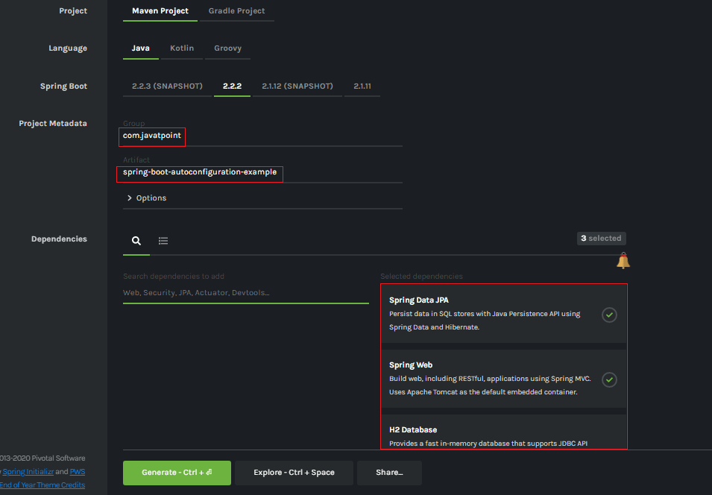
Step 6: Extract the Jar file and paste it into the STS workspace.
Step 7: Import the project folder into STS.
File -> Import -> Existing Maven Projects -> Browse -> Select the folder spring-boot-autoconfiguration-example -> Finish
It takes some time to import.
Step 8: Create a package with the name com.javatpoint.controller in the folder src/main/java.
Step 9: Create a Controller class with the name ControllerDemo in the package com.javatpoint.controller.
ControllerDemo.java
- package com.javatpoint.controller;
- import org.springframework.stereotype.Controller;
- import org.springframework.web.bind.annotation.RequestMapping;
- @Controller
- public class ControllerDemo
- {
- @RequestMapping("/")
- public String home()
- {
- return "home.jsp";
- }
- }
Step 10: Create another package with the name com.javatpoint.model in the folder src/main/java.
Step 11: Create a class with the name User in the package com.javatpoint.model.
User.java
- package com.javatpoint.model;
- import javax.persistence.Entity;
- import javax.persistence.Id;
- import javax.persistence.Table;
- @Entity
- @Table(name="userdata")
- public class User
- {
- @Id
- private int id;
- private String username;
- public int getId()
- {
- return id;
- }
- public void setId(int id)
- {
- this.id = id;
- }
- public String getUname()
- {
- return username;
- }
- public void setUname(String username)
- {
- this.username = username;
- }
- @Override
- public String toString()
- {
- return "User [id=" + id + ", uname=" + username + "]";
- }
- }
Now we need to Configure the H2 database.
Step 12: Open the application.properties file and configure the following things: port, enable the H2 console, datasource, and URL.
application.properties
- server.port=8085
- spring.h2.console.enabled=true
- spring.datasource.plateform=h2
- spring.datasource.url=jdbc:h2:mem:javatpoint
Step 13: Create a SQL file in the folder src/main/resources.
Right-click on the folder src/main/resources -> New -> File -> Provide the File name -> Finish
We have provided the file name data.sql and insert the following data into it.
data.sql
- insert into userdata values(101,'Tom');
- insert into userdata values(102,'Andrew');
- insert into userdata values(103,'Tony');
- insert into userdata values(104,'Bob');
- insert into userdata values(105,'Sam');
Step 14: Create a folder with the name webapp in the src folder.
Step 15: Create a JSP file with the name that we have returned in the ControllerDemo. In the ControllerDemo.java, we have returned home.jsp.
home.jsp
- <%@ page language="java" contentType="text/html; charset=ISO-8859-1"
- pageEncoding="ISO-8859-1"%>
- <!DOCTYPE html>
- <html>
- <head>
- <meta charset="ISO-8859-1">
- <title>Insert title here</title>
- </head>
- <body>
- <form action="addUser">
- ID :<br />
- <input type="text" name="t1"><br />
- User name :<br />
- <input type="text" name="t2"><br />
- <input type="submit" value="Add">
- </form>
- </body>
- </html>
Step 16: Run the SpringBootAutoconfigurationExampleApplication.java file. We can see in the console that our application is successfully running on port 8085.
Step 17: Open the browser and invoke the URL http://localhost:8085/h2-console/. It shows the Driver Class, JDBC URL that we have configured in the application.properties file, and the default User Name sa.
We can also test the connection by clicking on the Test Connection button. If the connection is successful, it shows a message Test Successful.
Step 18: Click on the Connect button. It shows the structure of the table userdata that we have defined in the User.java file.
Step 19: Execute the following query to see the data that we have inserted in the data.sql file.
- SELECT * FROM USERDATA;
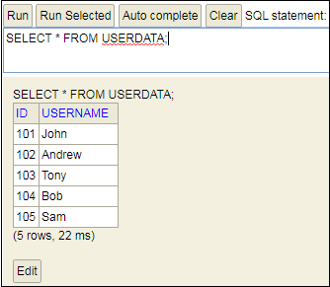
Let's have a close look at the console. We see that TransactionManagement, DispatcherServlet, EntityManagerFactory, and DataSource automatically configures, as shown in the following figure.
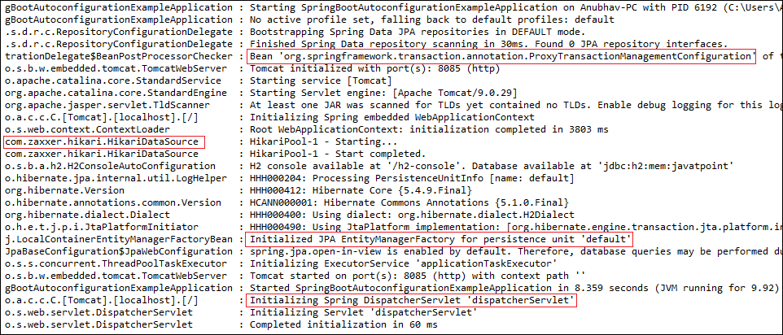

Debugging Auto-configuration
We can find more information about auto-configuration by using the following two ways:
- Turning on debug logging
- Using Spring Boot Actuator
Turning on debug logging
We can debug logging by adding a property in the application.properties file. Let's implement the debug logging in the above example. Open the application.properties file and add the following property:
- logging.level.org.springframework: DEBUG
Now restart the application. We see that an auto-configuration report printed in the log. The report includes all the classes that are auto-configured. It is divided into two parts: positive matches annegative matches, as shown in the following figure.
Positive matches
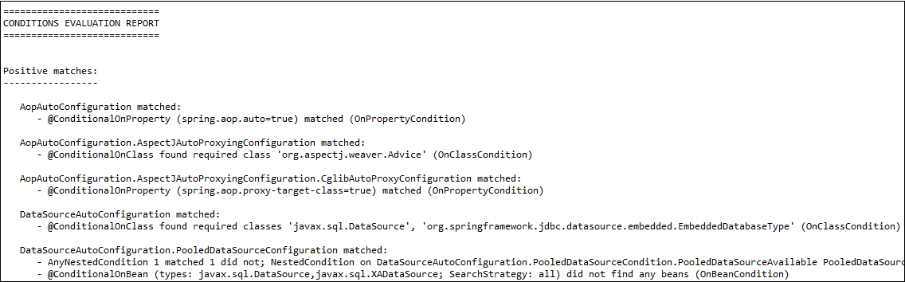
Negative matches
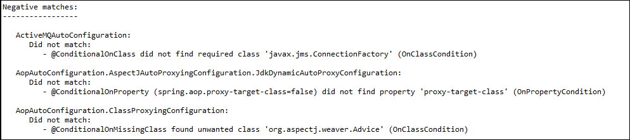
Spring Boot Actuator
We can also debug auto-configuration by using Actuator in the project. We will also add in HAL Browser to make things easy. It shows the details of all the beans that are auto-configured, and those are not.
Let's create an example of Spring Boot Actuator.
Step 1: Open Spring Initializr http://start.spring.io.
Step 2: Provide the Group name. We have provided com.javatpoint.
Step 3: Provide the Artifact Id. We have provided actuator-autoconfiguration-example.
Step 4: Add the dependencies: Spring Web and Spring Boot Actuator.
- <dependency>
- <groupId>org.springframework.boot</groupId>
- <artifactId>spring-boot-starter-web</artifactId>
- </dependency>
- <dependency>
- <groupId>org.springframework.boot</groupId>
- <artifactId>spring-boot-starter-actuator</artifactId>
- </dependency>
Step 5: Click on the Generate button. It binds all the specification related to project into a jar file and downloads it in our local system.
Step 6: Extract the downloaded jar file.
Step 7: Import the project folder by using the following steps:
File -> Import -> Existing Maven Project -> Next -> Browse -> Select the Project folder -> Finish
After importing the project, we can see the following directory structure in the Package Explorer section of the IDE.
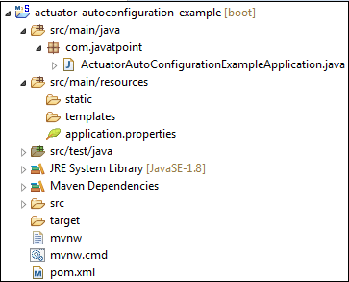
Step 8: Create a Controller class in the package com.javatpoint. We have created a controller class with the name DemoRestController.
In the Controller, we have defined a method named hello() that returns a string.
DemoRestController.java
- package com.javatpoint;
- import org.springframework.web.bind.annotation.GetMapping;
- import org.springframework.web.bind.annotation.RestController;
- @RestController
- public class DemoRestController
- {
- @GetMapping("/hello")
- public String hello()
- {
- return "Hello User, have a nice day.";
- }
- }
Step 9: Run the ActuatorAutoConfigurationExampleApplication.java file.
Step 10: Open the browser and invoke the URL http://localhost:8080/hello. It returns a string that we have specified in the controller.
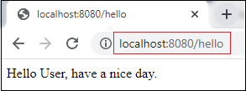
Now invoke the actuator URL http://localhost:8080/actuator. It launches the actuator that shows the three URLs: self, health, and info, as shown below.
- {"_links":{"self":{"href":"http://localhost:8080/actuator","templated":false},"health":{"href":"http://localhost:8080/actuator/health","templated":false},"health-path":{"href":"http://localhost:8080/actuator/health/{*path}","templated":true},"info":{"href":"http://localhost:8080/actuator/info","templated":false}}}
Step 11: Open the pom.xml file and add the HAL Browser dependency.
- <dependency>
- <groupId>org.springframework.data</groupId>
- <artifactId>spring-data-rest-hal-browser</artifactId>
- </dependency>
Step 12: Again, run the ActuatorAutoConfigurationExampleApplication.java file.
To access the HAL browser, type http://localhost:8080 in the browser and hit the enter key.
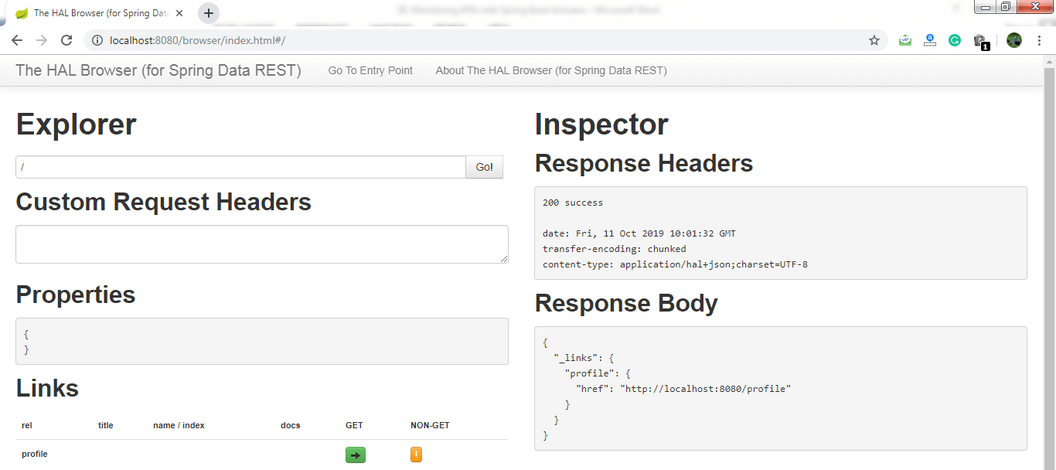
Now we can access the actuator through the HAL browser.
Type /actuator in the Explorer's text box and click on the Go button.
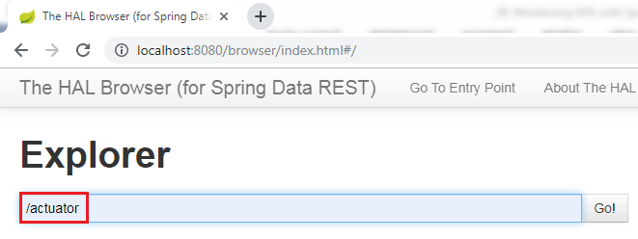
It shows all the things related to the actuator. The most important thing in the actuator is beans.
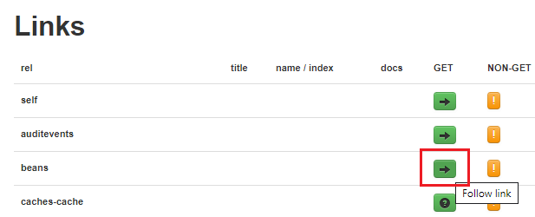
When we click on the bean's arrow, it shows all the beans configured in the Spring Boot project.
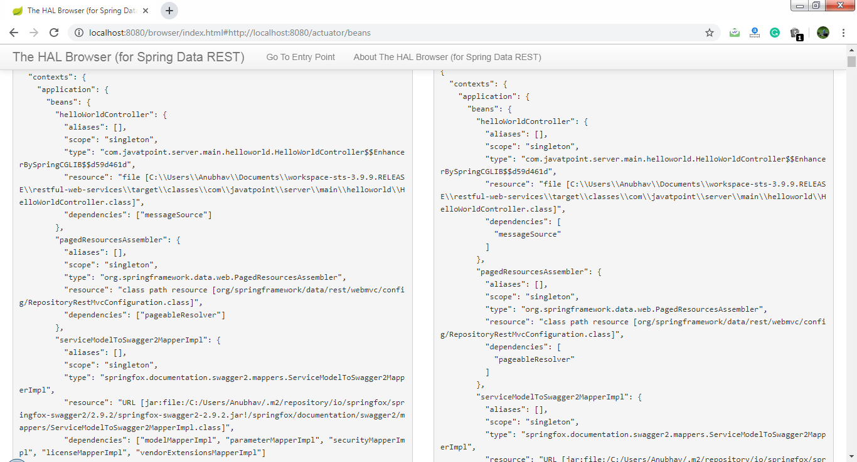
The above image shows the details of all the beans that are auto-configured and that are not.

Spring Boot Hello World Example
In the section, we will create a Maven project for Hello Word Example. We need the following tools and technologies to develop the same.
- Spring Boot 2.2.2.RELEASE
- JavaSE 1.8
- Maven 3.3.9
- STS IDE
Step 1: Open Spring Initializr https://start.spring.io/.
Step 2: Provide the Group name. We have provided com.javatpoint.
Step 3: Provide the Artifact Id. We have provided the spring-boot-hello-world-example.
Step 4: Add the dependency Spring Web.
Step 5: Click on the Generate button. When we click on the Generate button, it wraps all the specifications into a jar file and downloads it to our local system.
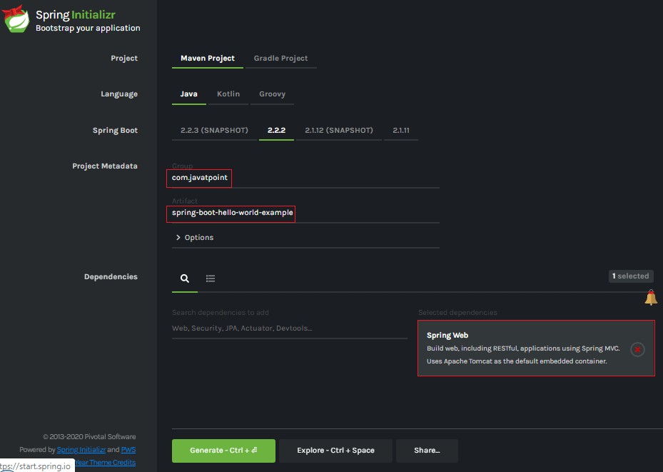
Step 6: Extract the RAR file.
Step 7: Import the project folder by using the following steps:
File -> Import -> Existing Maven Project -> Next -> Browse -> Select the Project Folder -> Finish
When the project imports successfully, it shows the following project directory in the Package Explorer section of the IDE.
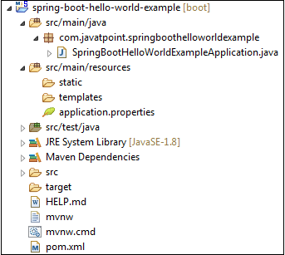
Step 8: Create a package with the name com.javatpoint.controller inside the folder src/main/java.
Step 9: Create a Controller class with the name HelloWorldController.
Step 10: Create a method named hello() that returns a String.
HelloWorldController.java
- package com.javatpoint.controller;
- import org.springframework.web.bind.annotation.RequestMapping;
- import org.springframework.web.bind.annotation.RestController;
- @RestController
- public class HelloWorldController
- {
- @RequestMapping("/")
- public String hello()
- {
- return "Hello javaTpoint";
- }
- }
Step 11: Run the SpringBootHelloWorldExampleApplication.java file.
SpringBootHelloWorldExampleApplication.java
- package com.javatpoint;
- import org.springframework.boot.SpringApplication;
- import org.springframework.boot.autoconfigure.SpringBootApplication;
- @SpringBootApplication
- public class SpringBootHelloWorldExampleApplication
- {
- public static void main(String[] args)
- {
- SpringApplication.run(SpringBootHelloWorldExampleApplication.class, args);
- }
- }
When the application runs successfully, it shows a massage in the console, as shown in the following figure.
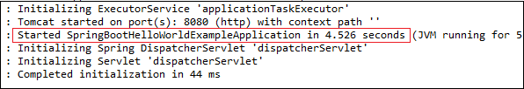
Step 12: Open the browser and invoke the URL https://localhost:8080. It returns a String that we have specified in the Controller.
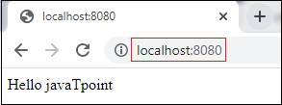

Project Deployment Using Tomcat
In this section, we will learn how to deploy the Spring Boot application on Tomcat Server.
It includes three steps:
- Setting up a Spring Boot Application
- Create a Spring Boot WAR
- Deploy the WAR to Tomcat

Example
Let's create a Maven example to be deployed on Tomcat
Setting up a Spring Boot Application
Step 1: Open Spring Initializr http://start.spring.io.
Step 2: Provide the Group name. We have provided the com.javatpoint.
Step 3: Provide the Artifact Id. We have provided the spring-boot-war-deployment-example.
Step 4: Add the Spring Web dependency.
- <dependency>
- <groupId>org.springframework.boot</groupId>
- <artifactId>spring-boot-starter-web</artifactId>
- </dependency>
Step 5: Click on the Generate button. It wraps all the specification related to the project and download the jar file in our local system.
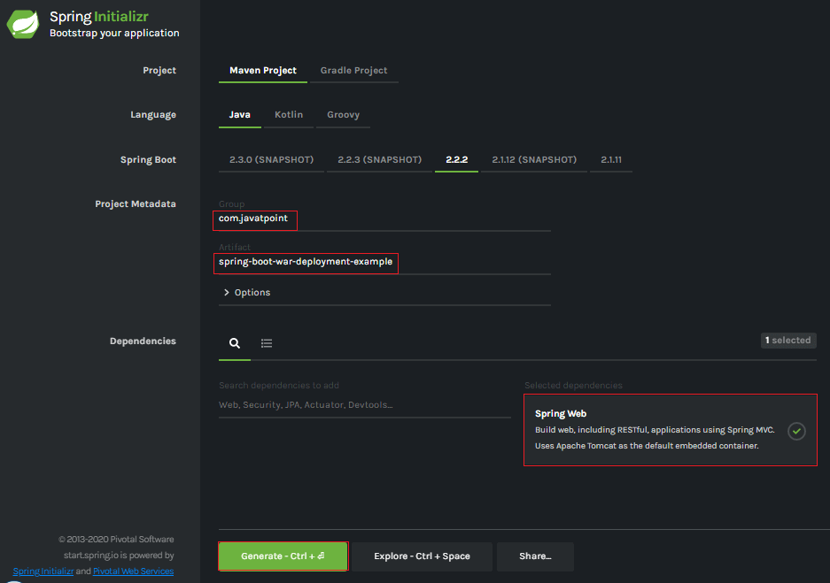
Step 6: Extract the jar file.
Step 7: Import the project folder by using the following steps:
File -> Import -> Existing Maven Project -> Next -> Browse -> Select the Project Folder -> Finish
After importing the project, we can see the following directory structure in the Package Explorer section of the IDE.
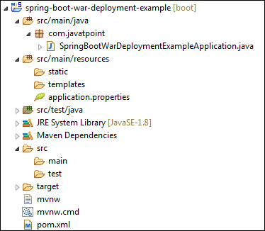
Step 8: Create a Controller class in the package com.javatpoint. We have created a class with the name DemoRestController.
Inside the controller class, we have defined a method hello() that returns a String.
DemoRestController.java
- package com.javatpoint;
- import org.springframework.web.bind.annotation.GetMapping;
- import org.springframework.web.bind.annotation.RestController;
- @RestController
- public class DemoRestController
- {
- @GetMapping("/hello")
- public String hello()
- {
- return "Hello User, have a nice day.";
- }
- }
Step 9: Run the SpringBootWarDeploymentExampleApplication.java file as Java Application.
Step 10: Open the browser and invoke the URL http://localhost:8080/hello.
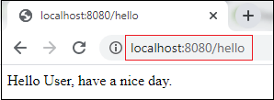

Note: Before moving to the next step, ensure that the application is running correctly.

Create a Spring Boot WAR
It makes use of Spring Framework's Servlet 3.0 support and allows us to configure application when the servlet container launches it. There are three steps to create a WAR for deployment:
- Extends the SpringBootServletInitializer class in the main class.
- Marked the embedded servlet container as provided.
- Update packaging JAR to
Let's implement the above three steps in an application.
Step 11: Open the SpringBootWarDeploymentExampleApplication.java file and initialize the Servlet Context required by the Tomcat. To achieve the same extends the SpringBootServletInitializer interface.
- public class SpringBootWarDeploymentExampleApplication extends SpringBootServletInitializer
- {
- }
Step 12: Override the Configure method.
- @Override
- protected SpringApplicationBuilder configure(SpringApplicationBuilder application)
- {
- return application.sources(SpringBootWarDeploymentExampleApplication.class);
- }
SpringBootWarDeploymentExampleApplication.java
- package com.javatpoint;
- import org.springframework.boot.SpringApplication;
- import org.springframework.boot.autoconfigure.SpringBootApplication;
- import org.springframework.boot.builder.SpringApplicationBuilder;
- import org.springframework.boot.web.servlet.support.SpringBootServletInitializer;
- @SpringBootApplication
- public class SpringBootWarDeploymentExampleApplication extends SpringBootServletInitializer
- {
- @Override
- protected SpringApplicationBuilder configure(SpringApplicationBuilder application)
- {
- return application.sources(SpringBootWarDeploymentExampleApplication.class);
- }
- public static void main(String[] args)
- {
- SpringApplication.run(SpringBootWarDeploymentExampleApplication.class, args);
- }
- }
Step 13: Open the pom.xml file and marked the servlet container (Tomcat) as provided.
- <dependency>
- <groupId>org.springframework.boot</groupId>
- <artifactId>spring-boot-starter-tomcat</artifactId>
- <scope>provided</scope>
- </dependency>
Step 14: We need to deploy WAR file so change the package type to WAR in pom.xml file.
- <packaging>war</packaging>
Step 15: Modify the final WAR file name by using the <finalName> tag to avoid including the version numbers. We have created a WAR file with the name web-services.
- <finalName>web-services</finalName>
pom.xml
- <?xml version="1.0" encoding="UTF-8"?>
- <project xmlns="http://maven.apache.org/POM/4.0.0" xmlns:xsi="http://www.w3.org/2001/XMLSchema-instance"
- xsi:schemaLocation="http://maven.apache.org/POM/4.0.0 http://maven.apache.org/xsd/maven-4.0.0.xsd">
- <modelVersion>4.0.0</modelVersion>
- <groupId>com.javatpoint</groupId>
- <artifactId>spring-boot-war-deployment-example</artifactId>
- <version>0.0.1-SNAPSHOT</version>
- <packaging>war</packaging>
- <name>spring-boot-war-deployment-example</name>
- <description>Demo project for Spring Boot</description>
- <parent>
- <groupId>org.springframework.boot</groupId>
- <artifactId>spring-boot-starter-parent</artifactId>
- <version>2.2.2.RELEASE</version>
- <relativePath/> <!-- lookup parent from repository -->
- </parent>
- <properties>
- <project.build.sourceEncoding>UTF-8</project.build.sourceEncoding>
- <project.reporting.outputEncoding>UTF-8</project.reporting.outputEncoding>
- <java.version>1.8</java.version>
- </properties>
- <dependencies>
- <dependency>
- <groupId>org.springframework.boot</groupId>
- <artifactId>spring-boot-starter-web</artifactId>
- </dependency>
- <dependency>
- <groupId>org.springframework.boot</groupId>
- <artifactId>spring-boot-starter-tomcat</artifactId>
- <scope>provided</scope>
- </dependency>
- <dependency>
- <groupId>org.springframework.boot</groupId>
- <artifactId>spring-boot-starter-test</artifactId>
- <scope>test</scope>
- </dependency>
- </dependencies>
- <build>
- <finalName>web-services</finalName>
- <plugins>
- <plugin>
- <groupId>org.springframework.boot</groupId>
- <artifactId>spring-boot-maven-plugin</artifactId>
- </plugin>
- </plugins>
- </build>
- </project>
To build our Tomcat-deployable WAR application, we execute the maven clean package. After that our WAR file is generated at /target/abc.war (where abc is assumed Artifact Id). We should consider that this new setup makes our Spring Boot Application a non-standalone application.
Step 16: Create a WAR file by using the following steps:
Right-click on the project -> Run As -> 5 Maven Build
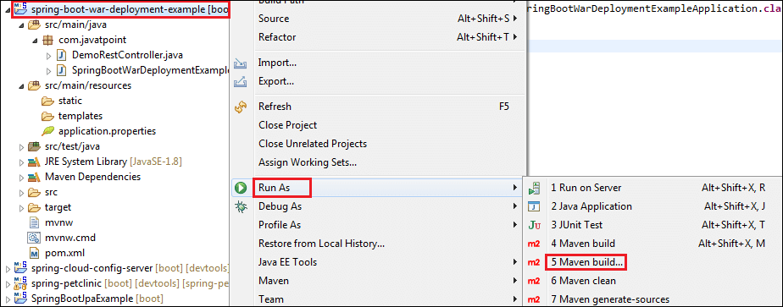
An Edit Configuration dialog box appears on the screen.
Step 17: Write clean install in the Goals label and check the Skip Tests. Click on the Apply and Run button, respectively.
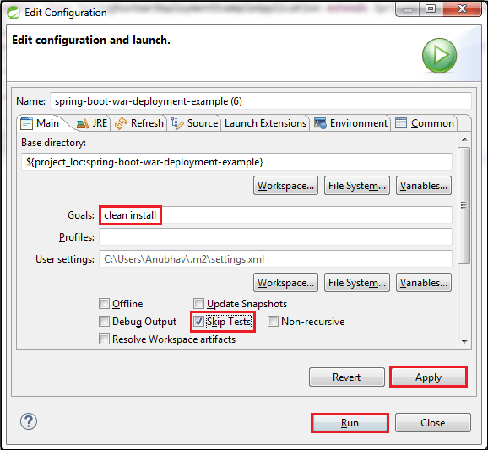
When the WAR file successfully created, it shows the WAR file path and a message BUILD SUCCESS in the console, as shown in the following figure.
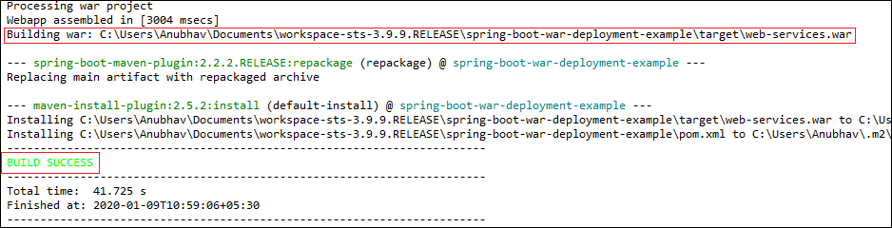
Step 18: Copy the path and access the target folder of the application. We found the WAR file inside the target folder with the same name as we have specified in the pom.xml file. In our case, path is:
- C:\Users\Anubhav\Documents\workspace-sts-3.9.9.RELEASE\spring-boot-war-deployment-example\target
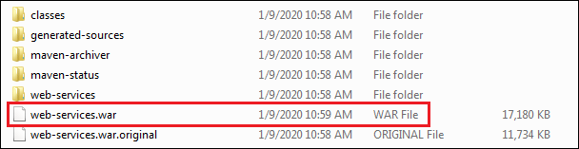

Deploy the WAR file to Tomcat
To deploy the WAR file, follow the steps below:
Step 19: Download and install the Apache Tomcat Server, if not installed.
Step 20: Copy the WAR file (web-services.war) and paste it inside the webapps folder of the Tomcat. In our case, the location of the webapps folder is:
- C:\Program Files\Apache Software Foundation\Tomcat 8.5\webapps
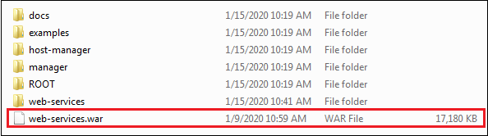
Step 21: Now open the Command Prompt and type the following commands:
- C:\Cd Program Files\Apache Software Foundation\Tomcat 8.5\bin
- C:\Cd Program Files\Apache Software Foundation\Tomcat 8.5\bin>startup
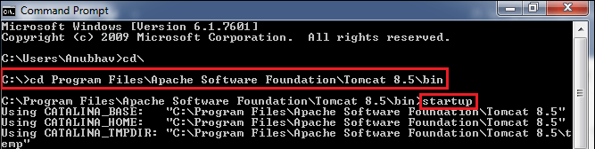
The startup command starts the Tomcat server and deploys the WAR file, as shown below.
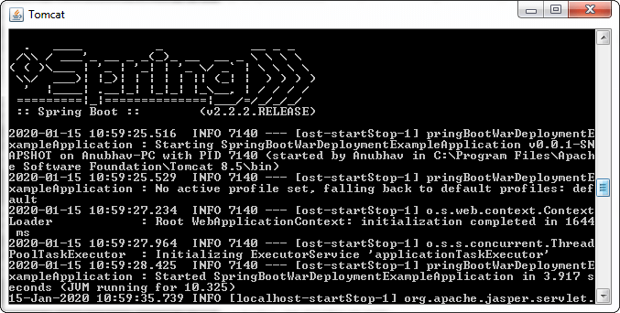
The following image shows that WAR is deployed successfully.
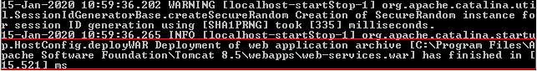
Step 23: Open the browser and invoke the URL http://localhost:8080/web-services/hello. It returns the message Hello User, have a nice day.

Spring Boot AOP
The application is generally developed with multiple layers. A typical Java application has the following layers:
- Web Layer: It exposes the services using the REST or web application.
- Business Layer: It implements the business logic of an application.
- Data Layer: It implements the persistence logic of the application.
The responsibility of each layer is different, but there are a few common aspects that apply to all layers are Logging, Security, validation, caching, etc. These common aspects are called cross-cutting concerns.
If we implement these concerns in each layer separately, the code becomes more difficult to maintain. To overcome this problem, Aspect-Oriented Programming (AOP) provides a solution to implement cross-cutting concerns.
- Implement the cross-cutting concern as an aspect.
- Define pointcuts to indicate where the aspect has to be applied.
It ensures that the cross-cutting concerns are defined in one cohesive code component.

AOP
AOP (Aspect-Oriented Programming) is a programming pattern that increases modularity by allowing the separation of the cross-cutting concern. These cross-cutting concerns are different from the main business logic. We can add additional behavior to existing code without modification of the code itself.
Spring's AOP framework helps us to implement these cross-cutting concerns.
Using AOP, we define common functionality in one place. We are free to define how and where this functionality is applied without modifying the class to which we are applying the new feature. The cross-cutting concern can now be modularized into special classes, called aspect.
There are two benefits of aspects:
- First, the logic for each concern is now in one place instead of scattered all over the codebase.
- Second, the business modules only contain code for their primary concern. The secondary concern has been moved to the aspect.
The aspects have the responsibility that is to be implemented, called advice. We can implement an aspect's functionality into a program at one or more join points.

Benefits of AOP
- It is implemented in pure Java.
- There is no requirement for a special compilation process.
- It supports only method execution Join points.
- Only run time weaving is available.
- Two types of AOP proxy is available: JDK dynamic proxy and CGLIB proxy.

Cross-cutting concern
The cross-cutting concern is a concern that we want to implement in multiple places in an application. It affects the entire application.

AOP Terminology
- Aspect: An aspect is a module that encapsulates advice and pointcuts and provides cross-cutting An application can have any number of aspects. We can implement an aspect using regular class annotated with @Aspect annotation.
- Pointcut: A pointcut is an expression that selects one or more join points where advice is executed. We can define pointcuts using expressions or patterns. It uses different kinds of expressions that matched with the join points. In Spring Framework, AspectJ pointcut expression language is used.
- Join point: A join point is a point in the application where we apply an AOP aspect. Or it is a specific execution instance of an advice. In AOP, join point can be a method execution, exception handling, changing object variable value, etc.
- Advice: The advice is an action that we take either before or after the method execution. The action is a piece of code that invokes during the program execution. There are five types of advices in the Spring AOP framework: before, after, after-returning, after-throwing, and around advice. Advices are taken for a particular join point. We will discuss these advices further in this section.
- Target object: An object on which advices are applied, is called the target object. Target objects are always a proxied It means a subclass is created at run time in which the target method is overridden, and advices are included based on their configuration.
- Weaving: It is a process of linking aspects with other application types. We can perform weaving at run time, load time, and compile time.
Proxy: It is an object that is created after applying advice to a target object is called proxy. The Spring AOP implements the JDK dynamic proxy to create the proxy classes with target classes and advice invocations. These are called AOP proxy classes.

AOP vs. OOP
The differences between AOP and OOP are as follows:
AOP | OOP
Aspect: A code unit that encapsulates pointcuts, advices, and attributes. | Class: A code unit that encapsulates methods and attributes.
Pointcut: It defines the set of entry points in which advice is executed. | Method signature: It defines the entry points for the execution of method bodies.
Advice: It is an implementation of cross-cutting concerns. | Method bodies: It is an implementation of the business logic concerns.
Waver: It constructs code (source or object) with advice. | Compiler: It converts source code to object code.
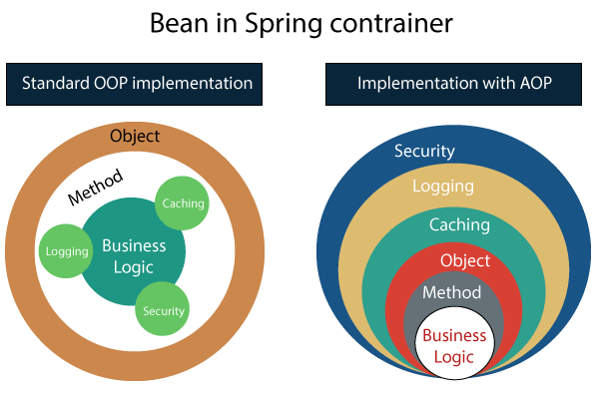

Spring AOP vs. AspectJ
The differences between AOP and OOP are as follows:
Spring AOP | AspectJ
There is a need for a separate compilation process. | It requires the AspectJ compiler.
It supports only method execution pointcuts. | It supports all pointcuts.
It can be implemented on beans managed by Spring Container. | It can be implemented on all domain objects.
It supports only method level weaving. | It can wave fields, methods, constructors, static initializers, final class, etc.

Types of AOP Advices
There are five types of AOP advices are as follows:
- Before Advice
- After Advice
- Around Advice
- After Throwing
- After Returning
Before Advice: An advice that executes before a join point, is called before advice. We use @Before annotation to mark an advice as Before advice.
After Advice: An advice that executes after a join point, is called after advice. We use @After annotation to mark an advice as After advice.
Around Advice: An advice that executes before and after of a join point, is called around advice.
After Throwing Advice: An advice that executes when a join point throws an exception.
After Returning Advice: An advice that executes when a method executes successfully.
Before implementing the AOP in an application, we are required to add Spring AOP dependency in the pom.xml file.

Spring Boot Starter AOP
Spring Boot Starter AOP is a dependency that provides Spring AOP and AspectJ. Where AOP provides basic AOP capabilities while the AspectJ provides a complete AOP framework.
- <dependency>
- <groupId>org.springframework.boot</groupId>
- <artifactId>spring-boot-starter-aop</artifactId>
- <version>2.2.2.RELEASE</version>
- </dependency>
In the next section, we will implement the different advices in the application.

Spring Boot AOP Before Advice
Before advice is used in Aspect-Oriented Programming to achieve the cross-cutting. It is an advice type which ensures that an advice runs before the method execution. We use @Before annotation to implement the before advice.
Let's understand before advice through an example.

Spring Boot Before Advice Example
Step 1: Open Spring Initializr http://start.spring.io.
Step 2: Provide the Group name. We have provided the Group name com.javatpoint.
Step 3: Provide the Artifact Id. We have provided the Artifact Id aop-before-advice-example.
Step 4: Add the Spring Web dependency.
Step 5: Click on the Generate button. When we click on the Generate button, it wraps all the specifications in a jar file and downloads it to the local system.
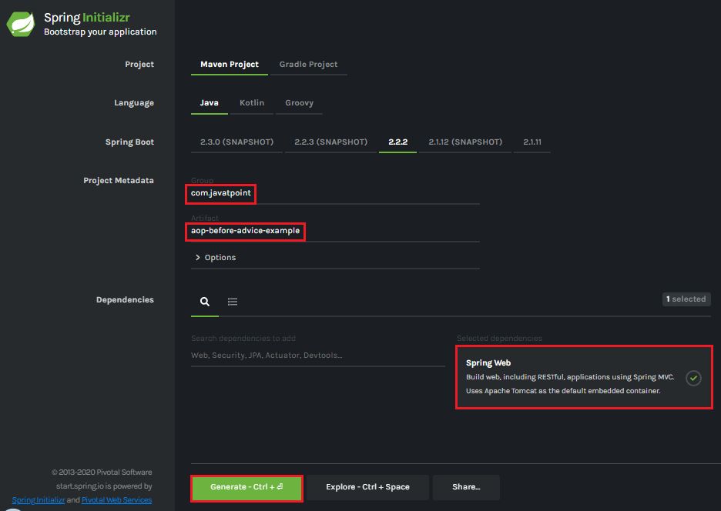
Step 6: Extract the downloaded jar file.
Step 7: Import the folder by using the following steps:
File -> Import -> Existing Maven Projects -> Next -> Browse the Folder aop-before-advice-example -> Finish.
Step 8: Open the pom.xml file and add the following AOP dependency. It is a starter for aspect-oriented programming with Spring AOP and AspectJ.
- <dependency>
- <groupId>org.springframework.boot</groupId>
- <artifactId>spring-boot-starter-aop</artifactId>
- </dependency>
- </dependencies>
pom.xml
- <project xmlns="http://maven.apache.org/POM/4.0.0" xmlns:xsi="http://www.w3.org/2001/XMLSchema-instance" xsi:schemaLocation="http://maven.apache.org/POM/4.0.0 http://maven.apache.org/xsd/maven-4.0.0.xsd">
- <modelVersion>4.0.0</modelVersion>
- <groupId>com.javatpoint</groupId>
- <artifactId> aop-before-advice-example</artifactId>
- <version>0.0.1-SNAPSHOT</version>
- <packaging>jar</packaging>
- <name>aop-before-advice-example</name>
- <description>Demo project for Spring Boot</description>
- <parent>
- <groupId>org.springframework.boot</groupId>
- <artifactId>spring-boot-starter-parent</artifactId>
- <version>2.2.2.RELEASE</version>
- <relativePath /> <!-- lookup parent from repository -->
- </parent>
- <properties>
- <project.build.sourceEncoding>UTF-8</project.build.sourceEncoding>
- <project.reporting.outputEncoding>UTF-8</project.reporting.outputEncoding>
- <java.version>1.8</java.version>
- </properties>
- <dependencies>
- <dependency>
- <groupId>org.springframework.boot</groupId>
- <artifactId>spring-boot-starter-web</artifactId>
- </dependency>
- <dependency>
- <groupId>org.springframework.boot</groupId>
- <artifactId>spring-boot-starter-aop</artifactId>
- </dependency>
- </dependencies>

- <build>
- <plugins>
- <plugin>
- <groupId>org.springframework.boot</groupId>
- <artifactId>spring-boot-maven-plugin</artifactId>
- </plugin>
- </plugins>
- </build>
- </project>
Step 9: Open AopBeforeAdviceExampleApplication.java file and add an annotation @EnableAspectJAutoProxy.
- @EnableAspectJAutoProxy(proxyTargetClass=true)
It enables support for handling components marked with AspectJ’s @Aspect annotation. It is used with @Configuration annotation. We can control the type of proxy by using the proxyTargetClass attribute. Its default value is false.
AopBeforeAdviceExampleApplication.java
- package com.javatpoint;
- import org.springframework.boot.SpringApplication;
- import org.springframework.boot.autoconfigure.SpringBootApplication;
- import org.springframework.context.annotation.EnableAspectJAutoProxy;
- @SpringBootApplication
- @EnableAspectJAutoProxy(proxyTargetClass=true)
- public class AopBeforeAdviceExampleApplication
- {
- public static void main(String[] args) {
- SpringApplication.run(AopBeforeAdviceExampleApplication.class, args);
- }
- }
Step 10: Create a package with the name com.javatpoint.model.
Step 11: Create a model class under the package com.javatpoint.model. We have created a class with the name Employee. In the class, define the following:
- Define three variables empId, firstName, and secondName of type String.
- Generate Getters and Setters.
- Create a default
Employee.java
- package com.javatpoint.model;
- public class Employee
- {
- private String empId;
- private String firstName;
- private String secondName;
- //default constructor
- public Employee()
- {
- }
- public String getEmpId()
- {
- return empId;
- }
- public void setEmpId(String empId)
- {
- this.empId = empId;
- }
- public String getFirstName()
- {
- return firstName;
- }
- public void setFirstName(String firstName)
- {
- this.firstName = firstName;
- }
- public String getSecondName()
- {
- return secondName;
- }
- public void setSecondName(String secondName)
- {
- this.secondName = secondName;
- }
- }
Step 12: Create a package with the name com.javatpoint.controller.
Step 13: Create a controller class under the package com.javatpoint.controller. We have created a class with the name EmployeeController.
In the controller class, we have defined the two mappings one for adding an employee and the other for removing an employee.
EmployeeController.java
- package com.javatpoint.controller;
- import org.springframework.beans.factory.annotation.Autowired;
- import org.springframework.web.bind.annotation.RequestMapping;
- import org.springframework.web.bind.annotation.RequestMethod;
- import org.springframework.web.bind.annotation.RequestParam;
- import org.springframework.web.bind.annotation.RestController;
- import com.javatpoint.model.Employee;
- import com.javatpoint.service.EmployeeService;
- @RestController
- public class EmployeeController
- {
- @Autowired
- private EmployeeService employeeService;
- @RequestMapping(value = "/add/employee", method = RequestMethod.GET)
- public com.javatpoint.model.Employee addEmployee(@RequestParam("empId") String empId, @RequestParam("firstName") String firstName, @RequestParam("secondName") String secondName)
- {
- return employeeService.createEmployee(empId, firstName, secondName);
- }
- @RequestMapping(value = "/remove/employee", method = RequestMethod.GET)
- public String removeEmployee( @RequestParam("empId") String empId)
- {
- employeeService.deleteEmployee(empId);
- return "Employee removed";
- }
- }
Step 14: Create a package with the name com.javatpoint.service.
Step 15: Create a Service class under the package com.javatpoint.service. We have created a class with the name EmployeeService.
In the Service class, we have defined two methods createEmployee and deleteEmployee.
EmployeeService.java
- package com.javatpoint.service;
- import org.springframework.stereotype.Service;
- import com.javatpoint.model.Employee;
- @Service
- public class EmployeeService
- {
- public Employee createEmployee( String empId, String fname, String sname)
- {
- Employee emp = new Employee();
- emp.setEmpId(empId);
- emp.setFirstName(fname);
- emp.setSecondName(sname);
- return emp;
- }
- public void deleteEmployee(String empId)
- {
- }
- }
Step 16: Create a package with the name com.javatpoint.aspect.
Step 17: Create an aspect class under the package com.javatpoint.aspect. We have created a class with the name EmployeeServiceAspect.
In the aspect class, we have defined the before advice logic.
EmployeeServiceAspect.java
- package com.javatpoint.aspect;
- import org.aspectj.lang.JoinPoint;
- import org.aspectj.lang.annotation.Aspect;
- import org.aspectj.lang.annotation.Before;
- import org.springframework.stereotype.Component;
- @Aspect
- @Component
- public class EmployeeServiceAspect
- {
- @Before(value = "execution(* com.javatpoint.service.EmployeeService.*(..)) and args(empId, fname, sname)")
- public void beforeAdvice(JoinPoint joinPoint, String empId, String fname, String sname) {
- System.out.println("Before method:" + joinPoint.getSignature());
- System.out.println("Creating Employee with first name - " + fname + ", second name - " + sname + " and id - " + empId);
- }
- }
In the above class:
- execution(expression): The expression is a method on which advice is to be applied.
- @Before: It marks a function as an advice to be executed before method that covered by PointCut.
After creating all the modules, the project directory looks like the following:
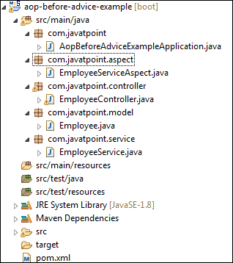
We have set-up all the modules. Now we will run the application.
Step 18: Open the eAopBeforeAdviceExampleApplication.java file and run it as Java Application.
Step 19: Open the browser and invoke the following URL : http://localhost:8080/add/employee?empId={id}&firstName={fname}&secondName={sname}
In the above URL, /add/employee is the mapping that we have created in the Controller class. We have used two separators (?) and (&) for separating two values.
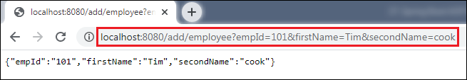
In the above output, we have assigned emId 101, firstName=Tim, and secondName=cook.
Let's have a look at the console. We see that before invoking the createEmployee() method of EmployeeService class, the method beforeAdvice() of EmployeeServiceAspect class invokes, as shown below.
Similarly, we can also remove an employee by invoking the URL http://localhost:8080/remove/employee?empId=101. It returns a message Employee removed, as shown in the following figure.
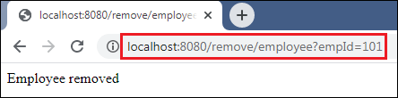
In this section, we have learned the working of before advice. In the next section, we will learn the working of after advice and implement it in an apllication.

Spring Boot AOP After Advice
After advice is used in Aspect-Oriented Programming to achieve the cross-cutting. It is an advice type which ensures that an advice runs after the method execution. We use @After annotation to implement the after advice.
Let's understand after advice through an example.

Spring Boot After Advice Example
Step 1: Open Spring Initializr http://start.spring.io.
Step 2: Provide the Group name. We have provided the Group name com.javatpoint.
Step 3: Provide the Artifact Id. We have provided the Artifact Id aop-after-advice-example.
Step 4: Add the Spring Web dependency.
Step 5: Click on the Generate button. When we click on the Generate button, it wraps all the specifications in a jar file and downloads it to the local system.
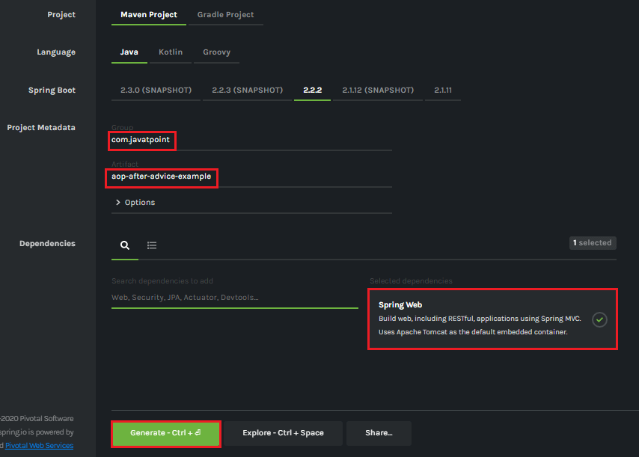
Step 6: Extract the downloaded jar file.
Step 7: Import the folder by using the following steps:
File -> Import -> Existing Maven Projects -> Next -> Browse the Folder aop-after-advice-example -> Finish.
Step 8: Open the pom.xml file and add the following AOP dependency. It is a starter for aspect-oriented programming with Spring AOP and AspectJ.
- <dependency>
- <groupId>org.springframework.boot</groupId>
- <artifactId>spring-boot-starter-aop</artifactId>
- </dependency>
- </dependencies>
pom.xml
- <project xmlns="http://maven.apache.org/POM/4.0.0" xmlns:xsi="http://www.w3.org/2001/XMLSchema-instance" xsi:schemaLocation="http://maven.apache.org/POM/4.0.0 http://maven.apache.org/xsd/maven-4.0.0.xsd">
- <modelVersion>4.0.0</modelVersion>
- <groupId>com.javatpoint</groupId>
- <artifactId> aop-after-advice-example</artifactId>
- <version>0.0.1-SNAPSHOT</version>
- <packaging>jar</packaging>
- <name>aop-after-advice-example</name>
- <description>Demo project for Spring Boot</description>
- <parent>
- <groupId>org.springframework.boot</groupId>
- <artifactId>spring-boot-starter-parent</artifactId>
- <version>2.2.2.RELEASE</version>
- <relativePath /> <!-- lookup parent from repository -->
- </parent>
- <properties>
- <project.build.sourceEncoding>UTF-8</project.build.sourceEncoding>
- <project.reporting.outputEncoding>UTF-8</project.reporting.outputEncoding>
- <java.version>1.8</java.version>
- </properties>
- <dependencies>
- <dependency>
- <groupId>org.springframework.boot</groupId>
- <artifactId>spring-boot-starter-web</artifactId>
- </dependency>
- <dependency>
- <groupId>org.springframework.boot</groupId>
- <artifactId>spring-boot-starter-aop</artifactId>
- </dependency>
- </dependencies>

- <build>
- <plugins>
- <plugin>
- <groupId>org.springframework.boot</groupId>
- <artifactId>spring-boot-maven-plugin</artifactId>
- </plugin>
- </plugins>
- </build>
- </project>
Step 9: Open AopAfterAdviceExampleApplication.java file and add an annotation @EnableAspectJAutoProxy.
- @EnableAspectJAutoProxy(proxyTargetClass=true)
It enables support for handling components marked with AspectJ's @Aspect annotation. It is used with @Configuration annotation. We can control the type of proxy by using the proxyTargetClass attribute. Its default value is false.
AopAfterAdviceExampleApplication.java
- package com.javatpoint;
- import org.springframework.boot.SpringApplication;
- import org.springframework.boot.autoconfigure.SpringBootApplication;
- import org.springframework.context.annotation.EnableAspectJAutoProxy;
- @SpringBootApplication
- @EnableAspectJAutoProxy(proxyTargetClass=true)
- public class AopAfterAdviceExampleApplication
- {
- public static void main(String[] args) {
- SpringApplication.run(AopAfterAdviceExampleApplication.class, args);
- }
- }
Step 10: Create a package with the name com.javatpoint.model.
Step 11: Create a model class under the package com.javatpoint.model. We have created a class with the name Employee. In the class, define the following:
- Define three variables empId, firstName, and secondName of type String.
- Generate Getters and Setters.
- Create a default
Employee.java
- package com.javatpoint.model;
- public class Employee
- {
- private String empId;
- private String firstName;
- private String secondName;
- //default constructor
- public Employee()
- {
- }
- public String getEmpId()
- {
- return empId;
- }
- public void setEmpId(String empId)
- {
- this.empId = empId;
- }
- public String getFirstName()
- {
- return firstName;
- }
- public void setFirstName(String firstName)
- {
- this.firstName = firstName;
- }
- public String getSecondName()
- {
- return secondName;
- }
- public void setSecondName(String secondName)
- {
- this.secondName = secondName;
- }
- }
Step 12: Create a package with the name com.javatpoint.controller.
Step 13: Create a controller class under the package com.javatpoint.controller. We have created a class with the name EmployeeController.
In the controller class, we have defined the two mappings one for adding an employee and the other for removing an employee.
EmployeeController.java
- package com.javatpoint.controller;
- import org.springframework.beans.factory.annotation.Autowired;
- import org.springframework.web.bind.annotation.RequestMapping;
- import org.springframework.web.bind.annotation.RequestMethod;
- import org.springframework.web.bind.annotation.RequestParam;
- import org.springframework.web.bind.annotation.RestController;
- import com.javatpoint.model.Employee;
- import com.javatpoint.service.EmployeeService;
- @RestController
- public class EmployeeController
- {
- @Autowired
- private EmployeeService employeeService;
- @RequestMapping(value = "/add/employee", method = RequestMethod.GET)
- public com.javatpoint.model.Employee addEmployee(@RequestParam("empId") String empId, @RequestParam("firstName") String firstName, @RequestParam("secondName") String secondName)
- {
- return employeeService.createEmployee(empId, firstName, secondName);
- }
- @RequestMapping(value = "/remove/employee", method = RequestMethod.GET)
- public String removeEmployee( @RequestParam("empId") String empId)
- {
- employeeService.deleteEmployee(empId);
- return "Employee removed";
- }
- }
Step 14: Create a package with the name com.javatpoint.service.
Step 15: Create a Service class under the package com.javatpoint.service. We have created a class with the name EmployeeService.
In the Service class, we have defined two methods createEmployee and deleteEmployee.
EmployeeService.java
- package com.javatpoint.service;
- import org.springframework.stereotype.Service;
- import com.javatpoint.model.Employee;
- @Service
- public class EmployeeService
- {
- public Employee createEmployee( String empId, String fname, String sname)
- {
- Employee emp = new Employee();
- emp.setEmpId(empId);
- emp.setFirstName(fname);
- emp.setSecondName(sname);
- return emp;
- }
- public void deleteEmployee(String empId)
- {
- }
- }
Step 16: Create a package with the name com.javatpoint.aspect.
Step 17: Create an aspect class under the package com.javatpoint.aspect. We have created a class with the name EmployeeServiceAspect.
In the aspect class, we have defined the after-advice logic.
EmployeeServiceAspect.java
- package com.javatpoint.aspect;
- import org.aspectj.lang.JoinPoint;
- import org.aspectj.lang.annotation.Aspect;
- import org.aspectj.lang.annotation.After;
- import org.springframework.stereotype.Component;
- @Aspect
- @Component
- public class EmployeeServiceAspect
- {
- @After(value = "execution(* com.javatpoint.service.EmployeeService.*(..)) and args(empId, fname, sname)")
- public void afterAdvice(JoinPoint joinPoint, String empId, String fname, String sname) {
- System.out.println("After method:" + joinPoint.getSignature());
- System.out.println("Creating Employee with first name - " + fname + ", second name - " + sname + " and id - " + empId);
- }
- }
In the above class:
- execution(expression): The expression is a method on which advice is to be applied.
- @After: The method annotated with @After executes after all the methods that matched with the pointcut expression.
After creating all the modules, the project directory looks like the following:
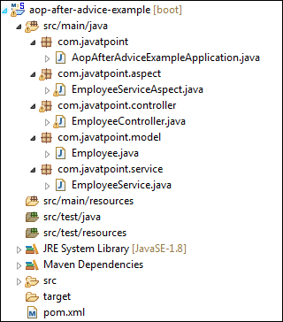
We have set-up all the modules. Now we will run the application.
Step 18: Open the AopAfterAdviceExampleApplication.java file and run it as Java Application.
Step 19: Open the browser and invoke the following URL : http://localhost:8080/add/employee?empId={id}&firstName={fname}&secondName={sname}
In the above URL, /add/employee is the mapping that we have created in the Controller class. We have used two separators (?) and (&) for separating two values.
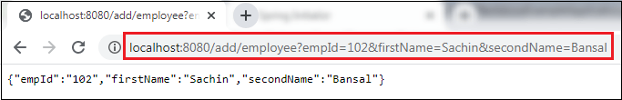
In the above output, we have assigned emId 102, firstName=Sachin, and secondName=Bansal.
Let's have a look at the console. We see that after invoking the createEmployee() method of EmployeeService class, the method afterAdvice() of EmployeeServiceAspect class invokes, as shown below.
Similarly, we can also remove an employee by invoking the URL http://localhost:8080/remove/employee?empId=102. It returns a message Employee removed, as shown in the following figure.
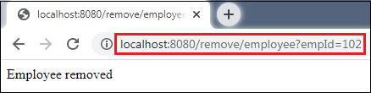
In this section, we have learned the working of after advice. In the next section, we will learn the working of around advice.

Spring Boot AOP Around Advice
Around advice is represented by @Around annotation. It executes before and after a join point. It is the most powerful advice. It also provides more control for end-user to get deal with ProceedingJoinPoint.
Let's implement around advice in an application.

Spring Boot Around Advice Example
Step 1: Open Spring Initializr http://start.spring.io.
Step 2: Provide the Group name. We have provided the Group name com.javatpoint.
Step 3: Provide the Artifact Id. We have provided the Artifact Id aop-around-advice-example.
Step 4: Add the Spring Web dependency.
Step 5: Click on the Generate button. When we click on the Generate button, it wraps all the specifications in a jar file and downloads it to the local system.
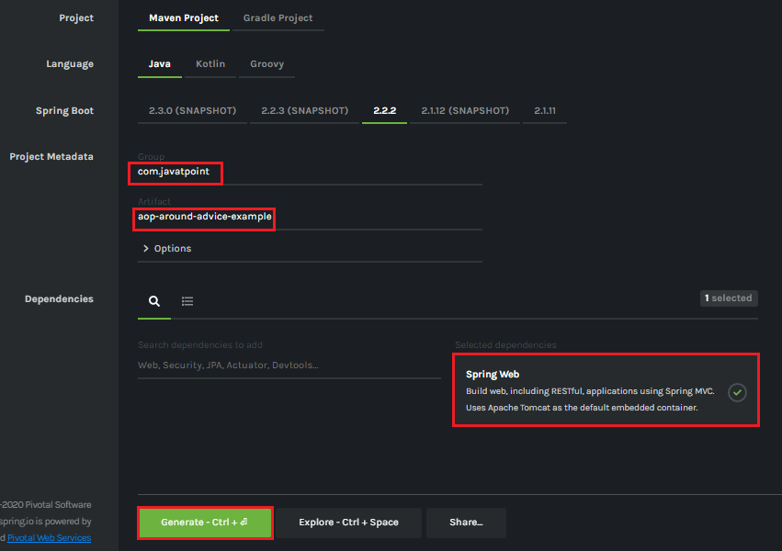
Step 6: Extract the downloaded jar file.
Step 7: Import the folder by using the following steps:
File -> Import -> Existing Maven Projects -> Next -> Browse the Folder aop-around-advice-example -> Finish.
Step 8: Open the pom.xml file and add the following AOP dependency. It is a starter for aspect-oriented programming with Spring AOP and AspectJ.
- <dependency>
- <groupId>org.springframework.boot</groupId>
- <artifactId>spring-boot-starter-aop</artifactId>
- </dependency>
- </dependencies>
pom.xml
- <?xml version="1.0" encoding="UTF-8"?>
- <project xmlns="http://maven.apache.org/POM/4.0.0" xmlns:xsi="http://www.w3.org/2001/XMLSchema-instance" xsi:schemaLocation="http://maven.apache.org/POM/4.0.0 https://maven.apache.org/xsd/maven-4.0.0.xsd">
- <modelVersion>4.0.0</modelVersion>
- <parent>
- <groupId>org.springframework.boot</groupId>
- <artifactId>spring-boot-starter-parent</artifactId>
- <version>2.2.2.RELEASE</version>
- <relativePath/> <!-- lookup parent from repository -->
- </parent>
- <groupId>com.javatpoint</groupId>
- <artifactId>aop-around-advice-example</artifactId>
- <version>0.0.1-SNAPSHOT</version>
- <name>aop-around-advice-example</name>
- <description>Demo project for Spring Boot</description>
- <properties>
- <java.version>1.8</java.version>
- </properties>
- <dependencies>
- <dependency>
- <groupId>org.springframework.boot</groupId>
- <artifactId>spring-boot-starter-web</artifactId>
- </dependency>
- <dependency>
- <groupId>org.springframework.boot</groupId>
- <artifactId>spring-boot-starter-aop</artifactId>
- </dependency>
- <dependency>
- <groupId>org.springframework.boot</groupId>
- <artifactId>spring-boot-starter-test</artifactId>
- <scope>test</scope>
- <exclusions>
- <exclusion>
- <groupId>org.junit.vintage</groupId>
- <artifactId>junit-vintage-engine</artifactId>
- </exclusion>
- </exclusions>
- </dependency>
- </dependencies>
- <build>
- <plugins>
- <plugin>
- <groupId>org.springframework.boot</groupId>
- <artifactId>spring-boot-maven-plugin</artifactId>
- </plugin>
- </plugins>
- </build>
- </project>
Step 9: Create a package with the name com.javatpoint.service.
Step 10: Create a class in the above package with the name BankService.
In this class, we have defined a method named displayBalance(). It checks the account number. If the account number is matched returns total amount, else returns a message.
BankService.java
- package com.javatpoint.service;
- import org.springframework.stereotype.Service;
- @Service
- public class BankService
- {
- public void displayBalance(String accNum)
- {
- System.out.println("Inside displayBalance() method");
- if(accNum.equals("12345"))
- {
- System.out.println("Total balance: 10,000");
- }
- else
- {
- System.out.println("Sorry! wrong account number.");
- }
- }
- }
Step 11: Create another package with the name com.javatpoint.aspect.
Step 12: Create a class in the above package with the name BankAspect.
In the following class, we have defined two methods named logDisplayingBalance() and aroundAdvice() method.
BankAspect.java
- package com.javatpoint.aspect;
- import org.aspectj.lang.ProceedingJoinPoint;
- import org.aspectj.lang.annotation.Around;
- import org.aspectj.lang.annotation.Aspect;
- import org.aspectj.lang.annotation.Pointcut;
- import org.springframework.stereotype.Component;
- //Enables the spring AOP functionality in an application
- @Aspect
- @Component
- public class BankAspect
- {
- //Displays all the available methods i.e. the advice will be called for all the methods
- @Pointcut(value= "execution(* com.javatpoint.service.BankService.*(..))")
- private void logDisplayingBalance()
- {
- }
- //Declares the around advice that is applied before and after the method matching with a pointcut expression
- @Around(value= "logDisplayingBalance()")
- public void aroundAdvice(ProceedingJoinPoint jp) throws Throwable
- {
- System.out.println("The method aroundAdvice() before invokation of the method " + jp.getSignature().getName() + " method");
- try
- {
- jp.proceed();
- }
- finally
- {

- }
- System.out.println("The method aroundAdvice() after invokation of the method " + jp.getSignature().getName() + " method");
- }
- }
Step 13: Open AopAroundAdviceExampleApplication.java file and add an annotation @EnableAspectJAutoProxy.
The annotation enables support for handling components marked with AspectJ's @Aspect annotation. It is used with @Configuration annotation.
ConfigurableApplicationContext is an interface that provides facilities to configure an application context in addition to the application context client methods in the ApplicationContext.
AopAroundAdviceExampleApplication.java
- package com.javatpoint;
- import org.springframework.boot.SpringApplication;
- import org.springframework.boot.autoconfigure.SpringBootApplication;
- import org.springframework.context.ConfigurableApplicationContext;
- import org.springframework.context.annotation.EnableAspectJAutoProxy;
- import com.javatpoint.service.BankService;
- @SpringBootApplication
- //@EnableAspectJAutoProxy annotation enables support for handling the components marked with @Aspect annotation. It is similar to tag in the xml configuration.
- @EnableAspectJAutoProxy
- public class AopAroundAdviceExampleApplication
- {
- public static void main(String[] args)
- {
- ConfigurableApplicationContext context = SpringApplication.run(AopAroundAdviceExampleApplication.class, args);
- // Fetching the employee object from the application context.
- BankService bank = context.getBean(BankService.class);
- // Displaying balance in the account
- String accnumber = "12345";
- bank.displayBalance(accnumber);
- // Closing the context object
- context.close();
- }
- }
After creating all the packages and classes the project directory looks like the following:
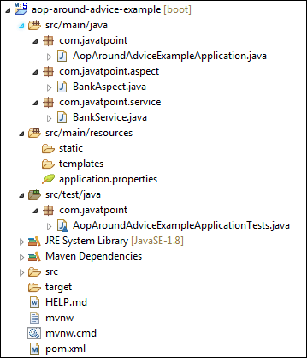
Now, run the application.
Step 14: Open the AopAroundAdviceExampleApplication.java and run it as Java Application.
In the above output, we see that the method aroundAdvice() invokes two times. First, before the execution of the displayBalance() method and second, after the execution of the displayBalance() method. It is called around advice.

Spring Boot AOP After Returning Advice
After returning is an advice in Spring AOP that invokes after the execution of join point complete (execute) normally. It does not invoke if an exception is thrown. We can implement after returning advice in an application by using @AfterReturning annotation. The annotation marks a function as an advice to be executed before the method covered by PointCut.
After returning advice runs when a matched method execution returns a value normally. The name that we define in the return attribute must correspond to the name of a parameter in the advice method. When a method returns a value, the value will be passed to the advice method as the corresponding argument value.
Let's implement the after returning advice in an application.

Spring Boot After Returning Advice Example
Step 1: Open Spring Initializr http://start.spring.io.
Step 2: Provide the Group name. We have provided the Group name com.javatpoint.
Step 3: Provide the Artifact Id. We have provided the Artifact Id aop-after-returning-advice-example.
Step 4: Add the Spring Web dependency.
Step 5: Click on the Generate button. When we click on the Generate button, it wraps all the specifications in a jar file and downloads it to the local system.
Step 6: Extract the downloaded jar file.
Step 7: Import the folder by using the following steps:
File -> Import -> Existing Maven Projects -> Next -> Browse the Folder aop-after-returning-advice-example -> Finish.
Step 8: Open the pom.xml file and add the following AOP dependency. It is a starter for aspect-oriented programming with Spring AOP and AspectJ.
- <dependency>
- <groupId>org.springframework.boot</groupId>
- <artifactId>spring-boot-starter-aop</artifactId>
- </dependency>
- </dependencies>
- pom.xml
- <?xml version="1.0" encoding="UTF-8"?>
- <project xmlns="http://maven.apache.org/POM/4.0.0" xmlns:xsi="http://www.w3.org/2001/XMLSchema-instance"
- xsi:schemaLocation="http://maven.apache.org/POM/4.0.0 http://maven.apache.org/xsd/maven-4.0.0.xsd">
- <modelVersion>4.0.0</modelVersion>
- <groupId>com.javatpoint</groupId>
- <artifactId>aop-after-returning-advice-example</artifactId>
- <version>0.0.1-SNAPSHOT</version>
- <packaging>jar</packaging>
- <name>aop-after-returning-advice-example</name>
- <description>Demo project for Spring Boot</description>
- <parent>
- <groupId>org.springframework.boot</groupId>
- <artifactId>spring-boot-starter-parent</artifactId>
- <version>2.2.2.RELEASE</version>
- <relativePath/> <!-- lookup parent from repository -->
- </parent>
- <properties>
- <project.build.sourceEncoding>UTF-8</project.build.sourceEncoding>
- <project.reporting.outputEncoding>UTF-8</project.reporting.outputEncoding>
- <java.version>1.8</java.version>
- </properties>
- <dependencies>
- <dependency>
- <groupId>org.springframework.boot</groupId>
- <artifactId>spring-boot-starter-aop</artifactId>
- </dependency>
- <dependency>
- <groupId>org.springframework.boot</groupId>
- <artifactId>spring-boot-starter-test</artifactId>
- <scope>test</scope>
- </dependency>
- </dependencies>
- <build>
- <plugins>
- <plugin>
- <groupId>org.springframework.boot</groupId>
- <artifactId>spring-boot-maven-plugin</artifactId>
- </plugin>
- </plugins>
- </build>
- </project>
Step 9: Create a package with the name com.javatpoint.model in src/main/java folder.
Step 10: Create a class with the name Account in the package com.javatpoint.model.
In the Account class, do the following:
- Defined two variables accountNumber and accountType of type String.
- Right-click on the file -> Source -> Generate Constructor using Fields
- Generate Getters.
Right-click on the file -> Source -> Generate Getters and Setters -> Select Getters -> Generate
- Generate a toString()
Right-click on the file -> Source -> Generate toString()…
Account.java
- package com.javatpoint.model;
- public class Account
- {
- private String accountNumber;
- private String accountType;
- public Account(String accountNumber, String accountType)
- {
- super();
- this.accountNumber = accountNumber;
- this.accountType = accountType;
- }
- public String getAccountType()
- {
- return accountType;
- }
- public String getAccountNumber()
- {
- return accountNumber;
- }
- @Override
- public String toString()
- {
- return "Account [accountNumber=" + accountNumber+ ", accountType=" + accountType + "]";
- }
- }
Step 11: Create another package with the name com.javatpoint.service.impl.
Step 12: In this package, create a class with the name AccountServiceImple.
In this class, we have defined account service.
AccountServiceImpl.java
- package com.javatpoint.service.impl;
- import java.util.HashMap;
- import java.util.Map;
- import java.util.Map.Entry;
- import java.util.Set;
- import org.springframework.stereotype.Service;
- import com.javatpoint.model.Account;
- @Service
- public class AccountServiceImpl implements AccountService
- {
- //storing account detail in the HashMap
- private static Map<String,Account> map = null;
- static
- {
- map = new HashMap<>();
- //adding account detail in the map
- map.put("M4546779", new Account("10441117000", "Saving Account"));
- map.put("K2434567", new Account("10863554577", "Current Account"));
- }
- @Override
- public Account getAccountByCustomerId(String customerId) throws Exception
- {
- if(customerId ==null)
- {
- throw new Exception("Invalid! Customer Id");
- }
- Account account= null;
- Set<Entry<String, Account>> entrySet = map.entrySet();
- for (Entry<String, Account> entry : entrySet)
- {
- if(entry.getKey().equals(customerId))
- {
- account= entry.getValue();
- }
- }
- return account;
- }
- }
Step 13: Create an interface with the name AccountService in the package com.javatpoint.service.impl.
AccountService.java
- package com.javatpoint.service.impl;
- import com.javatpoint.model.Account;
- //creating interface that throws exception if the customer id not found
- public interface AccountService
- {
- public abstract Account getAccountByCustomerId(String customerId)
- throws Exception;
- }
Step 14: Create a package with the name com.javatpoint.aspect.
Step 15: Create a class with the name AccountAspect in the package com.javatpoint.aspect.
In this class, we have implemented the after returning advice by using the annotation @AfterReturning. We have also defined a method afterReturningAdvice() method.
Note: The name (account) that we define in the returning attribute must correspond to the name of a parameter in the advice method.
AccountAspect.java
- package com.javatpoint.aspect;
- import org.aspectj.lang.JoinPoint;
- import org.aspectj.lang.annotation.AfterReturning;
- import org.aspectj.lang.annotation.Aspect;
- import org.springframework.stereotype.Component;
- import com.javatpoint.model.Account;
- @Aspect
- @Component
- public class AccountAspect
- {
- //implementing after returning advice
- @AfterReturning(value="execution(* com.javatpoint.service.impl.AccountServiceImpl.*(..))",returning="account")
- public void afterReturningAdvice(JoinPoint joinPoint, Account account)
- {
- System.out.println("After Returing method:"+joinPoint.getSignature());
- System.out.println(account);
- }
- }
Step 16: Open the AopAfterReturningAdviceExampleApplication.java file and add an annotation @EnableAspectJAutoProxy.
The annotation enables support for handling components marked with AspectJ's @Aspect annotation. It is used with @Configuration annotation.
We have used the proxyTargetClass attribute of the annotation @EnableAspectJAutoProxy. The attribute proxyTargetClass=true allows us to use CGLIB (Code Generation Library) proxies instead of the default interface-based JDK proxy approach.
ConfigurableApplicationContext is an interface that provides facilities to configure an application context in addition to the application context client methods in the ApplicationContext.
AopAfterReturningAdviceExampleApplication.java
- package com.javatpoint;
- import org.springframework.boot.SpringApplication;
- import org.springframework.boot.autoconfigure.SpringBootApplication;
- import org.springframework.context.ConfigurableApplicationContext;
- import org.springframework.context.annotation.EnableAspectJAutoProxy;
- import com.javatpoint.model.Account;
- import com.javatpoint.service.impl.AccountService;
- import com.javatpoint.service.impl.AccountServiceImpl;
- @SpringBootApplication
- //@EnableAspectJAutoProxy annotation enables support for handling the components marked with @Aspect annotation. It is similar to tag in the xml configuration.
- @EnableAspectJAutoProxy(proxyTargetClass=true)
- public class AopAfterReturningAdviceExampleApplication
- {
- public static void main(String[] args)
- {
- ConfigurableApplicationContext ac = SpringApplication.run(AopAfterReturningAdviceExampleApplication.class, args);
- //Fetching the account object from the application context
- AccountService accountService = ac.getBean("accountServiceImpl", AccountServiceImpl.class);
- Account account;
- try
- {
- account = accountService.getAccountByCustomerId("K2434567");
- if(account != null)
- System.out.println(account.getAccountNumber()+"\t"+account.getAccountType());
- }
- catch (Exception e)
- {
- System.out.println(e.getMessage());
- }
- }
- }
After creating all the class and packages, the project directory looks like the following:
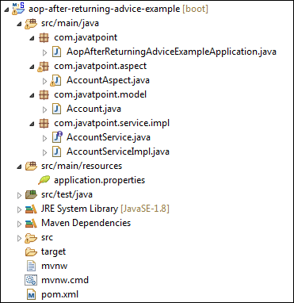
Step 17: Open the AopAfterReturningAdviceExampleApplication.java file and run it as Java Application. It shows the output, as shown below:
In the next section, we will understand after throwing advice.

Spring Boot AOP After Throwing Advice
After throwing is an advice type in Spring AOP. It ensures that an advice runs if a method throws an exception. We use @AfterThrowing annotation to implement the after throwing advice.
Syntax:
- @AfterThrowing(PointCut="execution(expression) ", throwing="name")
Where:
PointCut: It selects a function.
execution(expression): It is an expression on which advice is to be applied.
throwing: The name of the exception to be returned.
Let's implement the after throwing advice in an application.

Spring Boot After Throwing Advice Example
We will use the previous example in this section. You can download the project or make some modifications in the previous example.

Spring Boot After Throwing Advice Example
Step 1: Open Spring Initializr http://start.spring.io.
Step 2: Provide the Group name. We have provided the Group name com.javatpoint.
Step 3: Provide the Artifact Id. We have provided the Artifact Id aop-after-throwing-advice-example.
Step 4: Add the Spring Web dependency.
Step 5: Click on the Generate button. When we click on the Generate button, it wraps all the specifications in a jar file and downloads it to the local system.
Step 6: Extract the downloaded jar file.
Step 7: Import the folder by using the following steps:
File -> Import -> Existing Maven Projects -> Next -> Browse the Folder aop-after-throwing-advice-example -> Finish.
Step 8: Open the pom.xml file and add the following AOP dependency. It is a starter for aspect-oriented programming with Spring AOP and AspectJ.
- <dependency>
- <groupId>org.springframework.boot</groupId>
- <artifactId>spring-boot-starter-aop</artifactId>
- </dependency>
- </dependencies>
pom.xml
- <?xml version="1.0" encoding="UTF-8"?>
- <project xmlns="http://maven.apache.org/POM/4.0.0" xmlns:xsi="http://www.w3.org/2001/XMLSchema-instance"
- xsi:schemaLocation="http://maven.apache.org/POM/4.0.0 http://maven.apache.org/xsd/maven-4.0.0.xsd">
- <modelVersion>4.0.0</modelVersion>
- <groupId>com.javatpoint</groupId>
- <artifactId>aop-after-throwing-advice-example</artifactId>
- <version>0.0.1-SNAPSHOT</version>
- <packaging>jar</packaging>
- <name>aop-after-throwing-advice-example</name>
- <description>Demo project for Spring Boot</description>
- <parent>
- <groupId>org.springframework.boot</groupId>
- <artifactId>spring-boot-starter-parent</artifactId>
- <version>2.2.2.RELEASE</version>
- <relativePath/> <!-- lookup parent from repository -->
- </parent>
- <properties>
- <project.build.sourceEncoding>UTF-8</project.build.sourceEncoding>
- <project.reporting.outputEncoding>UTF-8</project.reporting.outputEncoding>
- <java.version>1.8</java.version>
- </properties>
- <dependencies>
- <dependency>
- <groupId>org.springframework.boot</groupId>
- <artifactId>spring-boot-starter-aop</artifactId>
- </dependency>
- <dependency>
- <groupId>org.springframework.boot</groupId>
- <artifactId>spring-boot-starter-test</artifactId>
- <scope>test</scope>
- </dependency>
- </dependencies>
- <build>
- <plugins>
- <plugin>
- <groupId>org.springframework.boot</groupId>
- <artifactId>spring-boot-maven-plugin</artifactId>
- </plugin>
- </plugins>
- </build>
- </project>
Step 9: Create a package with the name com.javatpoint.model in src/main/java folder.
Step 10: Create a class with the name Account in the package com.javatpoint.model.
In the Account class, do the following:
- Defined two variables accountNumber and accountType of type String.
- Right-click on the file -> Source -> Generate Constructor using Fields
- Generate Getters.
Right-click on the file -> Source -> Generate Getters and Setters -> Select Getters -> Generate
- Generate a toString()
Right-click on the file -> Source -> Generate toString()
Account.java
- package com.javatpoint.model;
- public class Account
- {
- private String accountNumber;
- private String accountType;
- public Account(String accountNumber, String accountType)
- {
- super();
- this.accountNumber = accountNumber;
- this.accountType = accountType;
- }
- public String getAccountType()
- {
- return accountType;
- }
- public String getAccountNumber()
- {
- return accountNumber;
- }
- @Override
- public String toString()
- {
- return "Account [accountNumber=" + accountNumber+ ", accountType=" + accountType + "]";
- }
- }
Step 11: Create another package with the name com.javatpoint.service.impl.
Step 12: In this package, create a class with the name AccountServiceImple.
In this class, we have defined account service.
AccountServiceImpl.java
- package com.javatpoint.service.impl;
- import java.util.HashMap;
- import java.util.Map;
- import java.util.Map.Entry;
- import java.util.Set;
- import org.springframework.stereotype.Service;
- import com.javatpoint.model.Account;
- @Service
- public class AccountServiceImpl implements AccountService
- {
- //storing account detail in the HashMap
- private static Map<String,Account> map = null;
- static
- {
- map = new HashMap<>();
- //adding account detail in the map
- map.put("M4546779", new Account("10441117000", "Saving Account"));
- map.put("K2434567", new Account("10863554577", "Current Account"));
- }
- @Override
- public Account getAccountByCustomerId(String customerId) throws Exception
- {
- if(customerId ==null)
- {
- throw new Exception("Invalid! Customer Id");
- }
- Account account= null;
- Set<Entry<String, Account>> entrySet = map.entrySet();
- for (Entry<String, Account> entry : entrySet)
- {
- if(entry.getKey().equals(customerId))
- {
- account= entry.getValue();
- }
- }
- return account;
- }
- }
Step 13: Create an interface with the name AccountService in the package com.javatpoint.service.impl.
AccountService.java
- package com.javatpoint.service.impl;
- import com.javatpoint.model.Account;
- //creating interface that throws exception if the customer id not found
- public interface AccountService
- {
- public abstract Account getAccountByCustomerId(String customerId)
- throws Exception;
- }
Step 14: Create a package with the name com.javatpoint.aspect.
Step 15: Create a class with the name AccountAspect in the package com.javatpoint.aspect.
In this class, we have implemented the after throwing advice by using the annotation @AfterThrowing. We have also defined a method afterThrowingAdvice() method.

Note: The name (ex) that we define in the throwing attribute must correspond to the name of a parameter in the advice method. Otherwise, advice will not run.
AccountAspect.java
- package com.javatpoint.aspect;
- import org.aspectj.lang.JoinPoint;
- import org.aspectj.lang.annotation.AfterThrowing;
- import org.aspectj.lang.annotation.Aspect;
- import org.springframework.stereotype.Component;
- @Aspect
- @Component
- public class AccountAspect
- {
- //implementing after throwing advice
- @AfterThrowing(value="execution(* com.javatpoint.service.impl.AccountServiceImpl.*(..))",throwing="ex")
- public void afterThrowingAdvice(JoinPoint joinPoint, Exception ex)
- {
- System.out.println("After Throwing exception in method:"+joinPoint.getSignature());
- System.out.println("Exception is:"+ex.getMessage());
- }
- }
Step 16: Open the AopAfterThrowingAdviceExampleApplication.java file and add an annotation @EnableAspectJAutoProxy.
The annotation enables support for handling components marked with AspectJ's @Aspect annotation. It is used with @Configuration annotation.
We have used the proxyTargetClass attribute of the annotation @EnableAspectJAutoProxy. The attribute proxyTargetClass=true allows us to use CGLIB (Code Generation Library) proxies instead of the default interface-based JDK proxy approach.
ConfigurableApplicationContext is an interface that provides facilities to configure an application context in addition to the application context client methods in the ApplicationContext.
AopAfterThrowingAdviceExampleApplication.java
- package com.javatpoint;
- import org.springframework.boot.SpringApplication;
- import org.springframework.boot.autoconfigure.SpringBootApplication;
- import org.springframework.context.ConfigurableApplicationContext;
- import org.springframework.context.annotation.EnableAspectJAutoProxy;
- import com.javatpoint.model.Account;
- import com.javatpoint.service.impl.AccountService;
- import com.javatpoint.service.impl.AccountServiceImpl;
- @SpringBootApplication
- //@EnableAspectJAutoProxy annotation enables support for handling the components marked with @Aspect annotation. It is similar to tag in the xml configuration.
- @EnableAspectJAutoProxy(proxyTargetClass=true)
- public class AopAfterThrowingAdviceExampleApplication
- {
- public static void main(String[] args)
- {
- ConfigurableApplicationContext ac = SpringApplication.run(AopAfterThrowingAdviceExampleApplication.class, args);
- //Fetching the account object from the application context
- AccountService accountService = ac.getBean("accountServiceImpl", AccountServiceImpl.class);
- Account account;
- try
- {
- //generating exception
- account = accountService.getAccountByCustomerId(null);
- if(account != null)
- System.out.println(account.getAccountNumber()+"\t"+account.getAccountType());
- }
- catch (Exception e)
- {
- System.out.println(e.getMessage());
- e.printStackTrace();
- }
- }
- }
After creating all the class and packages, the project directory looks like the following:
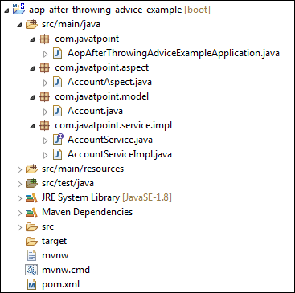
Step 17: Open the AopAfterThrowingAdviceExampleApplication.java file and run it as Java Application. It shows the output, as shown below:

Spring Boot JPA

What is JPA?
Spring Boot JPA is a Java specification for managing relational data in Java applications. It allows us to access and persist data between Java object/ class and relational database. JPA follows Object-Relation Mapping (ORM). It is a set of interfaces. It also provides a runtime EntityManager API for processing queries and transactions on the objects against the database. It uses a platform-independent object-oriented query language JPQL (Java Persistent Query Language).
In the context of persistence, it covers three areas:
- The Java Persistence API
- Object-Relational metadata
- The API itself, defined in the persistence package
JPA is not a framework. It defines a concept that can be implemented by any framework.

Why should we use JPA?
JPA is simpler, cleaner, and less labor-intensive than JDBC, SQL, and hand-written mapping. JPA is suitable for non-performance oriented complex applications. The main advantage of JPA over JDBC is that, in JPA, data is represented by objects and classes while in JDBC data is represented by tables and records. It uses POJO to represent persistent data that simplifies database programming. There are some other advantages of JPA:
- JPA avoids writing DDL in a database-specific dialect of SQL. Instead of this, it allows mapping in XML or using Java annotations.
- JPA allows us to avoid writing DML in the database-specific dialect of SQL.
- JPA allows us to save and load Java objects and graphs without any DML language at all.
- When we need to perform queries JPQL, it allows us to express the queries in terms of Java entities rather than the (native) SQL table and columns.

JPA Features
There are following features of JPA:
- It is a powerful repository and custom object-mapping abstraction.
- It supports for cross-store persistence. It means an entity can be partially stored in MySQL and Neo4j (Graph Database Management System).
- It dynamically generates queries from queries methods name.
- The domain base classes provide basic properties.
- It supports transparent auditing.
- Possibility to integrate custom repository code.
- It is easy to integrate with Spring Framework with the custom namespace.

JPA Architecture
JPA is a source to store business entities as relational entities. It shows how to define a POJO as an entity and how to manage entities with relation.
The following figure describes the class-level architecture of JPA that describes the core classes and interfaces of JPA that is defined in the javax persistence package. The JPA architecture contains the following units:
- Persistence: It is a class that contains static methods to obtain an EntityManagerFactory instance.
- EntityManagerFactory: It is a factory class of EntityManager. It creates and manages multiple instances of EntityManager.
- EntityManager: It is an interface. It controls the persistence operations on objects. It works for the Query instance.
- Entity: The entities are the persistence objects stores as a record in the database.
- Persistence Unit: It defines a set of all entity classes. In an application, EntityManager instances manage it. The set of entity classes represents the data contained within a single data store.
- EntityTransaction: It has a one-to-one relationship with the EntityManager class. For each EntityManager, operations are maintained by EntityTransaction class.
- Query: It is an interface that is implemented by each JPA vendor to obtain relation objects that meet the criteria.
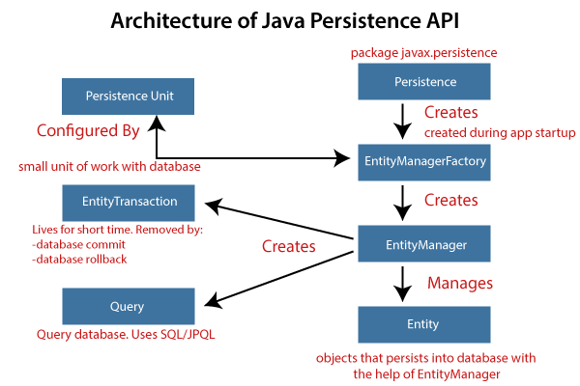

JPA Class Relationships
The classes and interfaces that we have discussed above maintain a relationship. The following figure shows the relationship between classes and interfaces.
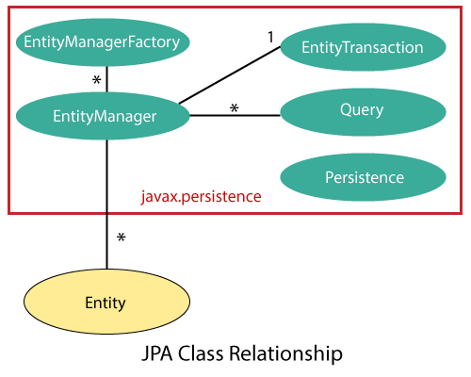
- The relationship between EntityManager and EntiyTransaction is one-to-one. There is an EntityTransaction instance for each EntityManager operation.
- The relationship between EntityManageFactory and EntiyManager is one-to-many. It is a factory class to EntityManager instance.
- The relationship between EntityManager and Query is one-to-many. We can execute any number of queries by using an instance of EntityManager class.
- The relationship between EntityManager and Entity is one-to-many. An EntityManager instance can manage multiple Entities.

JPA Implementations
JPA is an open-source API. There is various enterprises vendor such as Eclipse, RedHat, Oracle, etc. that provides new products by adding the JPA in them. There are some popular JPA implementations frameworks such as Hibernate, EclipseLink, DataNucleus, etc. It is also known as Object-Relation Mapping (ORM) tool.

Object-Relation Mapping (ORM)
In ORM, the mapping of Java objects to database tables, and vice-versa is called Object-Relational Mapping. The ORM mapping works as a bridge between a relational database (tables and records) and Java application (classes and objects).
In the following figure, the ORM layer is an adapter layer. It adapts the language of object graphs to the language of SQL and relation tables.
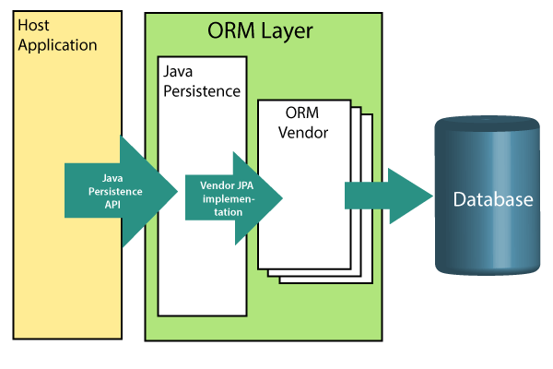
The ORM layer exists between the application and the database. It converts the Java classes and objects so that they can be stored and managed in a relational database. By default, the name that persists become the name of the table, and fields become columns. Once an application sets-up, each table row corresponds to an object.

JPA Versions
Earlier versions of EJB defines the persistence layer combined with the business logic layer using javax.ejb.EntityBean Interface. EJB specification includes the definition of JPA.
While introducing EJB 3.0, the persistence layer was separated and specified as JPA 1.0 (Java Persistence API). The specifications of this API were released along with the specifications of JAVA EE5 on May 11, 2006, using JSR 220.
In 2019, JPA renamed to Jakarta Persistence. The latest version of JPA is 2.2. It supports the following features:
- Java 8, data and time API
- CDI Injection in AttributeConvertes
- It makes annotations @Repeatable

Difference between JPA and Hibernate
JPA: JPA is a Java specification that is used to access, manage, and persist data between Java object and relational database. It is a standard approach for ORM.
Hibernate: It is a lightweight, open-source ORM tool that is used to store Java objects in the relational database system. It is a provider of JPA. It follows a common approach provided by JPA.
The following table describes the differences between JPA and Hibernate.
JPA | Hibernate
JPA is a Java specification for mapping relation data in Java application. | Hibernate is an ORM framework that deals with data persistence.
JPA does not provide any implementation classes. | It provides implementation classes.
It uses platform-independent query language called JPQL (Java Persistence Query Language). | It uses its own query language called HQL (Hibernate Query Language).
It is defined in javax.persistence package. | It is defined in org.hibernate package.
It is implemented in various ORM tools like Hibernate, EclipseLink, etc. | Hibernate is the provider of JPA.
JPA uses EntityManager for handling the persistence of data. | In Hibernate uses Session for handling the persistence of data.

Spring Boot Starter Data JPA
Spring Boot provides starter dependency spring-boot-starter-data-jpa to connect Spring Boot application with relational database efficiently. The spring-boot-starter-data-jpa internally uses the spring-boot-jpa dependency.
- <dependency>
- <groupId>org.springframework.boot</groupId>
- <artifactId>spring-boot-starter-data-jpa</artifactId>
- <version>2.2.2.RELEASE</version>
- </dependency>

Spring Boot JPA Example
Let's create a Spring Boot application that uses JPA to connect to the database. In the following example, we have used in-memory database Apache Derby.
Apache Derby: It is an open-source, embedded relational database implemented entirely in Java. It is available under the Apache License 2.0. There are following advantages of Apache Derby:
- It is easy to install, deploy, and use.
- It is based on Java, JDBC, and SQL standards.
- It provides an embedded JDBC driver that allows us to embed Derby in any Java-based solution.
- It also supports client/server mode with the Derby Network Client JDBC driver, and Derby Network Server.
Spring Boot can auto-configure an embedded database such as H2, HSQL, and Derbydatabases. We do not need to provide any connection URLs. We need only include a build dependency on the embedded database that we want to use.
In Spring Boot, we can easily integrate Apache Derby database just by adding Derby dependency in pom.xml file.
- <dependency>
- <groupId>org.apache.derby</groupId>
- <artifactId>derby</artifactId>
- <scope>runtime</scope>
- </dependency>
Step 1: Open Spring Initializr https://start.spring.io/.
Step 2: Select the latest version of Spring Boot 2.3.0(SNAPSHOT)
Step 3: Provide the Group name. We have provided com.javatpoint.
Step 4: Provide the Artifact Id. We have provided apache-derby-example.
Step 5: Add the dependencies: Spring Web, Spring Data JPA, and Apache Derby Database.
Step 6: Click on the Generate button. When we click on the Generate button, it wraps the project in a Jar file and downloads it to the local system.
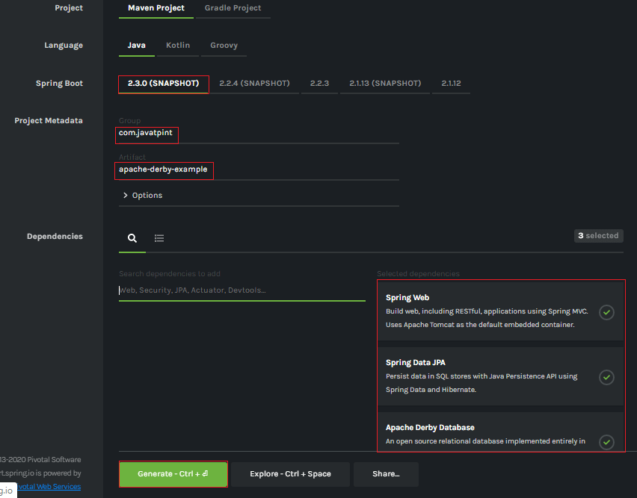
Step 7: Extract the Jar file and paste it into the STS workspace.
Step 8: Import the project folder into STS.
File -> Import -> Existing Maven Projects -> Browse -> Select the folder apache-derby-example -> Finish
It takes some time to import.
Step 9: Create a package with the name com.javatpoint.model in the folder src/main/java.
Step 10: Create a class with the name UserRecord in the package com.javatpoint.model and do the following:
- Define three variables id, name, and email.
- Generate Getters and Setter.
Right-click on the file -> Source -> Generate Getters and Setters
- Define a default constructor.
- Mark the class as an Entity by using the annotation @Entity.
- Mark Id as the primary key by using the annotation @Id.
UserRecord.java
- package com.javatpoint.model;
- import javax.persistence.Entity;
- import javax.persistence.Id;
- @Entity
- public class UserRecord
- {
- @Id
- private int id;
- private String name;
- private String email;
- //default conatructor
- public UserRecord()
- {
- }
- public int getId()
- {
- return id;
- }
- public void setId(int id)
- {
- this.id = id;
- }
- public String getName()
- {
- return name;
- }
- public void setName(String name)
- {
- this.name = name;
- }
- public String getEmail()
- {
- return email;
- }
- public void setEmail(String email)
- {
- this.email = email;
- }
- }
Step 11: Create a package with the name com.javatpoint.controller in the folder src/main/java.
Step 12: Create a Controller class with the name UserController in the package com.javatpoint.controller and do the following:
- Mark the class as a controller by using the annotation @RestController.
- Autowired the class UserService by using the annotation @Autowired.
- We have defined two mappings, one for getting all users and the other for add-user.
UserController.java
- package com.javatpoint.controller;
- import org.springframework.beans.factory.annotation.Autowired;
- import org.springframework.web.bind.annotation.RequestBody;
- import org.springframework.web.bind.annotation.RequestMapping;
- import org.springframework.web.bind.annotation.RequestMethod;
- import org.springframework.web.bind.annotation.RestController;
- import com.javatpoint.model.UserRecord;
- import com.javatpoint.service.UserService;
- import java.util.List;
- @RestController
- public class UserController
- {
- @Autowired
- private UserService userService;
- @RequestMapping("/")
- public List<UserRecord> getAllUser()
- {
- return userService.getAllUsers();
- }
- @RequestMapping(value="/add-user", method=RequestMethod.POST)
- public void addUser(@RequestBody UserRecord userRecord)
- {
- userService.addUser(userRecord);
- }
- }
Step 13: Create a package with the name com.javatpoint.service in the folder src/main/java.
Step 14: Create a Service class with the name UserController in the package com.javatpoint.service and do the following:
- Mark the class as service by using the annotation @Service.
- Autowired the UserRepository
- Define a method getAllUsers() that returns a List of
- Define another method name addUser() that saves the user record.
UserService.java
- package com.javatpoint.service;
- import java.util.List;
- import java.util.ArrayList;
- import org.springframework.beans.factory.annotation.Autowired;
- import org.springframework.stereotype.Service;
- import com.javatpoint.model.UserRecord;
- import com.javatpoint.repository.UserRepository;
- @Service
- public class UserService
- {
- @Autowired
- private UserRepository userRepository;
- public List<UserRecord> getAllUsers()
- {
- List<UserRecord>userRecords = new ArrayList<>();
- userRepository.findAll().forEach(userRecords::add);
- return userRecords;
- }
- public void addUser(UserRecord userRecord)
- {
- userRepository.save(userRecord);
- }
- }
Step 15: Create a package with the name com.javatpoint.repository in the folder src/main/java.
Step 16: Create a repository interface with the name UserRepository in the package com.javatpoint.repository and extends CrudRepository.
UserRepository.java
- package com.javatpoint.repository;
- import org.springframework.data.repository.CrudRepository;
- import com.javatpoint.model.UserRecord;
- public interface UserRepository extends CrudRepository<UserRecord, String>
- {
- }
Step 17: Now, open the ApacheDerbyExampleApplication.java file. It created by default when we set-up an application.
ApacheDerbyExampleApplication.java
- package com.javatpoint;
- import org.springframework.boot.SpringApplication;
- import org.springframework.boot.autoconfigure.SpringBootApplication;
- @SpringBootApplication
- public class ApacheDerbyExampleApplication
- {
- public static void main(String[] args)
- {
- SpringApplication.run(ApacheDerbyExampleApplication.class, args);
- }
- }
Now, we have set-up all the necessary classes and packages according to the requirements. Notice that we have not provided any connection URL for the database. After completing all the above steps, the project directory looks like the following:
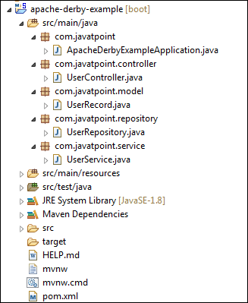
Let's run the application.
Step 18: Open the ApacheDerbyExampleApplication.java file and run it as Java Application.
Step 19: Open the browser and invoke the URL http://localhost:8080/. It returns an empty list because we have not added any user in the List.
To add a user to the database, we will send a POST request by using the Postman.
Step 20: Open the Postman and do the following:
- Select the POST
- Invoke the URL http://localhost:8080/add-user.
- Click on the Body
- Select Content-Type as JSON(application/json).
- Insert the data which want to insert in the database. We have inserted the following data:
- {
- "id": "001",
- "name": "Tom",
- "email": "tom@gmail.com"
- }
- Click on the Send button.
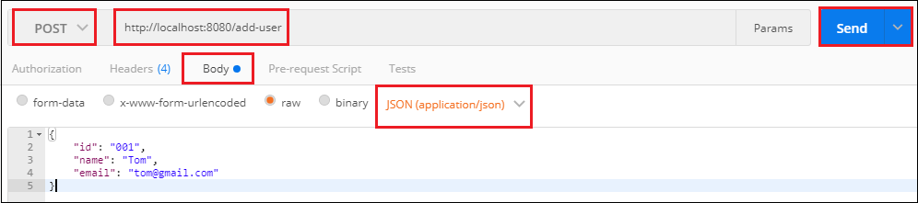
When we click on the Send button, it shows Status:200 OK. It means the request has been successfully executed.
Step 21: Open the browser and invoke the URL http://localhost:8080. It returns the user that we have inserted in the database.
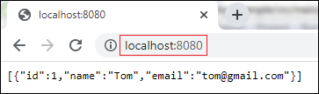

Spring Boot JDBC
Spring Boot JDBC provides starter and libraries for connecting an application with JDBC.
In Spring Boot JDBC, the database related beans such as DataSource, JdbcTemplate, and NamedParameterJdbcTemplate auto-configures and created during the startup. We can autowire these classes if we want to use it. For example:
- @Autowired
- JdbcTemplate jdbcTemplate;
- @Autowired
- private NamedParameterJdbcTemplate jdbcTemplate;
In application.properties file, we configure DataSource and connection pooling. Spring Boot chooses tomcat pooling by default.

JDBC Connection Pooling
JDBC connection pooling is a mechanism that manages multiple database connection requests. In other words, it facilitates connection reuse, a memory cache of database connections, called a connection pool. A connection pooling module maintains it as a layer on top of any standard JDBC driver product.
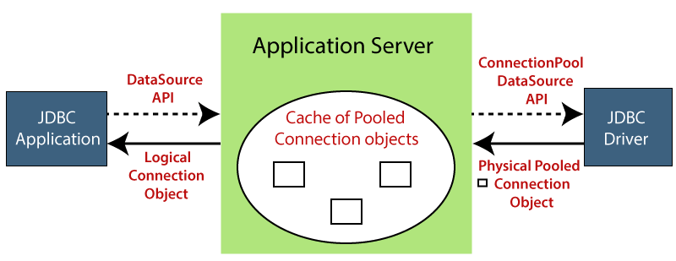
It increases the speed of data access and reduces the number of database connections for an application. It also improves the performance of an application. Connection pool performs the following tasks:
- Manage available connection
- Allocate new connection
- Close connection
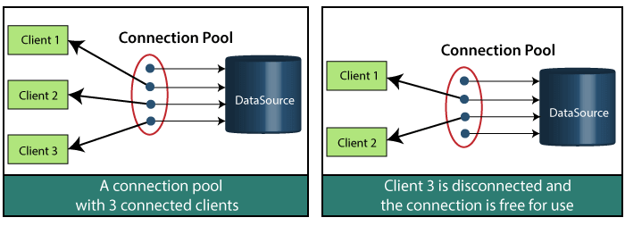
In the above figure, there are clients, a connection pool (that has four available connections), and a DataSource.
In the first figure, there are three clients connected with different connections, and a connection is available. In the second figure, Client 3 has disconnected, and that connection is available.
When a client completes his work, it releases the connection, and that connection is available for other clients.

HikariCP
The default connection pool in Spring Boot 2 is HikariCP. It provides enterprise-ready features and better performance. HikariCP is a JDBC DataSource implementation that provides a connection pooling mechanism.
- If the HikariCP is present on the classpath, the Spring Boot automatically configures it.
- If the HikariCP is not found on the classpath, Spring Boot looks for the Tomcat JDBC Connection Pool. If it is on the classpath Spring Boot, pick it up.
- If both the above options are not available, Spring Boot chooses Apache Commons DBCP2 as the JDBC connection pool.
We can also configure a connection pool manually, if we do not want to use the default connection pool. Suppose, we want to use Tomcat JDBC connection pool instead of HikariCP. We will exclude HikariCP dependency and add the tomcat-jdbc dependency in the pom.xml file, as shown below.
- <dependency>
- <groupId>org.springframework.boot</groupId>
- <artifactId>spring-boot-starter-data-jpa</ artifactId >
- <exclusions>
- <exclusion>
- <groupId>com.zaxxer</groupId>
- <artifactId>HikariCP</ artifactId >
- </exclusion>
- </exclusions>
- </dependency>
- <dependency>
- <groupId>org.apache.tomcat</groupId>
- <artifactId>tomcat-jdbc</artifactId>
- <version>9.0.10</version>
- </dependency>
- <dependency>
- <groupId>com.h2database</groupId>
- <artifactId>h2</artifactId>
- <version>1.4.9</version>
- <socpe>runtime</scoope>
- </dependency>
The above approach allows us to use Tomcat connection pool without having to write a @Configuration class and programmatically define a DataSource bean.
On the other hand, we can also skip the connection pool scanning algorithm that Spring Boot uses. We can explicitly specify a connection pooling datasource by adding the property spring.datasource.type in the application.properties file.

- Spring.datasource.type=org.apache.tomcat.jdbc.pool.DataSource
We have set up the Tomcat connection pool. Now, we will add some properties in application.properties that optimize its performance and suiting some specific requirements.
- spring.datasource.tomcat.initial-size=20
- spring.datasource.tomcat.max-wait=25000
- spring.datasource.tomcat.max-active=70
- spring.datasource.tomcat.max-idle=20
- spring.datasource.tomcat.min-idle=9
- spring.datasource.tomcat.default-auto-commit=true
If we want to connect to MySQL database, we need to include the JDBC driver in the application's classpath:
- <!-- MySQL JDBC driver -->
- <dependency>
- <groupId>mysql</groupId>
- <artifactId>mysql-connector-java</artifactId>
- </dependency>
After that, define the datasoure properties in application.properties file.
Use the following properties if you are using MySQL database:
- spring.datasource.url=jdbc:mysql://192.168.1.4:3306/test
- spring.datasource.username=javatpoint
- spring.datasource.password=password
Use the following properties if you are using Oracle database:
- spring.datasource.url=jdbc:oracle:thin:@localhost:1521:orcl
- spring.datasource.username=system
- spring.datasource.password=Password123

Note: Spring Boot 2 uses HikariCP as the database connection pool, by default. If the HikariCP is not present in the classpath, Spring Boot choose tomcat pooling by default.

Why should we use Spring Boot JDBC?
The functionality of Spring JDBC and Spring Boot JDBC is the same except the implementations. There are following advantages of Spring Boot JBDC over Spring JDBC:

Spring Boot JDBC | Spring JDBC
There is only a spring-boot-starter-jdbc dependency is required. | In Spring JDBC, multiple dependencies need to be configured like spring-jdbc and spring-context.
It automatically configures Datasource bean, if not maintain explicitly. If we do not want to use the bean, we can set a property spring.datasource.initialize to false. | In Spring JDBC, it is necessary to create a database bean either using XML or javaconfig.
We do not need to register Template beans because Spring Boot automatically registers beans. | The Template beans such as PlatformTransactionManager, JDBCTemplate, NamedParameterJdbcTemplate must be registered.
Any db initialization scripts stored in .sql file gets executed automatically. | If any db initialization scripts like dropping or creation of tables are created in SQL file, this info needs to be given explicitly in the configuration.

JDBC vs. Hibernate
JDBC | Hibernate
JDBC is a technology. | Hibernate is an ORM framework.
In JDBC, the user is responsible for creating and closing the connections. | In Hibernate, the run time system takes care of creating and closing the connections.
It does not support lazy loading. | It supports lazy loading that offers better performance.
It does not support associations (the connection between two separate classes). | It supports associations.
In the next section, we will learn the connectivity of MySQL in an Spring Boot application.

Spring Boot JDBC Example
Spring Boot provides starter and libraries for connecting to our application with JDBC. Here, we are creating an application which connects with Mysql database. It includes the following steps to create and setup JDBC with Spring Boot.
Create a database
- create database springbootdb
Create a table in to mysql
- create table user(id int UNSIGNED primary key not null auto_increment, name varchar(100), email varchar(100));
Creating a Spring Boot Pproject
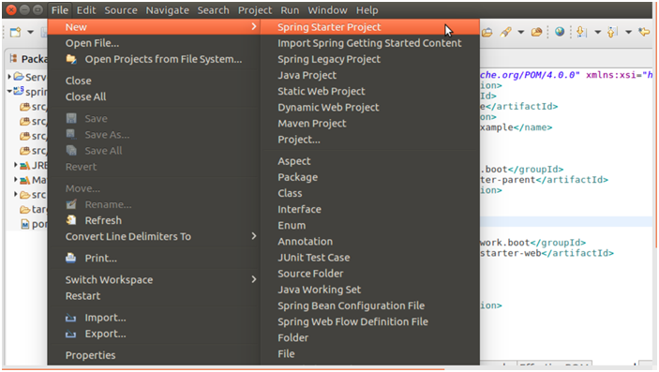
Providing project name and other project related information.
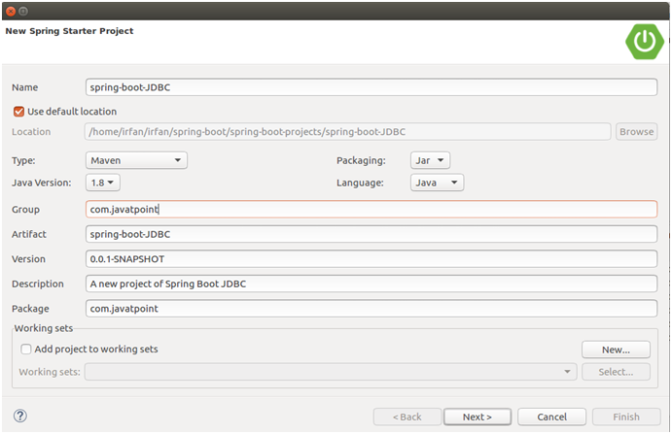
Providing dependencies
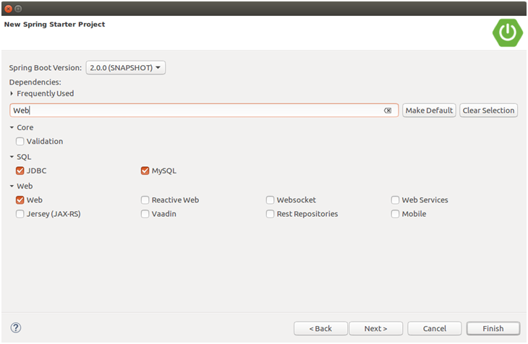
After finishing, create following files in your project.
Configure database into application.properties file.
// application.properties
- spring.datasource.url=jdbc:mysql://localhost:3306/springbootdb
- spring.datasource.username=root
- spring.datasource.password=mysql
- spring.jpa.hibernate.ddl-auto=create-drop
// SpringBootJdbcApplication.java
- package com.javatpoint;
- import org.springframework.boot.SpringApplication;
- import org.springframework.boot.autoconfigure.SpringBootApplication;
- @SpringBootApplication
- public class SpringBootJdbcApplication {
- public static void main(String[] args) {
- SpringApplication.run(SpringBootJdbcApplication.class, args);
- }
- }
Creating a controller to handle HTTP requests.
// SpringBootJdbcController.java
- package com.javatpoint;
- import org.springframework.web.bind.annotation.RequestMapping;
- import org.springframework.beans.factory.annotation.Autowired;
- import org.springframework.jdbc.core.JdbcTemplate;
- import org.springframework.web.bind.annotation.RestController;
- @RestController
- public class SpringBootJdbcController {
- @Autowired
- JdbcTemplate jdbc;
- @RequestMapping("/insert")
- public String index(){
- jdbc.execute("insert into user(name,email)values('javatpoint','java@javatpoint.com')");
- return"data inserted Successfully";
- }
- }

Run the application
Run SpringBootJdbcApplication.java file as Java application.
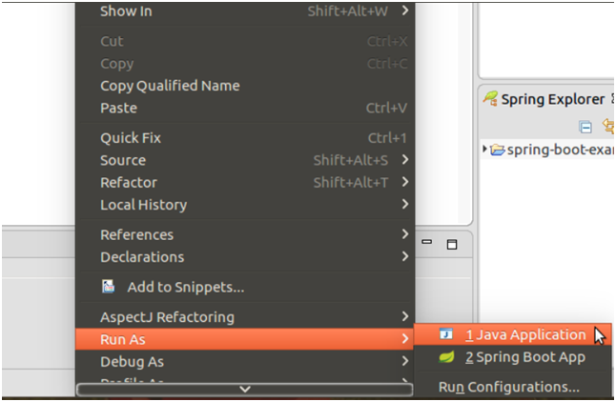
Now, open browser and follow the following URL.
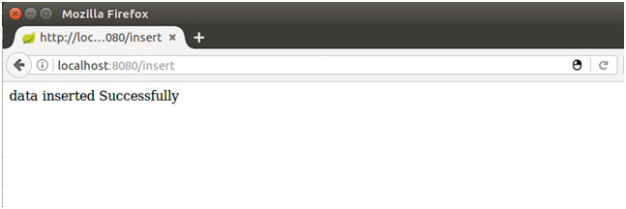
It says data has inserted successfully. let's confirm it by checking mysql table.
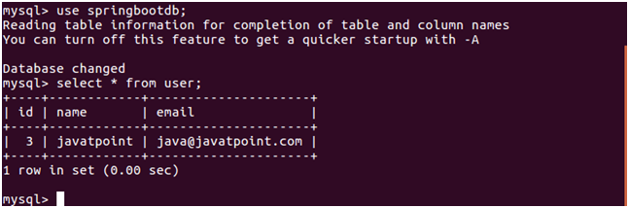
Well, our application is working fine. Now, we can perform other database operations as well.

Spring Boot H2 Database

What is the in-memory database
In-memory database relies on system memory as oppose to disk space for storage of data. Because memory access is faster than disk access. We use the in-memory database when we do not need to persist the data. The in-memory database is an embedded database. The in-memory databases are volatile, by default, and all stored data loss when we restart the application.
The widely used in-memory databases are H2, HSQLDB (HyperSQL Database), and Apache Derby. It creates the configuration automatically.

Persistence vs. In-memory Database
The persistent database persists the data in physical memory. The data will be available even if the database server is bounced. Some popular persistence databases are Oracle, MySQL, Postgres, etc.
In the case of the in-memory database, data store in the system memory. It lost the data when the program is closed. It is helpful for POCs (Proof of Concepts), not for a production application. The widely used in-memory database is H2.

What is the H2 Database
H2 is an embedded, open-source, and in-memory database. It is a relational database management system written in Java. It is a client/server application. It is generally used in unit testing. It stores data in memory, not persist the data on disk.
Advantages
- Zero configuration
- It is easy to use.
- It is lightweight and fast.
- It provides simple Configuration to switch between a real database and in-memory database.
- It supports standard SQL and JDBC API.
- It provides a web console to maintain in the database.

Configure H2 Database
If we want to use H2 database in an application we need to add the following dependency in pom.xml file:
- <dependency>
- <groupId>com.h2database</groupId>
- <artifactId>h2</artifactId>
- <scope>runtime</scope>
- </dependency>
After adding the dependency, we need to configure data source URL, driver class name, username, and password of H2 database. Spring Boot provide an easy way to configure these properties in application.properties file.
- spring.datasource.url=jdbc:h2:mem:testdb
- spring.datasource.driverClassName=org.h2.Driver
- spring.datasource.username=sa
- spring.datasource.password=
- spring.jpa.database-platform=org.hibernate.dialect.H2Dialect
In the spring.datasource.url property, mem is the name of an in-memory database and testdb is the name of schema that H2 provides, by default. We can also define our own schema and database. The default username is sa and the blank password denotes an empty password. If we want to change the username and password, we can override these values.

Persist the data in H2 Database
If we want to persist the data in the H2 database, we should store data in a file. To achieve the same, we need to change the datasource URL property.
- #persist the data
- spring.datasource.url=jdbc:h2:file:/data/sampledata
- spring.datasource.url=jdbc:h2:C:/data/sampledata
In the above property, the sampledata is a file name.

Create Schema and Populate Data
We can define schema by creating a SQL file in the resource folder (src/main/resource).
schema.sql
- DROP TABLE IF EXISTS CITY;
- CREATE TABLE CITY (
- City_code INT AUTO_INCREMENT PRIMARY KEY,
- city_name VARCHAR(50) NOT NULL,
- city_pincode INT(8) NOT NULL
- );
We can populate data in the table by creating a SQL file in the resource folder (src/main/resource).
data.sql
- INSERT INTO CITY VALUES (11, 'Delhi', 110001);
- INSERT INTO CITY VALUES (12, 'Kanpur', 208001);
- INSERT INTO CITY VALUES (13, 'Lucknow', 226001);
Spring Boot automatically picks up the data.sql file and run it against the H2 database during the application startup.

H2 Console
By default, the console view of the H2 database is disabled. Before accessing the H2 database, we must enable it by using the following property.
- #enabling the H2 console
- spring.h2.console.enabled=true
Once we have enabled the H2 console, now we can access the H2 console in the browser by invoking the URL http://localhost:8080/h2-console. The following figure shows the console view of the H2 database.
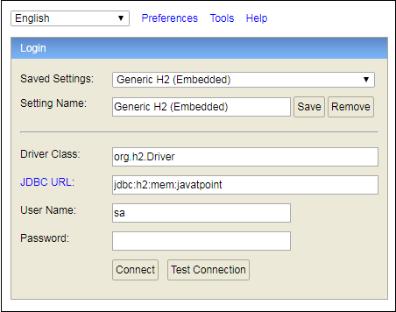
In the above screenshot, we have defined our own database named javatpoint.

Spring Boot H2 Example
Let's set up a Spring Boot application with the H2 database.
Step 1: Open Spring Initializr http://start.spring.io.
Step 2: Select the Spring Boot version 2.3.0.M1.
Step 2: Provide the Group name. We have provided com.javatpoint.
Step 3: Provide the Artifact Id. We have provided spring-boot-h2-database-example.
Step 5: Add the dependencies Spring Web, Spring Data JPA, and H2 Database.
Step 6: Click on the Generate button. When we click on the Generate button, it wraps the project in a Jar file and downloads it to the local system.
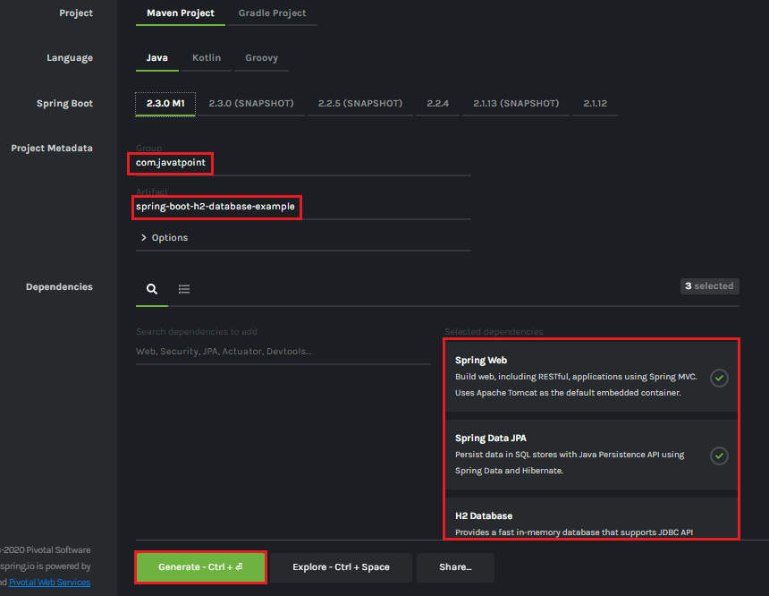
Step 7: Extract the Jar file and paste it into the STS workspace.
Step 8: Import the project folder into STS.
File -> Import -> Existing Maven Projects -> Browse -> Select the folder spring-boot-h2-database-example -> Finish
It takes some time to import.
Step 9: Create a package with the name com.javatpoint.model in the folder src/main/java.
Step 10: Create a model class in the package com.javatpoint.model. We have created model class with the name Student. In the Books class, we have done the following:
- Define four variable id, age, name, and
- Generate Getters and Setters.
Right-click on the file -> Source -> Generate Getters and Setters.
- Mark the class as Entity by using the annotation @Entity.
- Mark the class as Table name by using the annotation @Table.
- Define each variable as Column by using the annotation @Column.
Student.java
- package com.javatpoint.model;
- import javax.persistence.Column;
- import javax.persistence.Entity;
- import javax.persistence.Id;
- import javax.persistence.Table;
- //mark class as an Entity
- @Entity
- //defining class name as Table name
- @Table
- public class Student
- {
- //mark id as primary key
- @Id
- //defining id as column name
- @Column
- private int id;
- //defining name as column name
- @Column
- private String name;
- //defining age as column name
- @Column
- private int age;
- //defining email as column name
- @Column
- private String email;
- public int getId()
- {
- return id;
- }
- public void setId(int id)
- {
- this.id = id;
- }
- public String getName()
- {
- return name;
- }
- public void setName(String name)
- {
- this.name = name;
- }
- public int getAge()
- {
- return age;
- }
- public void setAge(int age)
- {
- this.age = age;
- }
- public String getEmail()
- {
- return email;
- }
- public void setEmail(String email)
- {
- this.email = email;
- }
- }
Step 11: Create a package with the name com.javatpoint.controller in the folder src/main/java.
Step 12: Create a Controller class in the package com.javatpoint.controller. We have created controller class with the name StudentController. In the StudentController class, we have done the following:
- Mark the class as RestController by using the annotation @RestController.
- Autowire the StudentService class by using the annotation @Autowired.
- Define the following methods:
  - getAllStudent(): It returns a List of all Students.
  - getStudent(): It returns a student detail that we have specified in the path variable. We have passed id as an argument by using the annotation @PathVariable. The annotation indicates that a method parameter should be bound to a URI template variable.
  - deleteStudent(): It deletes a specific student that we have specified in the path variable.
  - saveStudent(): It saves the student detail. The annotation @RequestBody indicates that a method parameter should be bound to the body of the web request.
StudentController.java
- package com.javatpoint.controller;
- import java.util.List;
- import org.springframework.beans.factory.annotation.Autowired;
- import org.springframework.web.bind.annotation.DeleteMapping;
- import org.springframework.web.bind.annotation.GetMapping;
- import org.springframework.web.bind.annotation.PathVariable;
- import org.springframework.web.bind.annotation.PostMapping;
- import org.springframework.web.bind.annotation.RequestBody;
- import org.springframework.web.bind.annotation.RestController;
- import com.javatpoint.model.Student;
- import com.javatpoint.service.StudentService;
- //creating RestController
- @RestController
- public class StudentController
- {
- //autowired the StudentService class
- @Autowired
- StudentService studentService;
- //creating a get mapping that retrieves all the students detail from the database
- @GetMapping("/student")
- private List<Student> getAllStudent()
- {
- return studentService.getAllStudent();
- }
- //creating a get mapping that retrieves the detail of a specific student
- @GetMapping("/student/{id}")
- private Student getStudent(@PathVariable("id") int id)
- {
- return studentService.getStudentById(id);
- }
- //creating a delete mapping that deletes a specific student
- @DeleteMapping("/student/{id}")
- private void deleteStudent(@PathVariable("id") int id)
- {
- studentService.delete(id);
- }
- //creating post mapping that post the student detail in the database
- @PostMapping("/student")
- private int saveStudent(@RequestBody Student student)
- {
- studentService.saveOrUpdate(student);
- return student.getId();
- }
- }
Step 13: Create a package with the name com.javatpoint.service in the folder src/main/java.
Step 14: Create a Service class. We have created a service class with the name StudentService in the package com.javatpoint.service.
StudentService.java
- package com.javatpoint.service;
- import java.util.ArrayList;
- import java.util.List;
- import org.springframework.beans.factory.annotation.Autowired;
- import org.springframework.stereotype.Service;
- import com.javatpoint.model.Student;
- import com.javatpoint.repository.StudentRepository;
- @Service
- public class StudentService
- {
- @Autowired
- StudentRepository studentRepository;
- //getting all student records
- public List<Student> getAllStudent()
- {
- List<Student> students = new ArrayList<Student>();
- studentRepository.findAll().forEach(student -> students.add(student));
- return students;
- }
- //getting a specific record
- public Student getStudentById(int id)
- {
- return studentRepository.findById(id).get();
- }
- public void saveOrUpdate(Student student)
- {
- studentRepository.save(student);
- }
- //deleting a specific record
- public void delete(int id)
- {
- studentRepository.deleteById(id);
- }
- }
Step 15: Create a package with the name com.javatpoint.repository in the folder src/main/java.
Step 16: Create a Repository interface. We have created a repository interface with the name StudentRepository in the package com.javatpoint.repository. It extends the Crud Repository interface.
StudentRepository.java
- package com.javatpoint.repository;
- import org.springframework.data.repository.CrudRepository;
- import com.javatpoint.model.Student;
- public interface StudentRepository extends CrudRepository<Student, Integer>
- {
- }
Now we will configure the datasource URL, driver class name, username, and password, in the application.properties file.
Step 17: Open the application.properties file and configure the following properties.
application.properties
- spring.datasource.url=jdbc:h2:mem:javatpoint
- spring.datasource.driverClassName=org.h2.Driver
- spring.datasource.username=sa
- spring.datasource.password=
- spring.jpa.database-platform=org.hibernate.dialect.H2Dialect
- #enabling the H2 console
- spring.h2.console.enabled=true

Note: Do not forget to enable the H2 console.
After creating all the classes and packages, the project directory looks like the following.
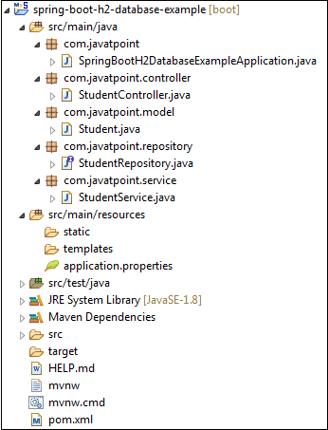
Now we will run the application.
Step 18: Open SpringBootH2DatabaseExampleApplication.java file and run it as Java Application.
SpringBootH2DatabaseExampleApplication.java
- package com.javatpoint;
- import org.springframework.boot.SpringApplication;
- import org.springframework.boot.autoconfigure.SpringBootApplication;
- @SpringBootApplication
- public class SpringBootH2DatabaseExampleApplication
- {
- public static void main(String[] args)
- {
- SpringApplication.run(SpringBootH2DatabaseExampleApplication.class, args);
- }
- }
In the next step, we will use rest client Postman for sending the POST and GET request. If the Postman is not installed in your system, follow the steps below:
- Download the Postman from https://www.getpostman.com/downloads/ or add Google Chrome extension in the browser https://bit.ly/1HCOCwF.
- Launch the Postman and Signup. Create a user name. We have created user with the name javatpointand clicked on Submit
Step 19: Open the Postman and do the following:
- Select the POST
- Invoke the URL http://localhost:8080/student.
- Select the Body
- Select he Content-Type JSON (application/json).
- Insert the data. We have inserted the following data in the body:
- {
- "id": "001",
- "age": "23",
- "name": "Amit",
- "email": "amit@yahoo.co.in"
- }
- Click on the Send
When the request is successfully executed, it shows the Status:200 OK. It means the record has been successfully inserted in the database.
Similarly, we have inserted the following data.
- {
- "id": "002",
- "age": "24",
- "name": "Vadik",
- "email": "vadik@yahoo.co.in"
- }
- {
- "id": "003",
- "age": "21",
- "name": "Prateek",
- "email": "prateek@yahoo.co.in"
- }
- {
- "id": "004",
- "age": "25",
- "name": "Harsh",
- "email": "harsh@yahoo.co.in"
- }
- {
- "id": "005",
- "age": "24",
- "name": "Swarit",
- "email": "Swarit@yahoo.co.in"
- }
Let's access the H2 console to see the data.
Step 20: Open the browser and invoke the URL http://localhost:8080/h2-console. Click on the Connect button, as shown below.
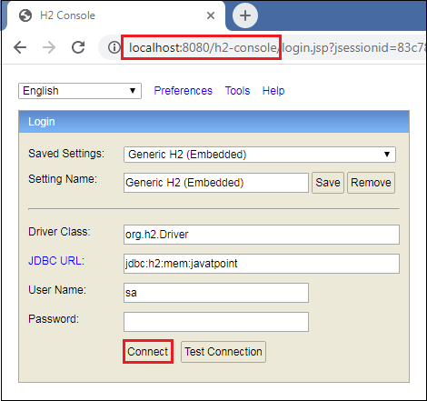
After clicking on the Connect button, we see the Student table in the database, as shown below.
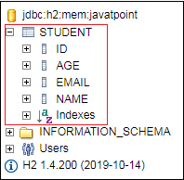
Step 21: Click on the Student table and then click on the Run button. The table shows the data that we have inserted in the body.
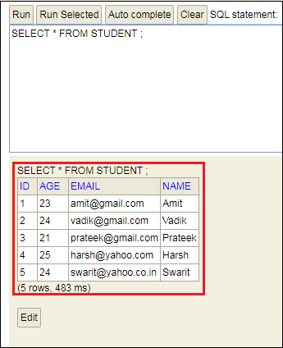
Step 22: Open the Postman and send a GET request. It returns the data that we have inserted in the database.
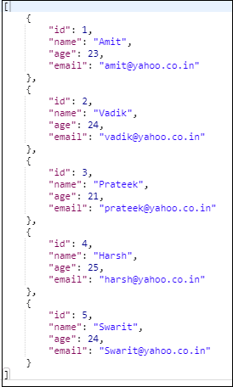
Let's send a GET request with the URL http://localhost:8080/student/{id}. We have invoked the URL http://localhost:8080/student/3. It returns the detail of the student whose id is 3.
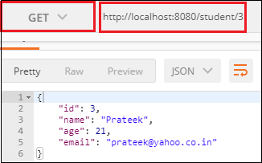
Similarly, we can also send a DELETE request. Suppose we want to delete a student record whose id is 2.
To delete a student record, send a DELETE request with the URL http://localhost:8080/student/2. We see that the student whose id is 2 has been deleted from the database.
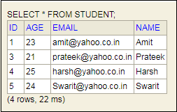

Spring Boot CRUD Operations

What is the CRUD operation?
The CRUD stands for Create, Read/Retrieve, Update, and Delete. These are the four basic functions of the persistence storage.
The CRUD operation can be defined as user interface conventions that allow view, search, and modify information through computer-based forms and reports. CRUD is data-oriented and the standardized use of HTTP action verbs. HTTP has a few important verbs.
- POST: Creates a new resource
- GET: Reads a resource
- PUT: Updates an existing resource
- DELETE: Deletes a resource
Within a database, each of these operations maps directly to a series of commands. However, their relationship with a RESTful API is slightly more complex.

Standard CRUD Operation
- CREATE Operation: It performs the INSERT statement to create a new record.
- READ Operation: It reads table records based on the input parameter.
- UPDATE Operation: It executes an update statement on the table. It is based on the input parameter.
- DELETE Operation: It deletes a specified row in the table. It is also based on the input parameter.

How CRUD Operations Works
CRUD operations are at the foundation of the most dynamic websites. Therefore, we should differentiate CRUD from the HTTP action verbs.
Suppose, if we want to create a new record, we should use HTTP action verb POST. To update a record, we should use the PUT verb. Similarly, if we want to delete a record, we should use the DELETE verb. Through CRUD operations, users and administrators have the right to retrieve, create, edit, and delete records online.
We have many options for executing CRUD operations. One of the most efficient choices is to create a set of stored procedures in SQL to execute operations.
The CRUD operations refer to all major functions that are implemented in relational database applications. Each letter of the CRUD can map to a SQL statement and HTTP methods.
Operation | SQL | HTTP verbs | RESTful Web Service
Create | INSERT | PUT/POST | POST
Read | SELECT | GET | GET
Update | UPDATE | PUT/POST/PATCH | PUT
Delete | DELETE | DELETE | DELETE

Spring Boot CrudRepository
Spring Boot provides an interface called CrudRepository that contains methods for CRUD operations. It is defined in the package org.springframework.data.repository. It extends the Spring Data Repository interface. It provides generic Crud operation on a repository. If we want to use CrudRepository in an application, we have to create an interface and extend the CrudRepository.
Syntax
- public interface CrudRepository<T,ID> extends Repository<T,ID>
where,
- T is the domain type that repository manages.
- ID is the type of the id of the entity that repository manages.
For example:
- public interface StudentRepository extends CrudRepository<Student, Integer>
- {
- }
In the above example, we have created an interface named StudentRepository that extends CrudRepository. Where Student is the repository to manage, and Integer is the type of Id that is defined in the Student repository.

Spring Boot JpaRepository
JpaRepository provides JPA related methods such as flushing, persistence context, and deletes a record in a batch. It is defined in the package org.springframework.data.jpa.repository. JpaRepository extends both CrudRepository and PagingAndSortingRepository.
For example:
- public interface BookDAO extends JpaRepository
- {
- }
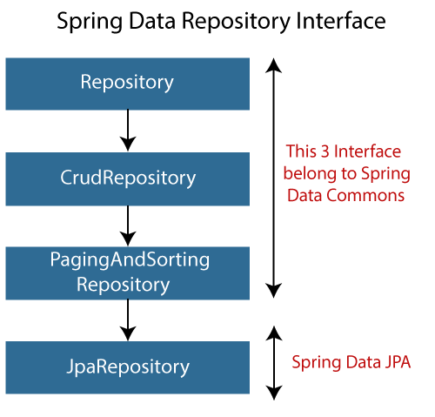

Why should we use these interfaces?
- The interfaces allow Spring to find the repository interface and create proxy objects for that.
- It provides methods that allow us to perform some common operations. We can also define custom methods as well.

CrudRepository vs. JpaRepository
CrudRepository | JpaRepository
CrudRepository does not provide any method for pagination and sorting. | JpaRepository extends PagingAndSortingRepository. It provides all the methods for implementing the pagination.
It works as a marker interface. | JpaRepository extends both CrudRepository and PagingAndSortingRepository.
It provides CRUD function only. For example findById(), findAll(), etc. | It provides some extra methods along with the method of PagingAndSortingRepository and CrudRepository. For example, flush(), deleteInBatch().
It is used when we do not need the functions provided by JpaRepository and PagingAndSortingRepository. | It is used when we want to implement pagination and sorting functionality in an application.

Spring Boot CRUD Operation Example
Let's set up a Spring Boot application and perform CRUD operation.
Step 1: Open Spring Initializr http://start.spring.io.
Step 2: Select the Spring Boot version 2.3.0.M1.
Step 2: Provide the Group name. We have provided com.javatpoint.
Step 3: Provide the Artifact Id. We have provided spring-boot-crud-operation.
Step 5: Add the dependencies Spring Web, Spring Data JPA, and H2 Database.
Step 6: Click on the Generate button. When we click on the Generate button, it wraps the specifications in a Jar file and downloads it to the local system.
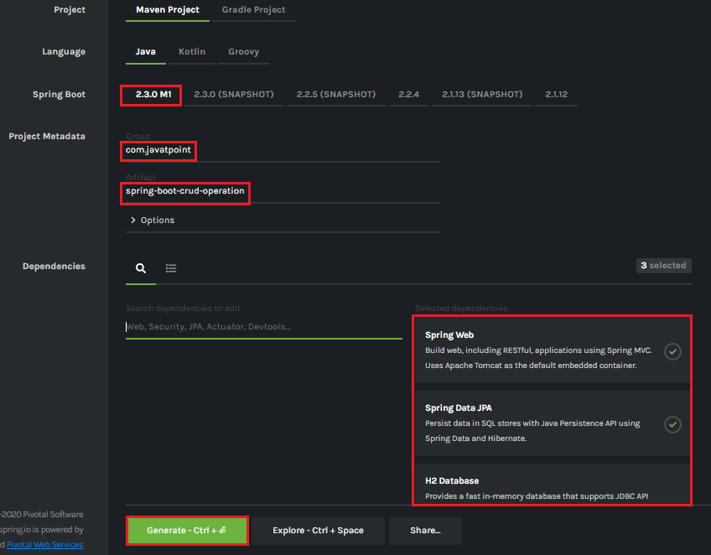
Step 7: Extract the Jar file and paste it into the STS workspace.
Step 8: Import the project folder into STS.
File -> Import -> Existing Maven Projects -> Browse -> Select the folder spring-boot-crud-operation -> Finish
It takes some time to import.
Step 9: Create a package with the name com.javatpoint.model in the folder src/main/java.
Step 10: Create a model class in the package com.javatpoint.model. We have created a model class with the name Books. In the Books class, we have done the following:
- Define four variable bookid, bookname, author, and
- Generate Getters and Setters.
Right-click on the file -> Source -> Generate Getters and Setters.
- Mark the class as an Entity by using the annotation @Entity.
- Mark the class as Table name by using the annotation @Table.
- Define each variable as Column by using the annotation @Column.
Books.java
- package com.javatpoint.model;
- import javax.persistence.Column;
- import javax.persistence.Entity;
- import javax.persistence.Id;
- import javax.persistence.Table;
- //mark class as an Entity
- @Entity
- //defining class name as Table name
- @Table
- public class Books
- {
- //Defining book id as primary key
- @Id
- @Column
- private int bookid;
- @Column
- private String bookname;
- @Column
- private String author;
- @Column
- private int price;
- public int getBookid()
- {
- return bookid;
- }
- public void setBookid(int bookid)
- {
- this.bookid = bookid;
- }
- public String getBookname()
- {
- return bookname;
- }
- public void setBookname(String bookname)
- {
- this.bookname = bookname;
- }
- public String getAuthor()
- {
- return author;
- }
- public void setAuthor(String author)
- {
- this.author = author;
- }
- public int getPrice()
- {
- return price;
- }
- public void setPrice(int price)
- {
- this.price = price;
- }
- }
Step 11: Create a package with the name com.javatpoint.controller in the folder src/main/java.
Step 12: Create a Controller class in the package com.javatpoint.controller. We have created a controller class with the name BooksController. In the BooksController class, we have done the following:
- Mark the class as RestController by using the annotation @RestController.
- Autowire the BooksService class by using the annotation @Autowired.
- Define the following methods:
  - getAllBooks(): It returns a List of all Books.
  - getBooks(): It returns a book detail that we have specified in the path variable. We have passed bookid as an argument by using the annotation @PathVariable. The annotation indicates that a method parameter should be bound to a URI template variable.
  - deleteBook(): It deletes a specific book that we have specified in the path variable.
  - saveBook(): It saves the book detail. The annotation @RequestBody indicates that a method parameter should be bound to the body of the web request.
  - update(): The method updates a record. We must specify the record in the body, which we want to update. To achieve the same, we have used the annotation @RequestBody.
BooksController.java
- package com.javatpoint.controller;
- import java.util.List;
- import org.springframework.beans.factory.annotation.Autowired;
- import org.springframework.web.bind.annotation.DeleteMapping;
- import org.springframework.web.bind.annotation.GetMapping;
- import org.springframework.web.bind.annotation.PathVariable;
- import org.springframework.web.bind.annotation.PostMapping;
- import org.springframework.web.bind.annotation.PutMapping;
- import org.springframework.web.bind.annotation.RequestBody;
- import org.springframework.web.bind.annotation.RestController;
- import com.javatpoint.model.Books;
- import com.javatpoint.service.BooksService;
- //mark class as Controller
- @RestController
- public class BooksController
- {
- //autowire the BooksService class
- @Autowired
- BooksService booksService;
- //creating a get mapping that retrieves all the books detail from the database
- @GetMapping("/book")
- private List<Books> getAllBooks()
- {
- return booksService.getAllBooks();
- }
- //creating a get mapping that retrieves the detail of a specific book
- @GetMapping("/book/{bookid}")
- private Books getBooks(@PathVariable("bookid") int bookid)
- {
- return booksService.getBooksById(bookid);
- }
- //creating a delete mapping that deletes a specified book
- @DeleteMapping("/book/{bookid}")
- private void deleteBook(@PathVariable("bookid") int bookid)
- {
- booksService.delete(bookid);
- }
- //creating post mapping that post the book detail in the database
- @PostMapping("/books")
- private int saveBook(@RequestBody Books books)
- {
- booksService.saveOrUpdate(books);
- return books.getBookid();
- }
- //creating put mapping that updates the book detail
- @PutMapping("/books")
- private Books update(@RequestBody Books books)
- {
- booksService.saveOrUpdate(books);
- return books;
- }
- }
Step 13: Create a package with the name com.javatpoint.service in the folder src/main/java.
Step 14: Create a Service class. We have created a service class with the name BooksService in the package com.javatpoint.service.
BooksService.java
- package com.javatpoint.service;
- import java.util.ArrayList;
- import java.util.List;
- import org.springframework.beans.factory.annotation.Autowired;
- import org.springframework.stereotype.Service;
- import com.javatpoint.model.Books;
- import com.javatpoint.repository.BooksRepository;
- //defining the business logic
- @Service
- public class BooksService
- {
- @Autowired
- BooksRepository booksRepository;
- //getting all books record by using the method findaAll() of CrudRepository
- public List<Books> getAllBooks()
- {
- List<Books> books = new ArrayList<Books>();
- booksRepository.findAll().forEach(books1 -> books.add(books1));
- return books;
- }
- //getting a specific record by using the method findById() of CrudRepository
- public Books getBooksById(int id)
- {
- return booksRepository.findById(id).get();
- }
- //saving a specific record by using the method save() of CrudRepository
- public void saveOrUpdate(Books books)
- {
- booksRepository.save(books);
- }
- //deleting a specific record by using the method deleteById() of CrudRepository
- public void delete(int id)
- {
- booksRepository.deleteById(id);
- }
- //updating a record
- public void update(Books books, int bookid)
- {
- booksRepository.save(books);
- }
- }
Step 15: Create a package with the name com.javatpoint.repository in the folder src/main/java.
Step 16: Create a Repository interface. We have created a repository interface with the name BooksRepository in the package com.javatpoint.repository. It extends the Crud Repository interface.
BooksRepository.java
- package com.javatpoint.repository;
- import org.springframework.data.repository.CrudRepository;
- import com.javatpoint.model.Books;
- //repository that extends CrudRepository
- public interface BooksRepository extends CrudRepository<Books, Integer>
- {
- }
Now we will configure the datasource URL, driver class name, username, and password, in the application.properties file.
Step 17: Open the application.properties file and configure the following properties.
application.properties

- spring.datasource.url=jdbc:h2:mem:books_data
- spring.datasource.driverClassName=org.h2.Driver
- spring.datasource.username=sa
- spring.datasource.password=
- spring.jpa.database-platform=org.hibernate.dialect.H2Dialect
- #enabling the H2 console
- spring.h2.console.enabled=true

Note: Do not forget to enable the H2 console.
After creating all the classes and packages, the project directory looks like the following.
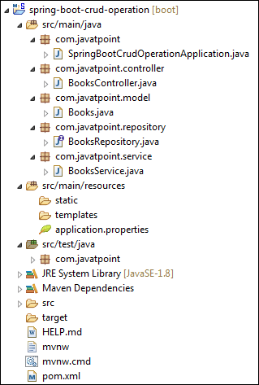
Now we will run the application.
Step 18: Open SpringBootCrudOperationApplication.java file and run it as Java Application.

SpringBootCrudOperationApplication.java
- package com.javatpoint;
- import org.springframework.boot.SpringApplication;
- import org.springframework.boot.autoconfigure.SpringBootApplication;
- @SpringBootApplication
- public class SpringBootCrudOperationApplication
- {
- public static void main(String[] args)
- {
- SpringApplication.run(SpringBootCrudOperationApplication.class, args);
- }
- }

Note: In the next steps we will use rest client Postman. So, ensure that the Postman application is already installed in your system.
Step 19: Open the Postman and do the following:
- Select the POST
- Invoke the URL http://localhost:8080/books.
- Select the Body
- Select he Content-Type JSON (application/json).
- Insert the data. We have inserted the following data in the Body:
- {
- "bookid": "5433",
- "bookname": "Core and Advance Java",
- "author": "R. Nageswara Rao",
- "price": "800"
- }
- Click on the Send
When the request is successfully executed, it shows the Status:200 OK. It means the record has been successfully inserted in the database.
Similarly, we have inserted the following data.
- {
- "bookid": "0982",
- "bookname": "Programming with Java",
- "author": "E. Balagurusamy",
- "price": "350"
- }
- {
- "bookid": "6321",
- "bookname": "Data Structures and Algorithms in Java",
- "author": "Robert Lafore",
- "price": "590"
- }
- {
- "bookid": "5433",
- "bookname": "Effective Java",
- "author": "Joshua Bloch",
- "price": "670"
- }
Let's access the H2 console to see the data.
Step 20: Open the browser and invoke the URL http://localhost:8080/h2-console. Click on the Connect button, as shown below.
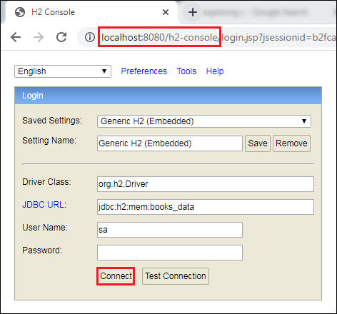
After clicking on the Connect button, we see the Books table in the database, as shown below.
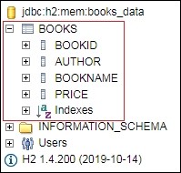
Step 21: Click on the Books table and then click on the Run button. The table shows the data that we have inserted in the body.
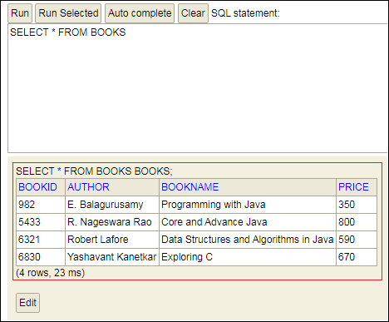
Step 22: Open the Postman and send a GET request with the URL http://localhost:8080/books. It returns the data that we have inserted in the database.
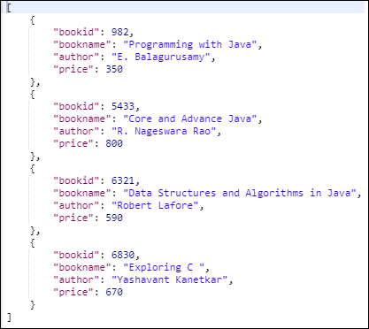
Let's send a GET request with the URL http://localhost:8080/book/{bookid}. We have specified the bookid 6830. It returns the detail of the book whose id is 6830.
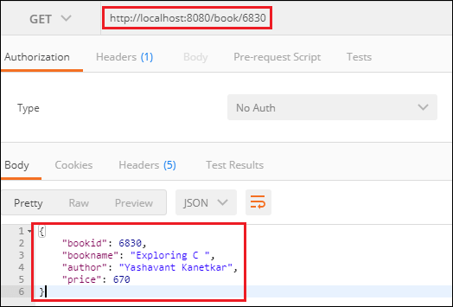
Similarly, we can also send a DELETE request to delete a record. Suppose we want to delete a book record whose id is 5433.
Select the DELETE method and invoke the URL http://localhost:8080/book/5433. Again, execute the Select query in the H2 console. We see that the book whose id is 5433 has been deleted from the database.
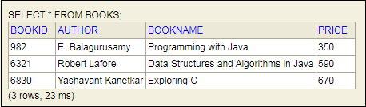
Similarly, we can also update a record by sending a PUT request. Let's update the price of the book whose id is 6321.
- Select the PUT
- In the request body, paste the record which you want to update and make the changes. In our case, we want to update the record of the book whose id is 6321. In the following record, we have changed the price of the book.
- {
- "bookid": "6321",
- "bookname": "Data Structures and Algorithms in Java",
- "author": "Robert Lafore",
- "price": "500"
- }
- Click on the Send
Now, move to the H2 console and see the changes have reflected or not. We see that the price of the book has been changed, as shown below.
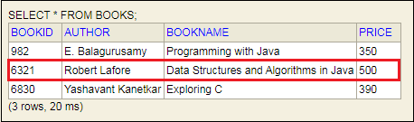

Spring Boot Thymeleaf

What is Thymeleaf?
The Thymeleaf is an open-source Java library that is licensed under the Apache License 2.0. It is a HTML5/XHTML/XML template engine. It is a server-side Java template engine for both web (servlet-based) and non-web (offline) environments. It is perfect for modern-day HTML5 JVM web development. It provides full integration with Spring Framework.
It applies a set of transformations to template files in order to display data or text produced by the application. It is appropriate for serving XHTML/HTML5 in web applications.
The goal of Thymeleaf is to provide a stylish and well-formed way of creating templates. It is based on XML tags and attributes. These XML tags define the execution of predefined logic on the DOM (Document Object Model) instead of explicitly writing that logic as code inside the template. It is a substitute for JSP.
The architecture of Thymeleaf allows the fast processing of templates that depends on the caching of parsed files. It uses the least possible amount of I/O operations during execution.

Why we use Thymeleaf?
JSP is more or less similar to HTML. But it is not completely compatible with HTML like Thymeleaf. We can open and display a Thymeleaf template file normally in the browser while the JSP file does not.
Thymeleaf supports variable expressions (${...}) like Spring EL and executes on model attributes, asterisk expressions (*{...}) execute on the form backing bean, hash expressions (#{...}) are for internationalization, and link expressions (@{...}) rewrite URLs.
Like JSP, Thymeleaf works well for Rich HTML emails.

What kind of templates can the Thymeleaf process?
Thymeleaf can process six types of templates (also known as Template Mode) are as follows:
- XML
- Valid XML
- XHTML
- Valid XHTML
- HTML5
- Legacy HTML5
Except for the Legacy HTML5 mode, all the above modes refer to well-defined XML files. It allows us to process HTML5 files with features such as standalone tags, tag attributes without value, or not written between quotes.
To process files in this specific mode, Thymeleaf performs a transformation that converts files into a well-formed XML file (valid HTML5 file).

Note: In Thymeleaf, validation is available only for XHTML and XML template.
Thymeleaf also allows us to define our own mode by specifying both a way to parse templates in this mode. In this way, whatever that can be modeled as a DOM tree could effectively be processed as a template by Thymeleaf.

The Standard Dialect
Thymeleaf is a template engine framework that allows us to define the DOM nodes. The DOM nodes processed in the templates.
An object that applies logic to a DOM node is called processor. A set of processors, along with some extra artifacts, is called the dialect. The dialect that contains the Thymeleaf's core library is called the Standard Dialect.
If we want to define our own processing logic while taking advantage of the library's advanced features, we can define our own dialects. In a template engine, we can configure several dialects at a time.
The Thymeleaf integration packages (thymeleaf-spring3 and thymeleaf-spring4) define a dialect called SpringStandard Dialect. The Standard Dialect and SpringStandard are almost the same. But the Standard Dialect has some small changes that make better use of some features in Spring Framework.
For example, use Spring Expression Language instead of Thymeleaf's standard ONGL (Object-Graph Navigation Language).
The Standard Dialect can process template in any mode. But it is perfect for web-oriented template modes (HTML5 and XHTML). It supports and validates the following XHTML specifications:
- XHTML 1.0 Transitional
- XHTML 1.0 Strict
- XHTML 1.0 Frameset
- XHTML 1.1.
Standard Dialect processor is the attribute processor that allows browsers to display HTML5/XHTML template files before being processed. It is because they ignore the additional attributes.
For example, when a JSP file uses tag library, it includes a fragment of code not displayable by a browser like:
- <form:inputText name="student.Name" value="${student.name}" />
The Thymeleaf Standard Dialect allows us to achieve the same functionality with the following code.
- <input type="text" name=" student Name" value="Thomas" th:value="${student.name}" />
The above code also allows us to define a value attribute in it (Thomas). The value will be displayed when the prototype is opened in the browser. The attribute will be substituted by the value resulting from the evaluation of ${student.name} during the Thymeleaf processing of the template.
It allows a designer and developer to work on the same template file that reduces the efforts required to transform a static prototype into a working template file. It is known as Natural Templating.

Thymeleaf Features
- It works on both web and non-web environments.
- Java template engine for HTML5/ XML/ XHTML.
- Its high-performance parsed template cache reduces I/O to the minimum.
- It can be used as a template engine framework if required.
- It supports several template modes: XML, XHTML, and HTML5.
- It allows developers to extend and create custom dialect.
- It is based on modular features sets called dialects.
- It supports internationalization.

Thymeleaf Implementation
We can implement Thymeleaf template engine by adding spring-boot-starter-thymeleaf dependency in our application's pom.xml file. Spring Boot configures template engine to read template file from /resource/templates.
- <dependency>
- <groupId>org.springframework.boot</groupId>
- <artifactId>spring-boot-starter-thymeleaf</artifactId>
- </dependency>

Spring Boot Thymeleaf Example
Let's create a Spring Boot application and implement Thymeleaf template.
Step 1: Open Spring Initializr http://start.spring.io.
Step 2: Select the Spring Boot version 2.3.0.M1.
Step 2: Provide the Group name. We have provided com.javatpoint.
Step 3: Provide the Artifact Id. We have provided spring-boot-thymeleaf-view-example.
Step 5: Add the dependencies Spring Web and Thymeleaf.
Step 6: Click on the Generate button. When we click on the Generate button, it wraps the specifications in a Jar file and downloads it to the local system.
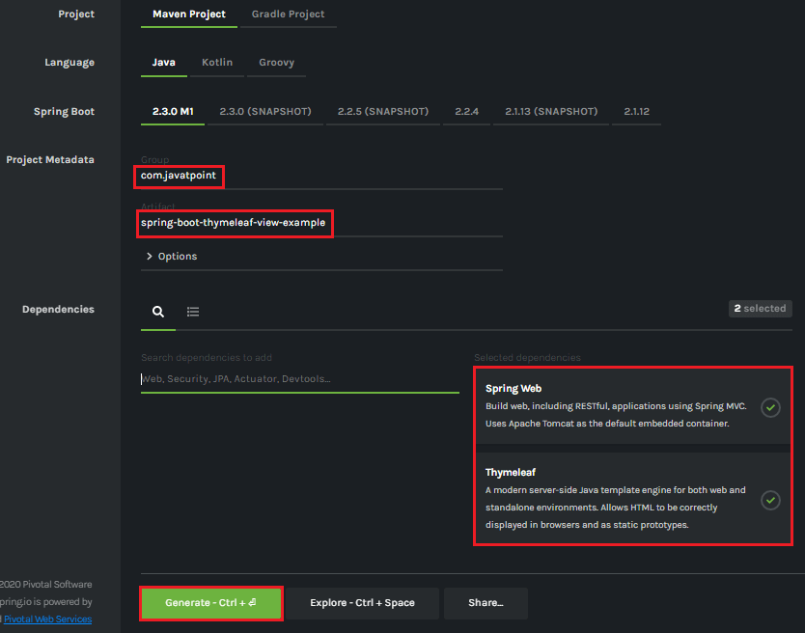
Step 7: Extract the Jar file and paste it into the STS workspace.
Step 8: Import the project folder in STS.
File -> Import -> Existing Maven Projects -> Browse -> Select the folder spring-boot-thymeleaf-view-example -> Finish
It takes some time to import.
Step 9: Create a model class in the package com.javatpoint. We have created a model class with the name User.
In this class, we have defined two variables name and email and generate Getters and Setters.
User.java
- package com.javatpoint;
- public class User
- {
- String name;
- String email;
- public String getName()
- {
- return name;
- }
- public void setName(String name)
- {
- this.name = name;
- }
- public String getEmail()
- {
- return email;
- }
- public void setEmail(String email)
- {
- this.email = email;
- }
- }
Step 10: Create a controller class. We have created a controller class with the name DemoController.
DemoController.java
- package com.javatpoint;
- import org.springframework.web.bind.annotation.ModelAttribute;
- import org.springframework.web.bind.annotation.RequestMapping;
- import org.springframework.web.bind.annotation.RequestMethod;
- import org.springframework.web.servlet.ModelAndView;
- import org.springframework.stereotype.Controller;
- @Controller
- public class DemoController
- {
- @RequestMapping("/")
- public String index()
- {
- return"index";
- }
- @RequestMapping(value="/save", method=RequestMethod.POST)
- public ModelAndView save(@ModelAttribute User user)
- {
- ModelAndView modelAndView = new ModelAndView();
- modelAndView.setViewName("user-data");
- modelAndView.addObject("user", user);
- return modelAndView;
- }
- }
In the next step, we will create the Thymeleaf templates.
Step 11: Inside the templates (src/main/resources/templates) folder of the project create a Thymeleaf template with the name user-data.
Right-click on the templates folder -> New -> Other -> HTML File -> Next -> Provide the File name -> Finish

Note: Do not forget to implement the following in the template file.
- <html lang="en" xmlns:th="http://www.thymeleaf.org">
user-data.html
- <html xmlns:th="https://thymeleaf.org">
- <table>
- <tr>
- <td><h4>User Name: </h4></td>
- <td><h4 th:text="${user.name}"></h4></td>
- </tr>
- <tr>
- <td><h4>Email ID: </h4></td>
- <td><h4 th:text="${user.email}"></h4></td>
- </tr>
- </table>
- </html>
Step 12: Similarly, create an HTML file in the folder templates. We have created an HTML file with the name index.
index.html
- <html lang="en">
- <head>
- <title>Index Page</title>
- </head>
- <body>
- <form action="save" method="post">
- <table>
- <tr>
- <td><label for="user-name">User Name</label></td>
- <td><input type="text" name="name"></input></td>
- </tr>
- <tr>
- <td><label for="email">Email</label></td>
- <td><input type="text" name="email"></input></td>
- </tr>
- <tr>
- <td></td>
- <td><input type="submit" value="Submit"></input></td>
- </tr>
- </table>
- </form>
- </body>
- </html>
Step 13: Open the application.properties file and add the following properties in it.
application.properties
- spring.thymeleaf.cache=false
- spring.thymeleaf.suffix: .html
After creating all the files, folders, and packages, the project directory looks like the following:
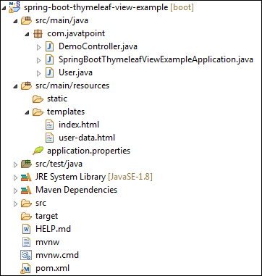
Let's run the application.
Step 14: Open the SpringBootThymeleafViewExampleApplication.java file and run it as Java Application.
SpringBootThymeleafViewExampleApplication.java
- package com.javatpoint;
- import org.springframework.boot.SpringApplication;
- import org.springframework.boot.autoconfigure.SpringBootApplication;
- @SpringBootApplication
- public class SpringBootThymeleafViewExampleApplication
- {
- public static void main(String[] args)
- {
- SpringApplication.run(SpringBootThymeleafViewExampleApplication.class, args);
- }
- }
Step 15: Now, open the browser and invoke the URL http://localhost:8080. It shows the output, as shown below.
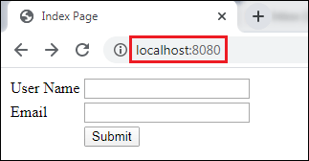
Provide the User Name and Email and click on the Submit button.
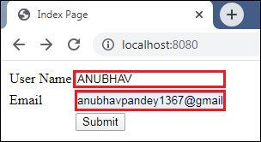
After clicking on the Submit button, the URL changes to http://localhost:8080/save and shows the show the user-data, as shown below.
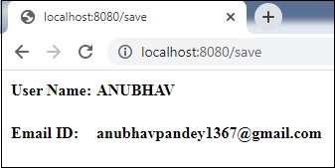
In this section, we have discussed the Thymeleaf view. If we want to make the view more attractive, we can add CSS and JS files in the application. These files must be located under the src/main/resources/static folder.

Spring Boot Caching
Spring Framework provides caching in a Spring Application, transparently. In Spring, the cache abstraction is a mechanism that allows consistent use of various caching methods with minimal impact on the code.

Cache Abstraction
The cache abstraction mechanism applies to Java methods. The main objective of using cache abstraction is to reduce the number of executions based on the information present in the cache. It applies to expensive methods such as CPU or IO bound.
Every time, when a method invokes, the abstraction applies a cache behavior to the method. It checks whether the method has already been executed for the given argument or not.
- If yes, the cached result is returned without executing the actual method.
- If no, first, the method executes, and the result is cached and returned to the user.

Note: This approach works only for the methods that are guaranteed to return the same result for a given input. It does not matter how many times the method executes.
The developers take care of two things while working with cache abstractions.
- Cache Declaration: It identifies the methods that need to be cached.
- Cache Configuration: The backing cache where the data is stored and read from.

Caching
Caching is a part of temporary memory (RAM). It lies between the application and persistence database. It stores the recently used data that reduces the number of database hits as much as possible. In other words, caching is to store data for future reference.

Why should we use the cache?
The primary reason for using cache is to make data access faster and less expensive. When the highly requested resource is requested multiple times, it is often beneficial for the developer to cache resources so that it can give responses quickly. Using cache in an application enhances the performance of the application. Data access from memory is always faster in comparison to fetching data from the database. It reduces both monetary cost and opportunity cost.

What data should be cached?
- The data that do not change frequently.
- The frequently used read query in which results does not change in each call, at least for a period.

Types of Caching
There are four types of caching are as follows:
- In-memory Caching
- Database Caching
- Web server Caching
- CDN Caching

In-memory Caching
In-memory caching increases the performance of the application. It is the area that is frequently used. Memcached and Redis are examples of in-memory caching. It stores key-value between application and database. Redis is an in-memory, distributed, and advanced caching tool that allows backup and restore facility. We can manage cache in distributed clusters, also.

Database Caching
Database caching is a mechanism that generates web pages on-demand (dynamically) by fetching the data from the database. It is used in a multi-tier environment that involved clients, web-application server, and database. It improves scalability and performance by distributing a query workload. The most popular database caching is the first level cache of Hibernate.

Web Server Caching
Web server caching is a mechanism that stores data for reuse. For example, a copy of a web page served by a web server. It is cached for the first time when a user visits the page. If the user requests the same next time, the cache serves a copy of the page. It avoids server form getting overloaded. Web server caching enhances the page delivery speed and reduces the work to be done by the backend server.

CDN Caching
The CDN stands for Content Delivery Network. It is a component used in modern web applications. It improves the delivery of the content by replicating commonly requested files (such as HTML Pages, stylesheet, JavaScript, images, videos, etc.) across a globally distributed set of caching servers.
It is the reason CDN becomes more popular. The CDN reduces the load on an application origin and improves the user experience. It delivers a local copy of the content from a nearby cache edge (a cache server that is closer to the end-user), or a Point of Presence (PoP).

Cache vs. Buffer
Cache | Buffer
The cache is based on Least Recently Used. | Buffer is based on First-In-First-Out.
It is the size of the page cache. | It is an in-memory raw block I/O buffer.
It lived for a long period. | It lived for a short period.
We read from the cache. | We write into the buffer.
It stores the actual file data. | It stores the file metadata.
It improves read performance. | It improves write performance.

Spring Boot Cache Annotations

@EnableCaching
It is a class-level annotation. We can enable caching in the Spring Boot application by using the annotation @EnableCaching. It is defined in org.springframework.cache.annotation package. It is used together with @Configuration class.
The auto-configuration enables caching and setup a CacheManager, if there is no already defined instance of CacheManager. It scans for a specific provider, and when it does not find, it creates an in-memory cache using concurrent HashMap.
Example
In the following example, @EnableCaching annotation enables the cache mechanism.
- @SpringBootApplication
- @EnableCaching
- public class SpringBootCachingApplication
- {
- public static void main(String[] args)
- {
- SpringApplication.run(SpringBootCachingApplication.class, args);
- }
- }

@CacheConfig
It is a class-level annotation that provides a common cache-related setting. It tells the Spring where to store cache for the class. When we annotate a class with the annotation, it provides a set of default settings for any cache operation defined in that class. Using the annotation, we need not to declare things multiple times.
Example
In the following example, employee is the name of the cache.
- @CacheConfig(cacheNames={"employee"})
- public class UserService
- {
- //some code
- }

@Caching
It is used when we need both annotations @CachePut or @CacheEvict at the same time on the same method. In other words, it is used when we want to use multiple annotations of the same type.
But Java does not allow multiple annotations of the same type to be declared for a given method. To avoid this problem, we use @Caching annotation.
Example
In the following example, we have used the annotation @Caching and grouped all the @CacheEvict annotations.
- @Caching(evict = {@CacheEvict("phone_number"), @CacheEvict(value="directory", key="#student.id") })
- public String getAddress(Student student)
- {
- //some code
- }

@Cacheable
It is a method level annotation. It defines a cache for a method's return value. The Spring Framework manages the requests and responses of the method to the cache that is specified in the annotation attribute. The @Cacheable annotation contains more options. For example, we can provide a cache name by using the value or cacheNames attribute.
We can also specify the key attribute of the annotation that uniquely identifies each entry in the cache. If we do not specify the key, Spring uses the default mechanism to create the key.
Example
In the following example, we have cached the return value of the method studentInfo() in cacheStudentInfo, and id is the unique key that identifies each entry in the cache.
- @Cacheable(value="cacheStudentInfo", key="#id")
- public List studentInfo()
- {
- //some code
- return studentDetails;
- }
We can also apply a condition in the annotation by using the condition attribute. When we apply the condition in the annotation, it is called conditional caching.
For example, the following method will be cached if the argument name has a length shorter than 20.
- @Cacheable(value="student", condition="#name.length<20")
- public Student findStudent(String name)
- {
- //some code
- }

@CacheEvict
It is a method level annotation. It is used when we want to remove stale or unused data from the cache. It requires one or multiple caches that are affected by the action. We can also specify a key or condition into it. If we want wide cache eviction, the @CacheEvict annotation provides a parameter called allEntries. It evicts all entries rather than one entry based on the key.
One important point about @CacheEvict annotation is that it can be used with void methods because the method acts as a trigger. It avoids return values. On the other hand, the annotation @Cacheable requires a return value that adds/updates data in the cache. We can use @CacheEvict annotation in the following ways:
Evict the whole cache:
- @CacheEvict(allEntries=true)
Evict an entry by key:
- @CacheEvict(key="#student.stud_name")
Example
The following annotated method evicts all the data from the cache student_data.
- @CacheEvict(value="student_data", allEntries=true) //removing all entries from the cache
- public String getNames(Student student)
- {
- //some code
- }

@CachePut
It is a method level annotation. It is used when we want to update the cache without interfering the method execution. It means the method will always execute, and its result will be placed into the cache. It supports the attributes of @Cacheable annotation.
A point to be noticed that the annotations @Cacheable and @CachePut are not the same because they have different behavior. There is a slight difference between @Cacheable and @CachePut annotation is that the @Cacheable annotation skips the method execution while the @CachePut annotation runs the method and put the result into the cache.
Example
The following method will update the cache itself.
- @CachePut(cacheNames="employee", key="#id") //updating cache
- public Employee updateEmp(ID id, EmployeeData data)
- {
- //some code
- }

Spring Boot Cache Dependency
If we want to enable cache mechanism in a Spring Boot application, we need to add cache dependency in the pom.xml file. It enables caching and configures a CacheManager.
- <dependency>
- <groupId>org.springframework.boot</groupId>
- <artifactId>spring-boot-starter-cache</artifactId>
- </dependency>

Spring Boot Cache Example
Let's create a Spring Boot application and implement cache mechanism into it.
Step 1: Open Spring Initializr http://start.spring.io.
Step 2: Select the Spring Boot version 2.3.0.M1.
Step 2: Provide the Group name. We have provided com.javatpoint.
Step 3: Provide the Artifact Id. We have provided spring-boot-cache-example.
Step 5: Add the dependencies Spring Web and Spring Cache Abstraction.
Step 6: Click on the Generate button. When we click on the Generate button, it wraps the specifications in a Jar file and downloads it to the local system.
Step 7: Extract the Jar file and paste it into the STS workspace.
Step 8: Import the project folder in STS.
File -> Import -> Existing Maven Projects -> Browse -> Select the folder spring-boot-cache-example -> Finish
It takes some time to import.
Let's open the pom.xml file and see which dependencies we have added into it.
pom.xml
- <?xml version="1.0" encoding="UTF-8"?>
- <project xmlns="http://maven.apache.org/POM/4.0.0" xmlns:xsi="http://www.w3.org/2001/XMLSchema-instance"
- xsi:schemaLocation="http://maven.apache.org/POM/4.0.0 https://maven.apache.org/xsd/maven-4.0.0.xsd">
- <modelVersion>4.0.0</modelVersion>
- <parent>
- <groupId>org.springframework.boot</groupId>
- <artifactId>spring-boot-starter-parent</artifactId>
- <version>2.3.0.M1</version>
- <relativePath/> <!-- lookup parent from repository -->
- </parent>
- <groupId>com.javatpoint</groupId>
- <artifactId>spring-boot-cache-example</artifactId>
- <version>0.0.1-SNAPSHOT</version>
- <name>spring-boot-cache-example</name>
- <description>Demo project for Spring Boot</description>
- <properties>
- <java.version>1.8</java.version>
- </properties>
- <dependencies>
- <dependency>
- <groupId>org.springframework.boot</groupId>
- <artifactId>spring-boot-starter-cache</artifactId>
- </dependency>
- <dependency>
- <groupId>org.springframework.boot</groupId>
- <artifactId>spring-boot-starter-web</artifactId>
- </dependency>
- <dependency>
- <groupId>org.springframework.boot</groupId>
- <artifactId>spring-boot-starter-test</artifactId>
- <scope>test</scope>
- <exclusions>
- <exclusion>
- <groupId>org.junit.vintage</groupId>
- <artifactId>junit-vintage-engine</artifactId>
- </exclusion>
- </exclusions>
- </dependency>
- </dependencies>
- <build>
- <plugins>
- <plugin>
- <groupId>org.springframework.boot</groupId>
- <artifactId>spring-boot-maven-plugin</artifactId>
- </plugin>
- </plugins>
- </build>
- <repositories>
- <repository>
- <id>spring-milestones</id>
- <name>Spring Milestones</name>
- <url>https://repo.spring.io/milestone</url>
- </repository>
- </repositories>
- <pluginRepositories>
- <pluginRepository>
- <id>spring-milestones</id>
- <name>Spring Milestones</name>
- <url>https://repo.spring.io/milestone</url>
- </pluginRepository>
- </pluginRepositories>
- </project>
Step 9: Open the SpringBootCacheExampleApplication.java file and enable cache by adding the annotation @EnableCaching.
- SpringBootCacheExampleApplication.java
- package com.javatpoint;
- import org.springframework.boot.SpringApplication;
- import org.springframework.boot.autoconfigure.SpringBootApplication;
- import org.springframework.cache.annotation.EnableCaching;
- @SpringBootApplication
- //enabling caching
- @EnableCaching
- public class SpringBootCacheExampleApplication
- {
- public static void main(String[] args)
- {
- SpringApplication.run(SpringBootCacheExampleApplication.class, args);
- }
- }
Step 10: Create a package in the folder src/main/java with the name com.javatpoint.model.
Step 11: In the model package, create a class with the name Customer and define the following:
- Define three variables accountno, customername, acounttype, and balance.
- Generate Constructor using fields.
Right-click on the file -> Source -> Generate Constructor using Fields -> Select All -> Generate
- Generate Getters and Setters.
Right-click on the file -> Source -> Generate Getters and Setters -> Select All -> Generate
Customer.java
- package com.javatpoint.model;
- public class Customer
- {
- private int accountno;
- private String customername;
- private String accounttype;
- private double balance;
- public Customer(int accountno, String customername, String accounttype, double balance)
- {
- this.accountno = accountno;
- this.customername = customername;
- this.accounttype = accounttype;
- this.balance = balance;
- }
- public int getAccountno()
- {
- return accountno;
- }
- public void setAccountno(int accountno)
- {
- this.accountno = accountno;
- }
- public String getCustomername()
- {
- return customername;
- }
- public void setCustomername(String customername)
- {
- this.customername = customername;
- }
- public String getAccounttype()
- {
- return accounttype;
- }
- public void setAccounttype(String accounttype)
- {
- this.accounttype = accounttype;
- }
- public double getBalance()
- {
- return balance;
- }
- public void setBalance(double balance)
- {
- this.balance = balance;
- }
- }
Step 11: Create a package in the folder src/main/java with the name com.javatpoint.controller.
Step 12: In the Controller package, create a controller class with the name CustomerController and do the following:
- Mark the class as Controller by using the annotation @RestController.
- Define a mapping for the controller by using the annotation @RequestMapping. We have defined the mapping /customerinfo.
- Create a cache for getting the data by using the annotation @Cacheable. We have defined the cache name by using the value attribute of the annotation.
- We have added two customer details in the
CustomerController.java
- package com.javatpoint.controller;
- import java.util.Arrays;
- import java.util.List;
- import org.springframework.cache.annotation.Cacheable;
- import org.springframework.web.bind.annotation.RequestMapping;
- import org.springframework.web.bind.annotation.RestController;
- import com.javatpoint.model.Customer;
- @RestController
- public class CustomerController
- {
- @RequestMapping("/customerinfo")
- //defines a cache for method's return value
- @Cacheable(value="customerInfo")
- public List customerInformation()
- {
- System.out.println("customer information from cache");
- //adding customer detail in the List
- List detail=Arrays.asList(new Customer(5126890,"Charlie Puth","Current A/c", 450000.00),
- new Customer(7620015,"Andrew Flintoff","Saving A/c", 210089.00)
- );
- return detail;
- }
- }
Now run the application.
Step 13: Open the SpringBootCacheExampleApplication.java file and run it as Java Application.
Step 14: Open the Postman and send a GET request with the URL http://locahost:8080/custmerinfo. It returns the customer details, as shown below.
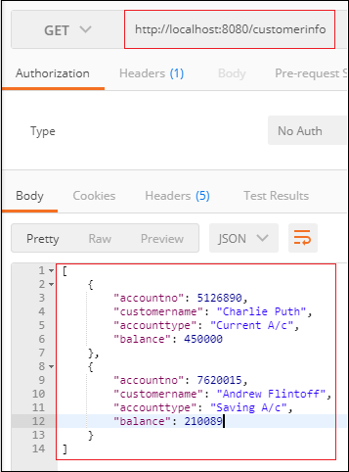

Spring Boot Cache Provider
The Spring Boot framework allows the integration of various cache providers, such as EhCache, Redis, Hazelcast, Infinispan, Caffeine, etc. The cache provider allows the developer to configure cache transparently and explicitly in an application. We should use cache because it reduces the number of executions and increases the performance of the application.
In Spring Boot, the cache abstraction does not provide the actual space for the cache. It depends on the abstraction that occurred by the org.springframework.cache.Cache or org.springframework.cache.CacheManager interfaces.

Caching Auto-configuration
The Spring Boot Framework simplifies the implementation of caching by auto-configuration support. It searches for the libraries and configuration-files in the classpath and initializes the required dependency beans at the time of application startup. The auto-configuration of caching includes the following steps:
- Add the annotation @EnableCaching in the configuration file.
- Add the required caching libraries in the classpath.
- In the root of the classpath, add the configuration filefor the cache provider.
For example, if we want to implement EhCache in an application, first we enable the cache in the configuration file.
- @SpringBootApplication
- @EnableCaching
- public class Employee
- {
- @Bean
- public CacheManager cacheManager()
- {
- //some code
- }
- }
Add EhCache dependency in the pom.xml file. It adds the required libraries in the classpath.
- <dependency>
- <groupId>org.ehcache</groupId>
- <artifactId>ehcache</artifactId>
- </dependency>
At the end, configure the file for cache provider. Here, we are using the EhCache so need to configure ehcache.xml file at the root of the classpath.
When we do not define a bean of type CacheManager or CacheResolver, the Spring Boot Framework tries to detect the following cache provider:
- Generic
- JCache
- EhCache
- Hazelcast
- Infinispan
- Couchbase
- Redis
- Caffeine
- Simple
If the Spring Boot finds the more than one cache provider in the classpath, in such cases, we must specify the cache provider explicitly in the application.properties file.
- spring.cache.ehcache.provider=net.sf.ehcache.CacheManager
- spring.cache.ehcache.config=classpath:config/another-config.xml
We can set up a particular cache provider by using the property spring.cache.type. It is used in a certain environment if we want to disable caching.
- spring.cache.type=none
The Spring Boot Framework provides a starter dependency that adds basic cache dependency in the application. The starter cache dependency, by default, provides the spring-context-support dependency.

Note: We must include spring-context-support dependency in pom.xml file if we add cache dependency manually. Because, it provides support for Jcache, EhCache, and Caffiene.
- <dependency>
- <groupId>org.springframework</groupId>
- <artifactId>spring-context-support</artifactId>
- <version>5.2.3.RELEASE</version>
- </dependency>
The Spring Boot Framework automatically configures the CacheManager that can be further customized by implementing the CacheManagerCustomizer interface.
In the follwoig example, we have set up a flag that passes the null values to the primary map.
- @Bean
- public CacheManagerCustomizer<ConcurrentMapCacheManager> cacheManagerCustomizer()
- {
- return new CacheManagerCustomizer<ConcurrentMapCacheManager>()
- {
- @Override
- public void customize(ConcurrentMapCacheManager cacheManager)
- {
- cacheManager.setAllowNullValues(false);
- }
- };
- }
The above bean expects a auto-configured ConcurrentMapCacheManager. If the ConcurrentMapCacheManager is not auto-configures, the customizer will not invoke in any way. We can have any number of customizer and arrange them in order by using the annotation @Order or @Ordered.

Generic Caching
If the spring-context-support defines at least one org.springframework.cache.Cache bean, it uses the Generic cache. The CacheManager bundled all the beans and configured them.

JCache
JCache is a self-starting process that is provided by the javax.cache.spi.CahingProvider. It is present on the classpath JSR 107. The spring-boot-starter-cache provides the JCacheCacheManager. We can add any other cache library as well.

Note: Spring Boot prefers the JSR support if a cache library provides both native implementation and JSR support.

EhCache 2.x
EHCache is Java-based, open-source, and widely used cache. In order to use EhCache we should use the following dependency.
- <dependency>
- <groupId>org.ehcache</groupId>
- <artifactId>ehcache</artifactId>
- </dependency>
There are two ways to configure EhCache:
- First, by configuring Java POJO file where all configuration parameters are configured through EhCache API.
- Second, by configuring the XML file where we configure EhCache according to the provided schema definition.
EhCache used a file called ehcache.xml. If the application found the file on the classpath, the EhCacheCacheManager provided by the spring-boot-starter-cache. We can configure the XML file by using the following property:
- spring.cache.ehcache.config=classpath:config/demo-config.xml

Hazelcast
When we enable the caching in an application, Spring Boot wraps the HazelcastInstance automatically in the CacheManager. It distributes the data equally among the nodes. We can configure Hazelcast by using the following property.
- spring.hazelcast.config=classpath:config/demo-hazelcast.xml
If the property is not set, Spring Boot tries to find the hazelcast.xml (Hazelcast configuration) file on the classpath.

Infinispan
Infinispan is an embedded Java library. It is used as a cache or a data grid. It stores data in the key-value form. It can be easily integrated with JCache, JPA Quarkus, Spring, etc.
It does not have a default file location, so we should specify it explicitly. If the infinispan is not specified explicitly, it uses default bootstrap.
- spring.cache.infinispan.config=infinispan.xml

Couchbase
The CouchebaseCacheManager is automatically configured when we implement couchbase-spring-cache, and Couchbase is configured. All the operations related to the cache perform in the Bucket. It allows us to create additional caches (if required) by setting up the property spring.cache.cache-name.
The customizer allows us to create additional Buckets, in which we can create another cache.
Let's understand the above concept through an example.
Suppose that we need three caches named cacheA, cacheB, and cacheC. The cacheA and cacheB are on the main Bucket (i.e., auto-configured Bucket). The cacheC is on another Bucket that is to live for a few seconds, say 4 seconds. Hence, we can create cacheA and cacheB by specifying the property, as follows:
- spring.cache.cache-names=cacheA, cacheB

Redis
The RedisCacheManager is autoconfigured when we configure Redis. It also allows us to create additional cache by using the property spring.cache.cache-names. The default configuration can be achieved by using the property spring.cache.redis.*.
We can take full control over the default configuration by using the RedisCacheConfiguration bean.
- spring.cache.cache-names=cacheA, cacheB
- spring.cache.redis.time-to-live=100000
The above properties configure two caches named cacheA and cacheB, that lives for 10 minutes.

Caffeine
The caffeine is a Java based caching library. It also provides an in-memory cache. The spring-boot-starter-cache dependency automatically configures the CaffeineCacheManger, if it founds the Caffeine in the classpath. If we want to use Caffeine in an application, we need to add the following dependency:
- <dependency>
- <groupId>com.github.ben-manes.caffeine</groupId>
- <artifactId>caffeine</artifactId>
- <version>2.7.0</version>
- </dependency>
The caffeine cache allows us to define size and time to live of the cache by using the property spring.cache.caffeine.spec. For example:
- spring.cache.cache-names=cacheA,cacheB
- spring.cache.caffeine.spec=maximumSize=500,expireAfterAccess=600s
The above configuration creates two caches named cache1 and cache2. The maximum size of the cache is 500 and the maximum time to live cache is 6 seconds.

Simple
It is the default implementation. If no cache provider is specified. It configures a ConcurrentHashMap as a cache store if the Spring Boot does not find any cache provider in the classpath.
For example, if we want two caches, set their name by using the following property:
- spring.cache.cache-names=cache1,cache2

None
When we enable the cache by using the annotation @EnableCaching, the application expects a suitable configuration. It is used when we want to disable the cache in a certain environment. We use the property spring.cache.type to disable the cache.
- spring.cache.type=none

Spring Boot EhCaching

EhCache
EhCache is an open-source, Java-based cache used to boost performance. The current version of Ehcache is 3. It provides the implementation of the JSR-107 cache manager. We can use it directly.

Features of EhCache
- It is fast, lightweight, Scalable, and Flexible.
- It allows us to perform Serializable and Object
- It offers cache eviction policies such as LRU, LFU, FIFO,
- It stores the cache in memory and disk (SSD).
- It depends on SLF4J for logging.
- It has a full implementation of JSR-107 and Jcache
- It supports distributed caching via JGroups or JMS and RMI.
- It uses fluent query language for distributed search.

EhCache Usage Patterns
The cache uses several access patterns. There are following patterns used by EhCache:
- Cache-aside
- Cache-as-SoR (system-of-record)
- Read-through
- Write-through
- Write-behind

Cache-aside
In the cache-aside pattern, first, the application consults with the cache. If the data is found, it returns the data directly. In the opposite scenario, it fetches the data from the SoR, stores it into the cache, and then return.

Cache-as-SoR
The cache-as-SoR pattern represents SoR reading and writing operations to the cache. It reduces the responsibility of the application. It uses the combination of read and write pattern that includes read-through, write-through, and write-behind. It reduces the difficulty of the application. It allows the cache to solve the thundering-herd problem

Read-through
The read-through pattern also copies the cache-aside pattern while reading data from the cache. The difference between the read-through and cache-aside is that read-through pattern implements the CacheEntryFactory interface. It guides the cache how to read an object from the cache. It is better to wrap the EhCache instance with the instance of SelfPopulatingCache while using the read-through pattern.

Write-through
The write-through pattern also copies the cache-aside pattern while writing data in the cache. The difference between write-through and cache-aside pattern is that write-through pattern implements the CacheWriter interface. It configures the cache for both write-through and write-behind pattern. It writes data to the SoR in the same thread of execution.

Write-behind
The write-behind pattern is different form the other three patterns. It modifies the cache entries after a configurable delay. The delay may in seconds, minutes, a day, a week, or for a long time. Simultaneously, it also queues the data to write at a later time in the same thread of execution.
The data write using write-behind pattern happens outside of the scope of the transaction. It means that it creates a new transaction to commit the data in the SoR that is distinct from the main transaction.

EhCaching Storage Tiers
EhCache allows us to use various data storage areas, such as heap, disk and clustered. We can configure a multi-storage cache (uses more than one storage area). It can be arranged and managed as tiers.
The tiers are organized in order. The bottom-most tier is known as authority tier, and the other tier is known as the caching tier. It is also known as nearer or near cache. The caching tier can have more than one storage area. The hottest data kept in the caching tier because it is faster than the authority tier. Other data is kept in the authority tier that is slower but richer in comparison to the caching tier.
There are four types of data storage supported by EhCache:
- On-Heap Store
- Off-Heap Store
- Disk Store
- Clustered Store

On-Heap Store
It stores cache entries in Java heap memory. It shares the storage with Java application. It is fast because it uses heap but has limited storage space. The garbage collector also scans the on-heap store.

Off-Heap Store
It uses the primary memory (RAM) to store cache entries. The garbage collector does not scan it. It is slower than the on-heap store because the cache entries move to the on-heap store before use. It is limited in size.

Disk Store
It uses a disk to store cache entries. It is much slower than RAM-based stores (on and off-heap store). It is better to use a dedicated disk if you are using a disk store pattern. It enhances throughput.

Clustered Store
It stores cache entries on the remote server. It is slower than off-heap storage. It may have a failover server that provides high availability.
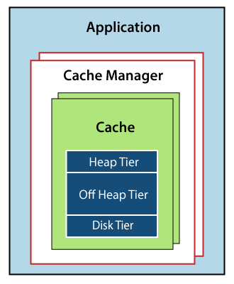
The above diagram shows that:
- An application may have more than one Cache Manager.
- Many caches can be handled by a Cache Manager.
- The caches can use more than one tier for storing cache entries.
- EhCache puts the recently used or frequently used data in the faster tier (caching tier).

Configuring EhCache
- Place the EhCache jar in the classpath.
- Configure the xml and put it in the classpath.
- Create a
- Reference a Cache.

Example of EhCache
In the following example, we are going to configure EhCache in an application.
Step 1: Open the Spring Initializr https://start.spring.io/.
Step 2: Select the Spring Boot version 2.3.0 M2.
Step 3: Provide the Group name. We have provided the Group name com.javatpoint.
Step 4: Provide the Artifact. We have provided the Artifact spring-boot-ehcache-example.
Step 5: Add the Spring Web dependency.
Step 6: Click on the Generate button. When we click on the Generate button, it wraps all the specifications related to application into a Jar file and downloads it to the local system.
Step 7: Extract the jar file.
Step 8: Copy the folder and paste it in the STS workspace.
Step 9: Import the project.
File -> Import -> Existing Maven Projects -> Next -> Browse -> Select the folder spring-boot-ehcache-example -> Select Folder -> Finish
It takes time to import the project.
Step 10: Copy the following dependency one by one from the Maven Repository https://mvnrepository.com/ and paste it into the pom.xml file.
- spring-boot-starter-cache
- ehcache 3
- cache API.

Note: Do not use the ehcache of the package net.sf.ehcache.
pom.xml
- <?xml version="1.0" encoding="UTF-8"?>
- <project xmlns="http://maven.apache.org/POM/4.0.0" xmlns:xsi=http://www.w3.org/2001/XMLSchema-instance xsi:schemaLocation="http://maven.apache.org/POM/4.0.0 https://maven.apache.org/xsd/maven-4.0.0.xsd">
- <modelVersion>4.0.0</modelVersion>
- <parent>
- <groupId>org.springframework.boot</groupId>
- <artifactId>spring-boot-starter-parent</artifactId>
- <version>2.3.0.M2</version>
- <relativePath/> <!-- lookup parent from repository -->
- </parent>
- <groupId>com.javatpoint</groupId>
- <artifactId>spring-boot-ehcache-example</artifactId>
- <version>0.0.1-SNAPSHOT</version>
- <name>spring-boot-ehcache-example</name>
- <description>Demo project for Spring Boot</description>
- <properties>
- <java.version>1.8</java.version>
- </properties>
- <dependencies>
- <dependency>
- <groupId>org.springframework.boot</groupId>
- <artifactId>spring-boot-starter-web</artifactId>
- </dependency>
- <dependency>
- <groupId>org.springframework.boot</groupId>
- <artifactId>spring-boot-starter-cache</artifactId>
- </dependency>
- <dependency>
- <groupId>org.ehcache</groupId>
- <artifactId>ehcache</artifactId>
- </dependency>
- <dependency>
- <groupId>javax.cache</groupId>
- <artifactId>cache-api</artifactId>
- </dependency>
- <dependency>
- <groupId>org.springframework.boot</groupId>
- <artifactId>spring-boot-starter-test</artifactId>
- <scope>test</scope>
- <exclusions>
- <exclusion>
- <groupId>org.junit.vintage</groupId>
- <artifactId>junit-vintage-engine</artifactId>
- </exclusion>
- </exclusions>
- </dependency>
- </dependencies>
- <build>
- <plugins>
- <plugin>
- <groupId>org.springframework.boot</groupId>
- <artifactId>spring-boot-maven-plugin</artifactId>
- </plugin>
- </plugins>
- </build>
- <repositories>
- <repository>
- <id>spring-milestones</id>
- <name>Spring Milestones</name>
- <url>https://repo.spring.io/milestone</url>
- </repository>
- </repositories>
- <pluginRepositories>
- <pluginRepository>
- <id>spring-milestones</id>
- <name>Spring Milestones</name>
- <url>https://repo.spring.io/milestone</url>
- </pluginRepository>
- </pluginRepositories>
- </project>
Now, we need to configure the ehcache.xml file. It tells the framework where to find the file.
Step 11: Open the application.properties file and configure the EhCache by using the following property.
application.properties
- #configuring ehcache.xml
- spring.cache.jcache.config=classpath:ehcache.xml
Step 12: Open the SpringBootEhcacheExampleApplication.java file and enable caching by using the annotation @EnableCaching.
SpringBootEhcacheExampleApplication.java
- package com.javatpoint;
- import org.springframework.boot.SpringApplication;
- import org.springframework.boot.autoconfigure.SpringBootApplication;
- import org.springframework.cache.annotation.EnableCaching;
- @SpringBootApplication
- //enables the cache management capability
- @EnableCaching
- public class SpringBootEhcacheExampleApplication
- {
- public static void main(String[] args)
- {
- SpringApplication.run(SpringBootEhcacheExampleApplication.class, args);
- }
- }

Note: If we do not want to use annotation @EnableCaching in main application file, we can create a separate CacheConfig class and annotate that call with the annotation.
- package com.javatpoint;
- import org.springframework.cache.annotation.EnableCaching;
- import org.springframework.context.annotation.Configuration;
- @Configuration
- //enable caching
- @EnableCaching
- public class CacheConfig
- {
- }
Step 13: Create a model class. We have created the model class in the package com.javatpoint with the name Student. In the model class do the following:
- Create five variable id, name, gender, and
- Generate Constructor using Fields.
Right-click on the file -> Source -> Generate Constructor using Fields -> Select All -> Generate
- Generate Getters and Setters.
Right-click on the file -> Source -> Generate Getters and Setters -> Select All -> Generate
- Generate a toString()
- Right-click on the file -> Source -> Generate toString() -> Generate
After completing all the above steps, the model class looks like the following.
Student.java
- package com.javatpoint;
- public class Student
- {
- private int id;
- private String name;
- private String gender;
- private String city;
- public Student(int id, String name, String gender, String city)
- {
- super();
- this.id = id;
- this.name = name;
- this.gender = gender;
- this.city = city;
- }
- public int getId()
- {
- return id;
- }
- public void setId(int id)
- {
- this.id = id;
- }
- public String getName()
- {
- return name;
- }
- public void setName(String name)
- {
- this.name = name;
- }
- public String getGender()
- {
- return gender;
- }
- public void setGender(String gender)
- {
- this.gender = gender;
- }
- public String getCity()
- {
- return city;
- }
- public void setCity(String city)
- {
- this.city = city;
- }
- @Override
- public String toString()
- {
- return "Student [id=" + id + ", name=" + name + ", gender=" + gender + ", city=" + city + "]";
- }
- }
Step 14: Create a Service class that manages the student. We have created the service class with the name StudentManager. In this class, we have done the following:
- Annotated the class with the annotation @Service.
- Create an instance of HashMap.
- In the static block, we have added student data in the map.
- By using the annotation @Cacheable, we have defined the name of the cache All the data will be saved in this cache. We have defined the id in the key attribute of the annotation. The cache searches the student on the basis of id.
- We have created a method getStudentById() that parses id as a parameter. It returns the id of the student.
StudentManager.java
- StudentManager.java
- package com.javatpoint;
- import java.util.HashMap;
- import org.springframework.cache.annotation.Cacheable;
- import org.springframework.stereotype.Service;
- @Service
- public class StudentManager
- {
- static HashMap<Integer, Student> student = new HashMap<>();
- static
- {
- student.put(1, new Student(100, "Alex", "Male", "Berlin"));
- student.put(2, new Student(101, "Tony", "Male", "Maxico"));
- student.put(3, new Student(102, "Andrew", "Male", "Chicago"));
- student.put(4, new Student(103, "Alexa", "Female", "Brussels"));
- student.put(5, new Student(104, "Maria", "Female", "Houston"));
- }
- @Cacheable(cacheNames="demoCache", key="#id")
- public Student getStudentById(Integer id)
- {
- System.out.println("Fetching student data from cache");
- return student.get(id);
- }
- }
Now we need to create ehcache.xml file. It contains the information related to cache such as name of the cache, no of element in the memory, time to live data in the cache, etc.
Step 15: Create a cache configure file named ehcache.xml in the src/main/resources folder.
ehcahe.xml
- <config
- xmlns:xsi='http://www.w3.org/2001/XMLSchema-instance'
- xmlns='http://www.ehcache.org/v3'
- xmlns:jsr107='http://www.ehcache.org/v3/jsr107'>
- <ehcache>
- <diskStore path="java.io.tmpdir" />
- <defaultCache maxElementsInMemory="2000"
- eternal="true"
- overflowToDisk="false"
- timeToLiveSeconds="1200" />
- <cache name="demoCache"
- maxElementsInMemory="2000"
- eternal="false"
- overflowToDisk="false"
- timeToLiveSeconds="10000" />
- </ehcache>
- </config>
Now we have created all the required files. After creating all the files, the project directory looks like the following:
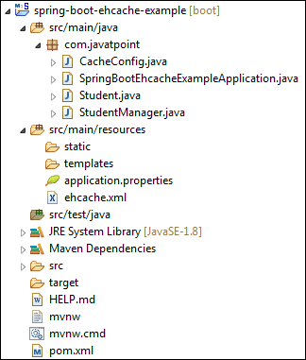
Let's run the application.
Step 16: Open the SpringBootEhcacheExampleApplication.java file and run it as Java Application.
It shows the following output:
- Getting Students from Cache
- [id=100, name=Alex, gender=Male, city=Berlin]
- [id=101, name=Tony, gender=Male, city=Mexico]
- [id=102, name=Andrew, gender=Male, city=Chicago]
- [id=103, name=Alexa, gender=Female, city=Brussels]
- [id=104, name=Maria, gender=Female, city=Houston]

How to Run Spring Boot Application
In this section, we will create and run a simple Spring Boot application.

Creating a Spring Boot Application
Step 1: Open the Spring Initializr https://start.spring.io/.
Step 2: Select the Spring Boot version 2.2.2.BUILD-SNAPSHOT.
Step 3: Provide the Group name. We have provided the Group name com.javatpoint.
Step 4: Provide the Artifact. We have provided the Artifact spring-boot-application-run.
Step 5: Add the Spring Web dependency.
Step 6: Click on the Generate button. When we click on the Generate button, it wraps all the specifications related to application into a Jar file and downloads it to the local system.
Step 7: Extract the jar file.
Step 8: Copy the folder and paste it in the STS workspace.
Step 9: Import the project.
File -> Import -> Existing Maven Projects -> Next -> Browse -> Select the folder spring- spring-boot-application-run -> Select Folder -> Finish
It takes time to import the project. When the project imports successfully, we can see it in the Package Explorer section of the IDE.
We see that two files are automatically created, one is pom.xml, and the other is Application.java file.
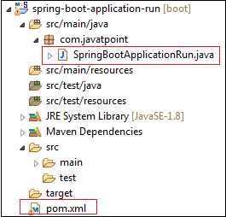
The pom.xml file contains the all the dependencies, application name, Spring Boot version, group name, artifact, and other plugins.
pom.xml
- <?xml version="1.0" encoding="UTF-8"?>
- <project xmlns="http://maven.apache.org/POM/4.0.0" xmlns:xsi="http://www.w3.org/2001/XMLSchema-instance"
- xsi:schemaLocation="http://maven.apache.org/POM/4.0.0 https://maven.apache.org/xsd/maven-4.0.0.xsd">
- <modelVersion>4.0.0</modelVersion>
- <parent>
- <groupId>org.springframework.boot</groupId>
- <artifactId>spring-boot-starter-parent</artifactId>
- <version>2.2.2.BUILD-SNAPSHOT</version>
- <relativePath/> <!-- lookup parent from repository -->
- </parent>
- <groupId>com.javatpoint</groupId>
- <artifactId>spring-boot-application-run</artifactId>
- <version>0.0.1-SNAPSHOT</version>
- <name>spring-boot-application-run</name>
- <description>Demo project for Spring Boot</description>
- <properties>
- <java.version>1.8</java.version>
- </properties>

- <dependencies>
- <dependency>
- <groupId>org.springframework.boot</groupId>
- <artifactId>spring-boot-starter</artifactId>
- </dependency>

- <dependency>
- <groupId>org.springframework.boot</groupId>
- <artifactId>spring-boot-starter-parent</artifactId>
- <version>2.2.1.RELEASE</version>
- <type>pom</type>
- </dependency>
- <dependency>
- <groupId>org.springframework.boot</groupId>
- <artifactId>spring-boot-starter-web</artifactId>
- </dependency>

- <dependency>
- <groupId>org.springframework.boot</groupId>
- <artifactId>spring-boot-starter-test</artifactId>
- <scope>test</scope>
- <exclusions>
- <exclusion>
- <groupId>org.junit.vintage</groupId>
- <artifactId>junit-vintage-engine</artifactId>
- </exclusion>
- </exclusions>
- </dependency>
- </dependencies>

- <build>
- <plugins>
- <plugin>
- <groupId>org.springframework.boot</groupId>
- <artifactId>spring-boot-maven-plugin</artifactId>
- </plugin>
- </plugins>
- </build>

- <repositories>
- <repository>
- <id>spring-milestones</id>
- <name>Spring Milestones</name>
- <url>https://repo.spring.io/milestone</url>
- </repository>
- <repository>
- <id>spring-snapshots</id>
- <name>Spring Snapshots</name>
- <url>https://repo.spring.io/snapshot</url>
- <snapshots>
- <enabled>true</enabled>
- </snapshots>
- </repository>
- </repositories>
- <pluginRepositories>
- <pluginRepository>
- <id>spring-milestones</id>
- <name>Spring Milestones</name>
- <url>https://repo.spring.io/milestone</url>
- </pluginRepository>
- <pluginRepository>
- <id>spring-snapshots</id>
- <name>Spring Snapshots</name>
- <url>https://repo.spring.io/snapshot</url>
- <snapshots>
- <enabled>true</enabled>
- </snapshots>
- </pluginRepository>
- </pluginRepositories>

- </project>
The main class is a class that contains the main() method. It starts the Spring ApplicationContext. It is the class that we run for the execution of the application.
SpringBootApplicationRun.java
- package com.javatpoint;
- import org.springframework.boot.SpringApplication;
- import org.springframework.boot.autoconfigure.SpringBootApplication;
- @SpringBootApplication
- public class SpringBootApplicationRun
- {
- public static void main(String[] args)
- {
- SpringApplication.run(SpringBootApplicationRun.class, args);
- }
- }
Step 10: Create a Controller. We have created a controller with the name HelloWorldController.
HelloWorldController.java
- package com.javatpoint;
- import org.springframework.web.bind.annotation.RequestMapping;
- import org.springframework.web.bind.annotation.RestController;
- @RestController
- public class HelloWorldController
- {
- @RequestMapping("/")
- public String hello()
- {
- return "Hello User";
- }
- }
Now we have created all the required files related to Spring Boot application.

Run the Spring Boot application
For running the Spring Boot application, open the main application file, and run it as Java Application.
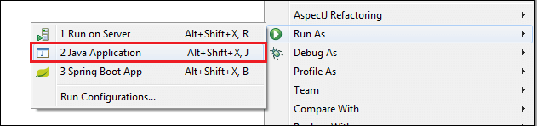
When the application runs successfully, it shows the message in the console, as shown below.
Now, open the browser and invoke the URL http://localhost:8080. It shows the message that we have returned to the controller.
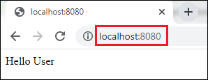

Spring Boot Change Port
The Spring Boot framework provides the default embedded server (Tomcat) to run the Spring Boot application. It runs on port 8080. It is possible to change the port in Spring Boot.
We can change the port in Spring Boot by using the following interfaces and properties files:
- Using application.properties file
- Using application.yml file
- Using EmbeddedServletContainerCustomizer Interface
- Using WebServerFactoryCustomizer Interface
- Using Command-Line Parameter

Using application.properties file
We recommend you to use the application.properties file if you want to change the default port. Because it is an easy and faster way to overwrite default values. We use the server.port property to overwrite the default property.
For example, if we want to change default port 8080 to 8082, specify the property in application.properties file.
application.properties
- server.port=8082
We can also set the port property to 0. It scans the random port for the application. It uses a new port whenever we restart our application.
application.properties
- server.port=0

Using application.yml file
Similarly, we can also change the default port by using a yml file. Use either application.properties or application.yml file, both the files works in the same manner.
application.yml
- server:
- port:8082

Using EmbeddedServletContainerCustomizer Interface
If you are using Spring Boot 1.x version, it provides an interface EmbeddedServletContainerCustomizer to change the default port.
EmbeddedServletContainerCustomizer Interface
By using the EmbeddedServletContainerCustomizer, we can customize auto-configured embedded servlet containers. All the beans of this type get a callback with the container factory before starting the container itself. Therefore, we can set the port, addresses, and even error pages. It is defined in the org.springframework.boot.context.embedded package.
The interface contains a method called customize(). It allows us to customize and specify ConfigurableEmbeddedServletContainer. It parses a parameter called container that we want to customize.

Syntax
- void customize(ConfigurableEmbeddedServletContainer container)
ConfigurableEmbeddedServletContainer Interface
It is an interface that reflects the changes in the EmbeddedServletContainerFactory interface (factory interface used to create EmbeddedServletContainers). It is defined in the org.springframework.boot.context.embedded package. It contains a method to change the port called the setPort() method.
setPort() method
The setPort() method configures the port of embedded servlet container should listen on. When we do not specify the port, it uses the default port 8080. If we want to disable the auto-start feature of the embedded server, use the port -1. The port -1 represents that it will not listen to any port but start the web application context. The method parses a parameter port (the port to set) of type int.

Syntax
- void setPort(int port)
In the following example, we have created a class named ServerCustomizer and implements the EmbeddedServletContainerCustomizer Interface. We have overridden the customize() method and invoke the setPort() method that sets the port 8097.
ServerCustomizer.java
- @Component
- public class ServerCustomizer implements EmbeddedServletContainerCustomizer
- {
- @Override
- public void customize(ConfigurableEmbeddedServletContainer container)
- {
- container.setPort(8097);
- }
- }

Using WebServerFactoryCustomizer Interface
Spring Boot 2.x version provides WebServerFactoryCustomizer interface to change the default port. It defined in the package org.springframework.boot.web.server. It parses a parameter T of type web server factory.

Syntax
- public interface WebServerFactoryCustomizer<T extends WebServerFactory<
The interface contains a method called customize(). It allows us to customize web server factories. It parses a parameter called factory that we want to customize. All the beans of this type get a callback with the server factory before starting the container itself. Therefore, we can set the port, addresses, and even error pages.

Syntax
- void customize(T factory)
WebServerFactory Interface
It is a tagging interface for factories. It is defined in org.springframework.boot.web.server package. It creates a WebServer.
ConfigurableWebServerFactory
It is an interface that configures web server factory. It is defined in the package org.springframework.boot.web.server. It extends WebServerFactory and ErrorPageRegistory. It contains a method to change the port called the setPort() method.
setPort()
The setPort() method configures the port of embedded servlet container should listen on. When we do not specify the port, it uses the default port 8080. If we want to disable the auto-start feature of the embedded server, use the port -1. The port -1 represents that it will not listen to any port but start the web application context. The method parses a parameter port (the port to set) of type int.

Syntax
- void setPort(int port)

Note: This setPort() method is of interface ConfigurableWebServerFactory
In the following example, we have created a class named ServerCustomizer that implements the WebServerFactoryCustomizer Interface. We have overridden the customize() method and invoke the setPort() method that sets the port 9001.
ServerCustomizer.java
- @Component
- public class ServerCustomizer implements WebServerFactoryCustomizer< ConfigurableWebServerFactory <
- {
- @Override
- public void customize(ConfigurableWebServerFactory factory)
- {
- factory.setPort(9001);
- }
- }

Using Command Line Parameter
We can also change the port in Spring Boot by using the command line parameter. We must follow the steps given below:
- Open any Spring Boot application.
- Click on Run menu and select Run Configurations Or right-click on the application file -< Run As -< Run Configurations. Run Configurations window appears on the screen.
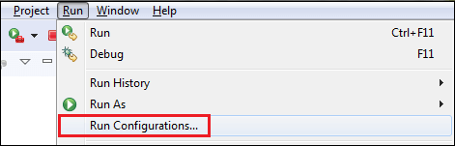
Run Configurations window appears on the screen.
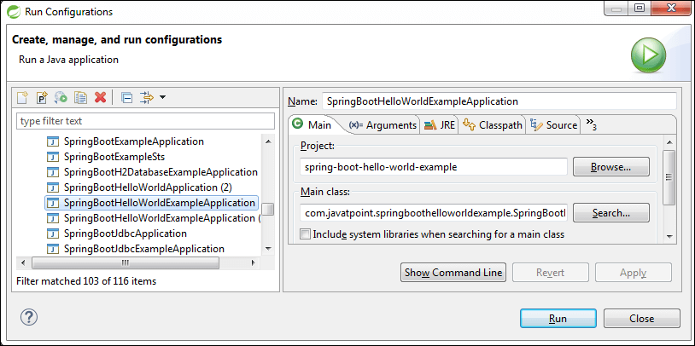
- Select the application file in which you want to change the port. In our case, we want to change the port of SpringBootHelloWorldExampleApplication, so we have selected it.
- Click on the Arguments tab.
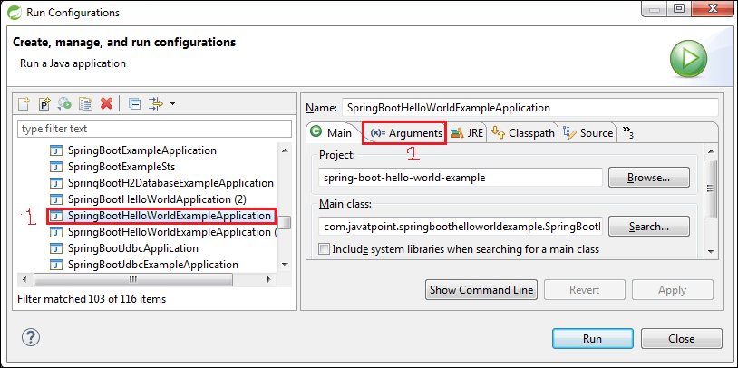
- Write -Dserver.port=9001 in the VM arguments field. You can specify your own port instead of 9001.
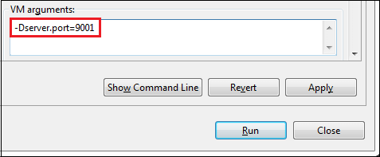
- Now, click on Apply and Run button, respectively.
After clicking on the Run button, the application starts running. We can see the console to see on which port server is running, as shown below.
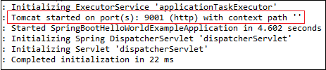
- Open the browser and invoke the URL http://localhost:9001. It runs the application on port 9001.
